

Timely, accurate results, providing effective care. Quality Manual

North Kent Pathology Service

and the Pathology Directorate of

Dartford and Gravesham NHS Trust

This document together with referenced procedures represents the Quality Management System of the North Kent Pathology Service (NKPS) and the Pathology Directorate at Dartford and Gravesham NHS Trust.

It has been compiled to meet the requirements of ISO 15189:2012 Standards, Screening Quality Assurance Service (SQAS), Public Health England (PHE) and the Blood Safety and Quality Regulations 2005 (BSQR).

All sites and departments within the North Kent Pathology Service and the Pathology Directorate operate within the same Quality Management System and this Quality Manual is common to all departments.

North Kent Pathology Service is the trading name of the Blood Sciences and Microbiology service which is a joint venture between Dartford and Gravesham NHS Trust and Medway NHS Foundation Trust with Dartford and Gravesham NHS Trust being the legal entity.

NKPS is part of the Kent and Medway Pathology Network (KMPN), a jointly owned programme with all Kent and Medway pathology providers (East Kent Hospital University Foundation Trust (EKHUFT), Maidstone Tunbridge Wells (MTW), and NKPS– Medway FT and Dartford) represented as members of the Network Board. It was formed in response to the 2017 NHS Improvement Directive and the requirement for a Pathology Programme to deliver excellent pathology services across the county.

KMPN and its programme of work is supported and partially funded (on a non-recurrent basis) by NHS England and Kent and Medway Integrated Care Board (ICB). It is one of over 20 similar networks across England who are all are seeking to future proof pathology services in the face of rising demand and increasingly scarce resources.

# Contents

Contents 3

1. DEFINITIONS 5

2. GENERAL INFORMATION 6

2.1. Pathology 6

2.2. Clinical Biochemistry 7

2.3. Haematology 8

2.4. Blood Transfusion 8

2.5. Microbiology 10

2.6. Mortuary 10

2.7. Point of Care Testing 11

2.8. Rapid Testing 11

2.9. Antenatal and Newborn screening 11

3. THE QUALITY MANUAL 12

3.1. Quality Policy 13

4. MANAGEMENT REQUIREMENTS 14

4.1. Organisation and Management Responsibility (4.1) 14

Organisation (4.1.1) 14

Management Responsibility (4.1.2) 16

4.2. Quality Management System (4.2) 28

4.3. Document Control 29

4.4. Service Agreements 30

4.5. Examination by Referral Laboratories 30

4.6. External Services and Supplies 31

4.7. Advisory Services 31

4.8. Resolution of Complaints 32

4.9. Identification and Control of Non-Conformities 33

4.10. Corrective Action 34

4.11. Preventive Action 34

4.12. Continual Improvement 35

4.13. Control of Records 36

4.14. Evaluation and Audits 36

4.15. Management Review 38

5. SECTION 5 – TECHNICAL REQUIREMENTS 39

5.1. Personnel 39

Personnel Qualifications 39

Job Descriptions and Contracts 39

Introduction to the Organisational Environment 39

Training 39

Competence assessment 40

Reviews of Staff Performance 40

Continuing Professional Development 41

Personnel Files and Staff Records 41

5.2. Accommodation and Environmental Conditions 41

Laboratory and Office Facilities 41

Storage Facilities 41

Staff Facilities 42

Patient Sample Collection Facilities 42

Facility maintenance and environmental conditions 42

5.3. Laboratory Equipment, Reagents and Consumables 43

Equipment 43

Reagents and Consumables 44

5.4. Pre-Examination Processes 45

Information for Patients and Users 45

Request form Information 46

Primary Sample Collection and Handling 47

Sample Transportation 48

Sample Reception 49

Pre-examination Handling, Preparation and Storage 50

5.5. Examination Processes 50

5.6. Ensuring Quality of Examination Results 51

5.7. Post-Examination Processes 52

5.8. Reporting of Results 52

5.9. Release of Results 53

5.10. Laboratory Information Management 54

1. **DEFINITIONS**

The following acronyms are used throughout this Quality Manual:

|  |  |  |  |
| --- | --- | --- | --- |
| * ACB | Association for Clinical Biochemistry and Laboratory Medicine | * NEQAS | National External Quality Assessment Service |
| * AMR | Annual Management Review | * NHS | National Health Service |
| * BCUK | Beckman Coulter Diagnostics UK | * NHSBT | National Health Service Blood and Tissue |
| * BSQR | Blood Safety and Quality Regulations | * NHSI | National Health Service Improvements |
| * CA/PA | Corrective Action/ Preventive Action | * NICE | National institute of clinical excellence |
| * CMV | Cytomegalovirus | * NKPS | North Kent Pathology Service |
| * COSHH | Control of Substances Hazardous to Health | * OSCAR | One Stop Clinic for Assessment of Risk |
| * CPD | Continual Professional Development | * OSNA | One Step Nucleic Acid Amplification |
| * CSR | Central Specimen Reception | * PALS | Patient advise and liaison service |
| * DGT | Dartford and Gravesham NHS Trust | * PAPP-A | Pregnancy Associated Plasma Protein – A |
| * DVH | Darent Valley Hospital | * PAS | Patient administration system |
| * DXC | DXC Technology | * PAT | Portable Appliance Testing |
| * EQA | External quality assurance | * PHE | Public Health England |
| * GCH | Gravesend Community Hospital | * PoCT | Point of Care Testing |
| * GP | General Practitioner | * PPE | Personal protective equipment |
| * HbA1c | Haemoglobin A1c | * QIPP | Quality, innovation, productivity & prevention |
| * HCPC | The Health and Care Professions Council | * QMH | Queen Mary’s Hospital, Sidcup |
| * HIV | Human Immunodeficiency Virus | * QMS | Quality Management System |
| * HPLC | High Performance Liquid Chromatography | * RCPath | Royal College of Pathologists |
| * HR | Human Resources | * SABRE | Serious Adverse Blood Reactions and Events |
| * IBMS | Institute of Biomedical Science | * SHOT | Serious Hazards of Transfusion |
| * ICP | Integrated Care Partnership | * SI | International System of Units |
| * IQC | Internal Quality Assurance | * SLA | Service Level Agreement |
| * ISO | International Organization for Standardization | * SOP | standard operating procedure |
| * IT | Information Technology | * SQAS | Screening Quality Assurance service |
| * ToR | Terms of Reference |
| * KCC | Kent County Council | * UCH | University College Hospital |
| * KCN | Kent Cancer Network | * UKAS | United Kingdom Accreditation Service |
| * LIMS | Laboratory Information Management System | * UN | United Nations |
| * MFT | Medway NHS Foundation Trust | * URS | User Requirement Specification |
| * WEQAS | Welsh External Quality Assessment Service |
| * MHRA | Medicines and Healthcare products Regulatory Agency | * β-hCG | Beta – Human Chorionic Gonadotropin |
| * MMH | Medway Maritime Hospital |  |  |

# GENERAL INFORMATION

## Pathology

North Kent Pathology Service (NKPS) is a joint venture between Dartford and Gravesham NHS Trust (DGT) and Medway NHS Foundation Trust (MFT) providing Blood Science (Blood Transfusion, Clinical Biochemistry and Haematology) and Microbiology services to both Trusts.

NKPS has two laboratories providing services to a population of over 670,000.

The main site is located on Level 3, East Wing at Darent Valley Hospital.

|  |  |  |
| --- | --- | --- |
| Postal Address: | Pathology Department  Darent Valley Hospital  Darenth Wood Road  Dartford  Kent  DA2 8DA | Telephone: 01322 428491 |

The sister site is located on Level 4, Red Zone at Medway Maritime Hospital

|  |  |  |
| --- | --- | --- |
| Postal Address: | Pathology Department  Medway Maritime Hospital  Windmill Road  Gillingham  Kent  ME7 5NY | Telephone: 01634 825183 |

DGT provides a comprehensive range of acute health services to the residents of Dartford, Gravesham and Swanley. DGT headquarters are based at Darent Valley Hospital and have offsite facilities at Queen Mary’s Hospital (QMH), Sidcup and Gravesend Community Hospital (GCH).

MFT is a single site hospital based at Medway Maritime Hospital (MMH), which provides a range of health services to people across Medway and Swale.

The two Trusts provide services to two Integrated Care Partnerships (ICP) within the Kent and Medway Clinical Commissioning Group:

* Dartford Gravesham and Swanley Integrated Care Partnership
* Medway and Swale Integrated Care Partnership

The Pathology departments that are situated across both Darent Valley Hospital and Medway Maritime Hospital operate under a single Quality Management System in order to comply with the requirements of ISO 15189:2012 standard Multi-Site Laboratories.

See: POL.PAT.15

The Pathology service is divided into several categories:

Services provided to both DGT and MFT within the scope of NKPS and consist of:

* Clinical Biochemistry including Central Specimen reception
* Haematology
* Blood Transfusion
* Microbiology

Services provided solely for the use of DGT that are inside the scope of NKPS:

* Point of Care Testing Services

Services provided solely for the use of MFT which are outside the scope of NKPS:

* MMH Blood Transfusion Practitioner

CSR within the Pathology Service organises specimens on their arrival within the laboratory, ensuring that the samples are redirected to the appropriate departments.

## Clinical Biochemistry

The Clinical Biochemistry department consists of two laboratories, a main laboratory at DVH and an acute laboratory at MMH. Full details of the services provided by the department can be found in the departmental user handbook.

See: MAN.PAT.2

The services provided by the Clinical Biochemistry Department are briefly described below:

#### Automated Section - DVH

This section provides testing of routine and urgent samples for metabolic and endocrine investigations, paediatric biochemistry, protein & lipid biochemistry, tumour markers, therapeutic drug/antibiotic monitoring and toxicological investigations. It consists of a large open area laboratory where samples are analysed on high throughput general chemistry and immunoassay analysers that are linked by an automated track system.

#### Miscellaneous Section - DVH

This section provides assays that are not connected to the automated track system and is comprised of a wide variety of techniques and assays, some manual and some automated. The range of assays includes tests such as HbA1c, protein electrophoresis and spectrophotometric analysis.

#### Acute Laboratory - MMH

This section is an acute laboratory providing urgent sample analysis required by the acute units and wards within MMH. It also offers serum testing for PAPP-A and free β-hCG for Medway Maritime Hospital. Additional sample analysis that is not urgent is referred to the main laboratory at DVH.

## Haematology

The Haematology department consists of two laboratories, a main laboratory at DVH and an acute laboratory at MMH. Full details of the services provided by the department can be found in the departmental user handbook.

See: MAN.PAT.5

The services provided by the Haematology Department are briefly described below:

#### Routine Haematology

This section deals with the majority of requests that are dealt with within the Haematology Department. It consists of a large open area laboratory where samples are analysed on high throughput analysers or manually by Biomedical Scientists. The range of assays includes full blood count, reticulocyte counts, blood film preparation, malaria screening, infectious mononucleosis screening and Erythrocyte Sedimentation Rate (ESR) analysis.

#### Haemostasis

This section deals with all requests for coagulation studies received by the Haematology Department. The range of assays includes clotting screens, INR (International Normalised Ratio) analysis, and thrombophilia testing and coagulation factor analysis.

#### Morphology

This section provides morphological services to assist in diagnosis. The range of assays includes cell morphology analysis, malaria screening and bone marrow preparation.

#### Haemoglobinopathy

This section primarily provides an ante-natal screening service for haemoglobinopathy to the ante-natal departments at DVH and MMH as well as to the midwifery services in the Medway and Swale communities.

#### Acute Laboratory - MMH

This section is an acute laboratory providing urgent sample analysis required by the acute units and wards within MMH. The range of assays includes full blood count, coagulation screening, morphology, malaria screening and sickle cell screening analysis. Any additional sample analysis that is not urgent is referred to the main laboratory at DVH.

## Blood Transfusion

The Blood Transfusion department consists of two laboratories, a laboratory at DVH and laboratory at MMH. These laboratories operate in accordance with each Trust’s requirements and as such, NKPS provides a full blood transfusion service on both sites. Full details of the services provided by each laboratory can be found in the departmental user handbooks.

See: MAN.PAT.10

See: MAN.PAT.7

The services provided by the Blood Transfusion Department are briefly described below:

#### Darent Valley Hospital

This laboratory performs pre-transfusion testing of blood group and antibody status using fully automated blood grouping analysers. This includes antenatal blood group and antibody screening for midwifery services within the Dartford, Gravesham and Swanley ICP. Further automated testing performed when required and includes antibody identification, direct agglutination tests and basic phenotyping when required or indicated during pre-transfusion testing.

Kleihauer tests are performed manually.

By means of these tests, the laboratory is able to provide safe blood and blood products for patients including:

* Red cells
* Platelets
* Plasma
* Cryoprecipitate

In addition, other products are available when required including:

* Anti-D immunoglobulin for Rh Negative pregnant women
* Beriplex for the reversal of Warfarin
* Clotting factors for the replacement of clotting factors

#### Medway Maritime Hospital

This laboratory performs pre-transfusion testing of blood group and antibody status using fully automated blood grouping analysers. This includes antenatal blood group and antibody screening for midwifery services within the Medway and Swale ICP. Further automated testing performed when required and includes antibody identification, direct agglutination tests and basic phenotyping when required or indicated during pre-transfusion testing.

By performing these tests, the laboratory is able to provide safe blood and blood products for patients including:

* Red cells
* Platelets
* Plasma
* Cryoprecipitate

In addition, other products are available when required including:

* Anti-D immunoglobulin for Rh Negative pregnant women
* Beriplex for the reversal of Warfarin
* Clotting factors for the replacement of clotting factors

## Microbiology

The microbiology department consists of one main laboratory at DVH. Full details of the services provided by the department can be found in the departmental user handbook.

See: MAN.PAT.9

The services provided by the Microbiology Department are briefly described below:

#### General Microbiology

This section of the laboratory is concerned with the isolation of medically significant bacteria, fungi and parasites. The laboratory carries out microscopy and culture investigations on urine, faeces, swabs from body sites and orifices, sputum, fluids, skin, hair, nails and blood. This section also performs investigations for the detection of *Mycobacterium* species and antimicrobial susceptibility.

#### Serology

This section of the laboratory deals with serological testing for a range of antigens and antibodies including (but not exhaustive) hepatitis (A, B, and C), HIV, syphilis, CMV, *Toxoplasma* and varicella zoster.

#### OSNA

The One Step Nucleic Acid Amplification (OSNA) test is performed on sentinel lymph node biopsies as part of the investigation of breast cancer.

#### Andrology

This service involves the microscopic examination of semen to assess the concentration, motility and morphology of spermatozoa in fertility and post vasectomy samples.

#### Molecular

This section includes SARS-CoV-2 RNA, Influenza A and B RNA and RSV RNA (Respiratory Syncytial Virus).

## Point of Care Testing

North Kent Pathology Service provides Point of Care Services for DGT.

The Point of Care Service provides the management of equipment and training of staff at Darent Valley Hospital and Queen Mary’s Hospital, Sidcup on the use of Point of Care Devices including blood gas analysers, haemocues, blood glucose and ketone meters and urinalysis.

## Rapid Testing

Managed by the Point of care Team offers rapid testing of SARS-CoV-2 RNA, Influenza A and B RNA and RSV RNA (Respiratory Syncytial Virus) to inpatients.

## Antenatal and Newborn screening

NKPS offers the following antenatal and screening services:

#### Sickle Cell and Thalassaemia (SCT) screening programme. Performed for DVH and MFT: these are analysed by Haematology at DVH.

#### Infectious Diseases in Pregnancy Screening (IDPS) programme. Performed for DVH and MFT: these are analysed in Serology at DVH.

Incidents are addressed by SQAS according to the process for managing safety incidents in NHS screening programmes.

The Kent and Medway antenatal/ newborn screening programme board is attended by a staff member from both Haematology and Microbiology. Staff in microbiology (for IDPS) and haematology (for SCT) attend quarterly screening meetings at DVH and MMH.

Microbiology communicates results as detailed in the Antenatal SOP (SOP.MIC.25). Haematology communicate results for the SCT programme as per Haemoglobinopathy Reporting (SOP.HAE.56), which includes the failsafe procedure.

When required, non-conformities involving antenatal testing are reported to the UKHSA by maternity via a Serious Incident Assessment Form (SIAF). For further information, see https://www.gov.uk/government/publications/managing-safety-incidents-in-nhs-screening-programmes

# THE QUALITY MANUAL

This Quality Manual describes the QMS that is used with NKPS and the Pathology Directorate that provides services to DGT and MFT. Throughout this Manual, there are references to ‘Medical Laboratories – Requirements for Quality and Competency ISO 15189:2012 Standards’ (Bracketed in Red) and to North Kent Pathology Service policies and procedures in Blue. These policies and procedures have been written to ensure compliance to the ISO 15189:2012 Standards.

The Quality Manual fulfils two main functions:

1. It describes the quality management system for the benefit of the laboratories own management and staff (4.2)
2. It provides information for users, accreditation boards and inspection bodies.

The Quality Manual can be regarded as the master index of all the separate manuals for management, laboratory, clinical and quality procedures.

The sections of the Quality Manual are arranged so that they provide statements to describe how the service complies with the ISO 15189:2012 Standards:

|  |  |
| --- | --- |
| **Section of the Quality Manual** | **Section of the ISO 15189:2012 Standards** |
| 4 | Management Requirements |
| 5 | Technical Requirements |

For each Standard, there is a brief description of how the Pathology service seeks to comply with the particular standard and includes references to any appropriate policy or procedure used by the Pathology service.

The QMS and the examination processes are continually evaluated and quality assured by internal and external audit and review (4.14). The findings from these audits are used to maintain and improve the QMS, meet the needs and requirements of our service users and to continually improve our services (4.12).

## Quality Policy

The scope of service provided by the Pathology Service is a clinical diagnostic service for Haematology, Blood Transfusion, Clinical Biochemistry and Microbiology – these departments provide a continuous testing service separated into routine core hours and an out of hours’ service. There is a Mortuary that provides post mortem facilities for the Coroner.

The Pathology Service is committed to providing a high quality service for its users and to ensure that the Directorate will:

* Operate a Quality Management System to integrate the organisation, procedures, processes and resources.
* Set Quality Objectives and plans to implement this Quality Policy taking into consideration the needs and requirements of its users which are to be reviewed throughout the year.
* Ensure that all personnel are familiar with the Quality Manual and all procedures relevant to their work.
* Commit to the health, safety and welfare of all its’ staff.
* Ensure that visitors to Pathology at either site will be treated with respect and due consideration will be given to their safety when on site.
* Uphold professional values and be committed to good professional practice and conduct.
* Commit to comply with all relevant environmental legislation as appropriate.
* Commit to confidentiality in accordance with the Data Protection Act, Caldicott Principles and Duty of Candour.

The Pathology Service will comply with the International Medical Laboratories -Requirements for Quality and Competence (ISO 15189:2012) Standards, the Blood Safety and Quality Regulations (BSQR), PHE Antenatal Screening Requirements and the Human Tissue Authority (HTA) and is committed to:

* Staff recruitment, training, development and retention at all levels to provide a full and effective service for all its users (5.1)
* Providing suitable staff facilities, storage facilities patient sample collection facilities (responsibility of Dartford and Gravesham NHS Trust and Medway Foundation Trust) and laboratory and office facilities (5.2)
* The proper procurement and maintenance of such equipment and resources as are required for the provision of the service (5.3)
* The collection, transport and handling of all specimens in such a way as to ensure the correct performance of laboratory examinations (5.4)
* The use of examination procedures that will ensure high quality testing and are fit for purpose for the users of the service (5.5)
* Ensuring the quality of examination results by undertaking the assessment of user satisfaction, internal and external audit, external quality assessments, identification and control of non-conformities (4.9) in order to produce Continual Quality Improvement (5.6)
* Ensuring that results are reviewed by authorised personnel and released on condition of having successful quality assurance (5.7)
* Reporting and releasing results of examinations in ways that are timely, confidential, accurate and clinically useful with access to clinical support (5.8, 5.9)
* Having a Laboratory Information Management System that has the access and information needed to provide a service to meet the needs and requirements users (5.10)

Signature: Signed by: Date:

# MANAGEMENT REQUIREMENTS

## Organisation and Management Responsibility (4.1)

### Organisation (4.1.1)

#### Legal Entity (4.1.1.2)

North Kent Pathology Service is a joint venture agreement between DGT and MFT. DGT are the legal entity for NKPS and all other services provided by the Pathology service and are legally responsible for all its activities.

See: EXT.PAT.40.

#### Ethical Conduct (4.1.1.3)

The ethical conduct expected of staff is outlined at induction and within the mandatory equality and diversity training provided by the Trust. All staff are bound by the DGT policies which clearly define the rules regarding conflict of interest and any undue pressures which may adversely affect their work. These policies include:

* Anti-Fraud, Bribery and Corruption Policy
* Gifts, Hospitality, Sponsorship and Interests Policy
* Equality, Diversity and Human Rights Policy
* People with Disability in Employment Policy

All staff members are also required to read and acknowledge the local Ethical Conduct policy.

See: POL.PAT.8

#### Laboratory Director (General Manager North Kent Pathology service) (4.1.1.4)

The laboratory Director, attributed the title General Manager North Kent Pathology Service, Patrick Ruffle, is responsible for the performance of the Pathology Service. This includes complying with the terms of agreement with UKAS, specifically regarding clause 3.4: ensuring that any safety-related incidents are communicated promptly to UKAS. Patrick Ruffle’s designated deputy is Rachel Nicholas, Deputy General Manager NKPS.

Key roles and responsibilities of the General Manager NKPS can be delegated to other personnel within the Pathology service and where this is the case, these individuals are indicated in brackets. These roles and responsibilities include:

* Provide effective leadership of the medical laboratory service, including budget planning and financial management, in accordance with institutional assignment of such responsibilities (General Manager NKPS and Laboratory Heads of Department/Scientific Leads) (4.1.1.4a)
* Relate and function effectively with applicable accrediting and regulatory agencies, appropriate administrative officials, the healthcare community, and the patient population served, and providers of formal agreements, when required (General Manager NKPS, Laboratory Head of Department/Scientific Lead and Deputy General Manager NKPS) (4.1.1.4b)
* Ensure that there are appropriate numbers of staff with the required education, training and competence to provide medical laboratory services that meets the needs and requirements of users. (General Manager NKPS and Laboratory Head of Department/Scientific Lead*)* (4.1.1.4c)
* Ensure the implementation of the quality policy (General Manager NKPS, Clinical Specialty Laboratory Leads and Pathology Quality Manager) (4.1.1.4d)
* Implement a safe laboratory environment in compliance with good practice and applicable requirements (General Manager NKPS, Laboratory Head of Department/Scientific Lead and Health and Safety Leads)(4.1.1.4e)
* Serve as a contributing member of the medical staff for those facilities served, if applicable and appropriate. (Clinical Director, Clinical Specialty Laboratory Leads, Laboratory Clinicians) (4.1.1.4f)
* Ensure the provision of clinical advice with respect to the choice of examinations, use of the service and interpretation of examination results (Clinical Specialty Laboratory Leads and Departmental Clinicians) (4.1.1.4g)
* Select and monitor laboratory suppliers (General Manager NKPS, Laboratory Head of Department/Scientific Lead and Deputy General Manager NKPS) (4.1.1.4h)
* Select referral laboratories and monitor the quality of their service (General Manager NKPS, Laboratory Head of Department/Scientific Lead and Deputy General Manager NKPS*)* (4.1.1.4i)
* Provide professional development programs for laboratory staff and opportunities to participate in scientific and other activities of professional laboratory organisations (General Manager NKPS, Laboratory Head of Department/Scientific Lead and Pathology Training Manager/Department Training leads)(4.1.1.4j)
* Define, implement and monitor standards of performance and quality improvement of the medical laboratory service or services. (Clinical Director, Clinical Specialty Laboratory Leads, Departmental Clinicians, Laboratory Head of Department/Scientific Lead and Pathology Quality Manager*)* (4.1.1.4k)
* Monitor all work performed in the laboratory to determine that clinically relevant information is being generated. (Laboratory Head of Department/Scientific Lead, Clinical Specialty Laboratory Leads, Departmental Clinicians, Departmental Scientific Leads and Senior Biomedical Scientists) (4.1.1.4l)
* Address any complaint, request or suggestion from staff and/or users of laboratory services (General Manager NKPS, Laboratory Head of Department/Scientific Lead, Clinical Specialty Laboratory Leads and Departmental Clinicians, Pathology Quality Manager) (4.1.1.4m)
* Design and implement a contingency plan to ensure that the essential services are available during emergency situations or other conditions when laboratory services are limited or unavailable. (General Manager NKPS, Laboratory Head of Department/Scientific Lead, Clinical Specialty Laboratory LeadsandDepartmental Clinicians) (4.1.1.4n)
* Plan and direct research and development, where appropriate(Clinical Director, General Manager NKPS, Laboratory Head of Department/Scientific Lead, Specialty Laboratory Leads and Departmental Lead Clinicians*)* (4.1.1.4o)

#### Clinical Director

The Clinical Director is Dr Supriya Joshi. Dr Supriya Joshi does not have a designated deputy, but will designate a clinical lead to deputise in her absence; the individual is chosen on availability and speciality.

The Clinical Director manages the medical staff of the service, ensuring that quality and governance targets are met, and that future plans for the service provision and development are aimed against evidence for best practice.

The Clinical Director forms part of a group of senior medical staff. This group coordinates the medical services and communication with medical colleagues in primary care and other service users. They share the responsibility for specific clinical services and play an active role in developing future plans. This includes identifying and securing the resources necessary for delivering agreed service level agreements.

#### Clinical Specialty Laboratory Leads

The Clinical Specialty laboratory leads are accountable to the laboratory Clinical Director. They provide clinical direction for each of the departments and are available for clinical advice for users when required.

The Clinical Specialty laboratory leads and their deputies are:

|  |  |  |
| --- | --- | --- |
| **Laboratory Department** | **Lead** |  |
| Clinical Biochemistry | Dr R Patle |  |
| Haematology | Dr V Dhanapal |  |
| Blood Transfusion DVH | Dr Z Galani |  |
| Blood Transfusion MMH | Dr S Arnott |  |
| Microbiology | Dr V Laza-Stanca |  |

In Addition, Dr V Dhanapal as clinical lead attends the SCT Screening Services reviews, meetings and Screening compliance events.

### **Management Responsibility** (4.1.2)

#### Management Commitment (4.1.2.1)

##### General Manager NKPS

The General Manager NKPS is responsible for the Pathology Service in regards to service delivery and financial balance of the service, the operational management of the service and the modernisation of the service in line with local and national strategies.

The General Manager NKPS provides management and operational leadership to the service and works alongside the Heads of Department/Scientific Leads to ensure effective budget management, workforce management and planning. This ensures effective use of resource and equipment within NKPS.

The General Manager NKPS has overall responsibility for ensuring that the Heads of Department/Scientific Leads manage the requirements of ISO 15189:2012 compliance in order to achieve and maintain full UKAS accreditation. The role is deputised if and when required to the Head of Blood Transfusion, Scientific Lead Clinical Biochemistry, Scientific Lead of Haematology or Head of Microbiology where responsibilities are disseminated based on particular speciality and appropriateness.

##### Deputy General Manager NKPS

The Deputy General Manager NKPS is responsible for the business operational aspects of the pathology service and includes the contractual and commercial support for business planning, strategic planning and business development processes of the service.

##### Head of Department/Scientific Lead

There is a Head of Department/Scientific Lead for each Pathology department who have responsibility for operational, technical, quality and budgetary issues. These include:

* Head of Blood Transfusion
* Scientific Lead Clinical Biochemistry
* Scientific Lead Haematology
* Head of Microbiology

They provide the strategic leadership to the department and provide day-to-day operational management of the non-clinical workforce within their discipline.

The Heads of Department/Scientific Leads have lead roles in managerial, educational, professional and technical issues within the department including:

* Developing and promoting Pathology wide working and standardization of operational policies, procedures and practices within the department.
* Contributing to the NKPS Senior Management Team by developing and planning the service and managing its performance.
* Taking a lead role in the implementation of new techniques and to facilitate research and development in collaboration with the specialty laboratory lead of the department.
* Aiming to achieve and maintain ISO 15189:2012 accreditation within their department.
* Personnel Management, Health and safety and professional development of staff within the department.
* Improving quality of the service and overseeing quality activities within the department.
* To continually challenge and review procedures to ensure best working practice.
* Manage and facilitate change in a way that improves service delivery.

##### IMT Operations Manager

The Pathology department has three staff members (IMT Operations Manager a Pathology Systems Lead and Pathology Systems Support Assistant) allocated to maintain and update the IT infrastructure within the directorate utilising DXC and BCUK contracts to provide a continual service. This team is expected to:

* Be responsible for the IT development of the service and direct assessment of new software and hardware for the provision of effective IT solutions for NKPS.
* Provide timely and accurate management and performance information as required by the Clinical Director, General Manager NKPS, members of the Pathology Senior Management team and users of the service.
* Develop systems to enhance the financial management of the service.
* Collaborate with DGT IT services with regards to Trust wide and GP electronic reporting system.

There are key staff within Pathology who have a higher responsibility to manage the LIMS within their department. There are service level agreements in place between NKPS and the respective Trust IT departments.

See: EXT.PAT.43.

##### The point of care (PoCT) Manager

Reports to the General Manager NKPS and is supported by the Consultant Clinical Scientist – Biochemistry. The role is responsible for the day to day planning and implementation of policies, procedures and guidance relating to PoCT equipment and services across DVH and QMH. The PoCT Manager is responsible for ensuring user compliance with appropriate SOPs which reflect local and national standards of work practice. The PoCT manager works across DVH and QMH with the PoCT team based at DVH.

##### Pathology Training Manager

The Pathology Training Manager identifies, and develops current and future training needs for all laboratory personnel and is supported in this role by the departmental Training leads.

##### Department Training leads

There is one Training Lead in per department per site and the role includes:

* Acquiring and maintaining suitable training for the requirements of the role.
* Monitoring and managing departmental competency matrices and mandatory training records.
* To attend the NKPS Training and Education committee meetings.
* Providing an update on all training activities to the AMR.
* Encouraging CPD, including:
  + Liaising with the IBMS
  + Arranging lunch time presentations (internal and external)
  + Supporting journal based learning
* Liaising with the DGT Training and Education department on all aspects of training and education.
* Ensuring that all trainees are trained in a timely manner in line with current HCPC, ISO 15189:2012, IBMS, BSQR, HTA and ACB protocols

See: POL.PAT.14:

##### Health and Safety Leads

There is one Health and Safety lead in each department per site and the role includes:

* Acquiring and maintaining suitable training for the requirements of the role.
* To acquire and maintain suitable knowledge of Trust policies and procedures relating to health and safety, risk management and incident reporting.
* To attend the NKPS Health and Safety committee meetings.
* To promote the education and training of staff in health and safety issues.
* To maintain an up to date knowledge of health and safety legislation and publications.
* To perform audits relating to laboratory health and safety.
* To provide an update on health and safety to the AMR.

##### Transfusion Practitioner

The DGT Pathology directorate provides a Transfusion Practitioner for Darent Valley Hospital and their role includes:

* To be the name contact within Pathology with reference to the use of blood and blood products in the Trust.
* To monitor surgical activity with reference to provision of the transfusion service and prepare reports on trends as required.
* To design and initiate audits concerning surgical issues.
* To monitor and regularly audit the integrated care pathway documentation for blood tracking as required by the BSQR.
* To devise and deliver training sessions as required by the BSQR to educate and encourage best practice in handling of blood components.
* To monitor blood fating by regular audit.
* To attend and report to the Hospital Transfusion Committee
* To be a member of the Hospital Transfusion Team.
* To report appropriately to SHOT and SABRE as required by the BSQR.

#### Pathology Quality Manager (4.1.2.7)

The Pathology Quality Manager ensures that the QMS for the service functions correctly on behalf of the laboratory management. The role includes:

* Ensuring that processes needed for a QMS are established, implemented and maintained. (4.1.2.7a)
* Providing the laboratory management with reports related to the performance of the QMS and any need for improvement.
* Reporting to the laboratory management when decisions are required on laboratory policy, objectives and resources and providing recommendations. (4.1.2.7b)
* Ensuring the promotion of awareness of user needs and requirements throughout NKPS and the Pathology directorate. (4.1.2.7c)

When required, the Pathology Quality Lead will deputise for the Pathology Quality Manager when absent.

##### Deputies for Key individuals

* The Clinical Director has no overall designated deputy, but will designate a clinical lead to deputise in their absence; the individual is chosen on availability.
* The General Manager NKPS is deputised by Deputy General Manager NKPS.
* All Heads of Department/Scientific Leads/Scientific Lead are deputised by one of the senior BMS within the discipline; the individual is chosen on availability.
* Clinical Leads are deputised by Consultant colleagues as appropriate at the time of their absence.
* There are two Consultant Clinical Biochemistry Scientists that deputise for each other
* The IT Manager is deputised by the IT deputy.
* The Pathology Quality Manager is deputised by the Pathology Quality Lead
* Other key individuals including the H&S lead and training lead, designate a deputy as necessary to another member of the associated committee.

#### Needs of Users (4.1.2.2)

The Needs of Users is under constant review through a number of mechanisms:

* Provision of statistical information to both DGT and MFT, the two ICPs and other external agencies.
* Collaboration on Clinical Governance issues with users.
* Continual user engagement via user meetings and Trust meetings.
* Analysis of complaints leading to improvements in the quality of the service provided.
* Analysis of DATIX reports raised by the Trust users of NKPS.
* Assessment of queries raised by users via email or telephone.

The needs of the users have been assessed and have been used as a focus for objective settings and planning within the QMS. Assessment of user satisfaction and complaints is conducted monthly at the Risk and Governance meetings and any findings are taken into consideration when objectives are set at the AMR. Objectives are reviewed at regular intervals during the year in the directorate meetings.

See: POL.PAT.16:

#### Quality Policy (4.1.2.3)

The NKPS Quality Policy has been detailed in Section 3.1 of this Quality Manual.

#### Quality Objectives and Planning (4.1.2.4)

As part of a commitment to quality improvement, including continuous compliance with ISO 15189:2012, Pathology senior management has established procedures to define, monitor, achieve and maintain quality objectives.

See: POL.PAT.12:

##### Quality Objective Planning

Quality objective planning is an annual activity that occurs during the AMR. These objectives are set and agreed by the individual Heads of Department/Scientific Leads/Scientific Lead in conjunction with the General Manager NKPS, Pathology Quality Manager and Clinical Specialty Laboratory Leads.

Formal planning is based on follow up of the previous year’s objectives, Trust plans and requirements, staffing, accreditation and legislative requirements and any other factors that could affect the quality of the service provided.

Quality objectives can be redefined or added to throughout the year as a result of incidents, complaints, departmental developments and a number of other reasons. These objectives must be made in line with the SMART principles (Specific, Measurable, Achievable, Relevant, Time-based) consistent with the quality policy.

##### Key Quality Indicators

Each department has a set of defined key quality indicators which identify aspects of service measurement that are critical in defining service delivery and achievement. These can be based on the quality objectives and are reviewed for suitability annually at the AMR. These are discussed quarterly at departmental and directorate meetings following review by the Head of Department/Scientific Lead or General Manager NKPS.

##### Records

Quality objectives are recorded and reviewed at the departmental laboratory meetings and management appraisals. A review of the quality objectives also occurs at the NKPS directorate meetings on a quarterly basis and is presented by the Head of Department/Scientific Lead.

##### Quality Objective Monitoring

Quality objectives are reviewed and updated every three months within the departments of NKPS. They are reviewed initially by the Head of Department/Scientific Lead alongside the owners of individual objectives before being scheduled for review at the departmental meetings. Review of the quality objectives can also occur at the Directorate meeting when it is required.

##### Achievement and Maintenance of Objectives

The achievement of objectives is recorded at the Pathology Directorate meeting alongside updates of each objective including where deviations have occurred. These can then have sub-actions set with objective owners and associated timescales set. Achievement and maintenance of quality objectives form part of the personal objectives for the Heads of Department/Scientific Leads, the Pathology Quality Manager and departmental Quality leads.

#### Responsibility, authority and interrelationships (4.1.2.5)

NKPS interacts with the following external organisations:

* UKAS United Kingdom Accreditation Service
* MHRA Medicines and Healthcare Products Regulatory Agency
* NHSBT National Health Service Blood and Tissue
* HTA Human Tissue Authority
* PHE Public Health England
* NEQAS National External Quality Assessment Service
* WEQAS Welsh External Quality Assessment Service
* KCN Kent Cancer Network
* KCC Kent County Council

#### This graphic outlines the executive structure of Dartford and Gravesham NHS Foundation Trust. Dartford and Gravesham NHS Trust Executive Structure – July 2023

#### 

#### Dartford and Gravesham NHS Trust Divisional Leadership Structure

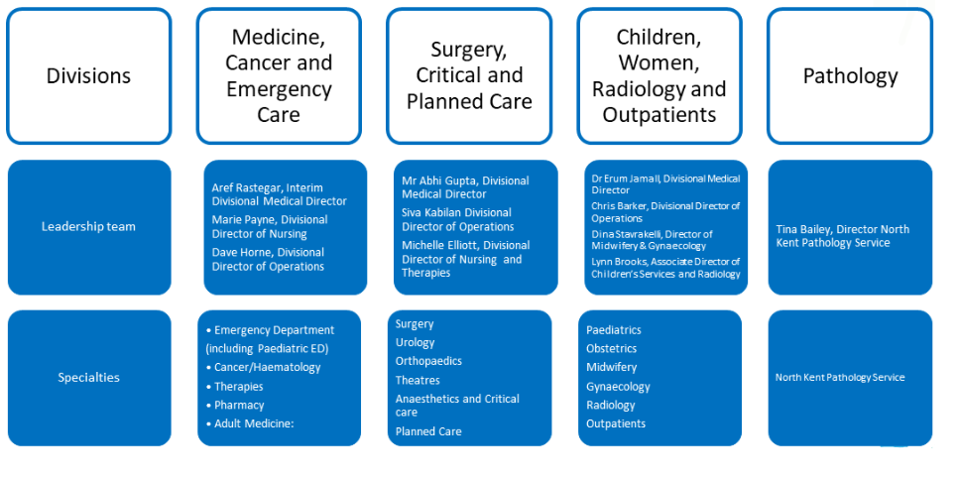

Patrick Ruffle General Manager NKPS

#### Pathology Organogram

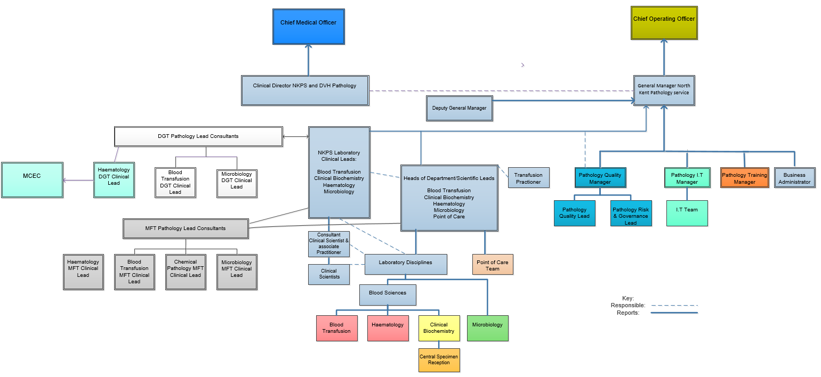

The following charts show the structures within the different departments in Pathology

#### Microbiology Organisational Chart

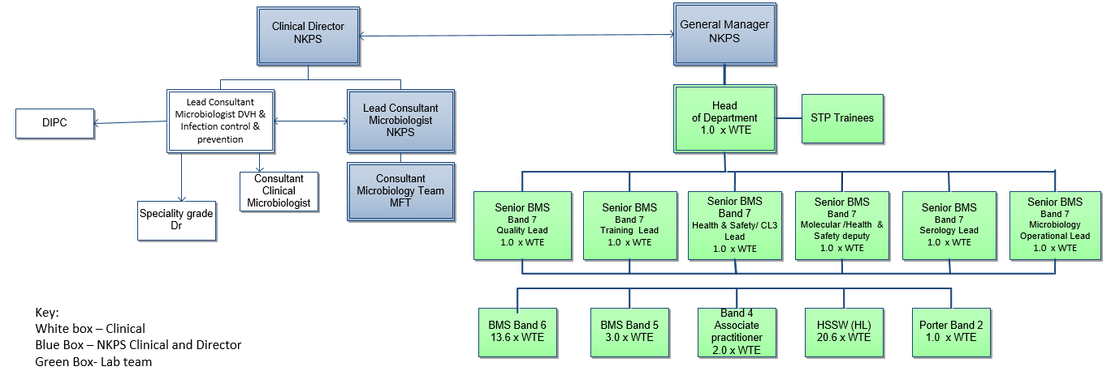

#### This organogram sets out the management structure of Clinical Biochemistry Clinical Biochemistry Organisational chart

#### Haematology and Blood Transfusion Organisational Chart

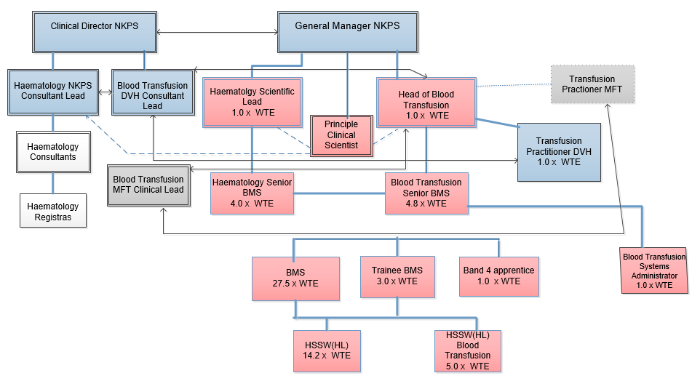

Organogram depicting the working relationship for screening services

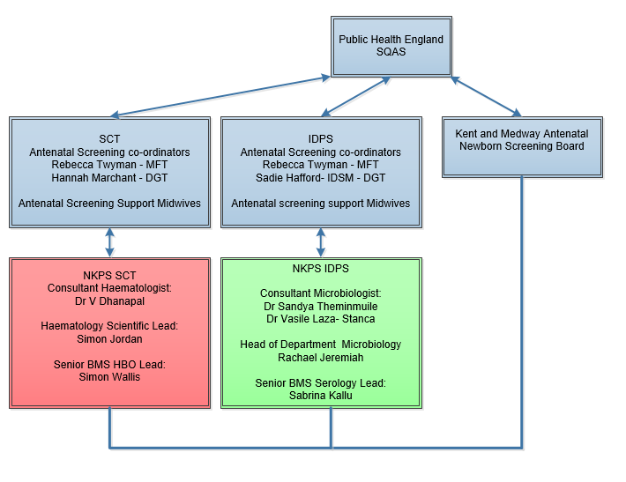

#### Communication (4.1.2.6)

NKPS endeavours to communicate effectively with all of its users and does this in a number of ways.

Communication between NKPS and DGT utilise the following means:

* The Trust Newsletter
* E-mail Updates – Trust Communications
* Trust Risk Management Committee
* Trust Patient Safety Committee
* Trust Health and Safety Committee
* Pathology User Group
* ANNB Screening
* Hospital Transfusion Committee

Communications between NKPS and MFT utilise the following means:

* NKPS Assurance Board
* NKPS Operational Board
* Diagnostic and Clinical Support Services Governance Meetings.
* Hospital Transfusion Committee

Communication with external non-Trust users utilise the following means:

* DGT Trust Internet site – Pathology Pages
* Email communications

Local communication within the service occurs through internal meetings:

* Assurance Board Meeting
* Operational Board Meeting
* Directorate Meeting
* Quality Committee Meeting
* Risk and Governance Committee Meeting
* Health and Safety Committee Meeting
* Training and Education Committee Meeting
* Point of Care Testing Meetings
* Hospital Transfusion Team

And

* NKPS Newsletter
* General Staff notice board.

Department communication

* Daily Huddles
* General Staff Meetings
* Senior Staff meetings
* Ad Hoc Meetings held by the Head BMS

## Quality Management System (4.2)

The laboratory has established a QMS which is documented and maintained to continually review and improve the quality and effectiveness of the service to ensure that it meets the requirements of its users (4.2.1b)

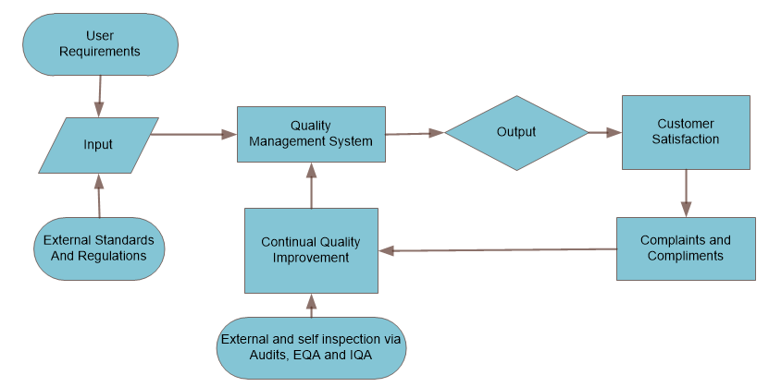

The components and relationships within the QMS are described throughout this Quality Manual. This includes:

* The Quality Policy (4.2.2.2a, 4.2.2.2b)

Outlined in Section 4.1, page 14

* The Organisational and Management Structure of the laboratory (4.2.2.2c)

Outlined in Section 5.1.2, page 22 - 27.

* The Roles and Responsibilities of Laboratory Management (4.2.2.2d)

Outlined in Section 5.1.2, page 14 - 20.

* The managerial and technical aspects of the QMS. (4.2.2.2f)

Found throughout the Quality Manual and are referenced in Blue.

## Document Control

The electronic QMS, Q-Pulse, is utilised for Document Control within NKPS and the Pathology Directorate. All documents produced in word format within the departments are controlled by the use of headers and footers. This is managed within the QMS and all documents are given set review periods.

See: POL.PAT.17

This ensures that:

* Documents are reviewed and approved for use by authorised personnel prior to use (4.3a)
* Documents contain a title, unique identifier, date of current edition and/ or edition number, page x of y and the authority for issue (4.3b)
* There are readily accessible master lists that identify current revision status and distribution of documents (4.3c)
* Only current, authorised editions of applicable documents are available at points of use (4.3d)
* Changes to documents are identified (4.3f)
* Documents remain legible (4.3g)
* Documents will be periodically reviewed and updated at a frequency appropriate to their purpose (4.3h)
* Obsolete controlled documents are dated and marked as obsolete (4.3i)
* At least one copy of an obsolete controlled document is retained for the time specified as per Control of Records (4.3j)

Changes to documents by hand are not permitted.

An outline of the structure and relationships of the documentation used in the QMS is depicted in the following diagram.

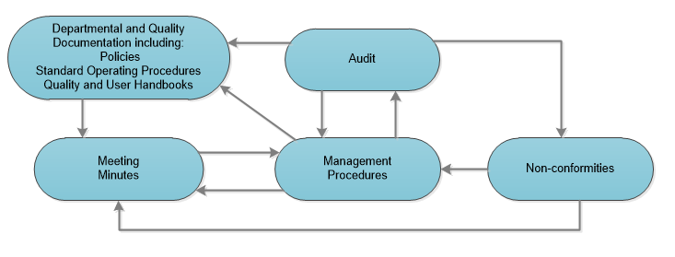

## Service Agreements

When a SLA is necessary between NKPs and an external service or user, an agreement must include all aspects of the service provided from both parties. A section should be included in the agreement which details the duties of each party, a revision period for the agreement and the amount of notice needed for cancellation of the service. The review period is set by both party members and if an amendment is required before this date; the SLA is reviewed at this point and alterations noted in the agreement.

See: SOP.PAT.19

The SLA must be approved by the General Manager NKPS and if the value exceeds £5000, it should also be approved by the Head of Contracts (within the finance department). An annual review is undertaken by an authorised individual for each specific contract. (4.4)

## Examination by Referral Laboratories

The laboratory refers samples to referral laboratories for additional or specialised testing when it is required by the user. The choice of referral laboratory used is determine through formal evaluation which includes review of UKAS accreditation, assay principle, turnaround time, available transportation and availability of interpretation of results by Consultants.

See: POL.PAT.18

The policy for selecting referral laboratories ensures that:

* NKPS is responsible for selecting referral laboratories, monitoring the quality of the performance provided by the referral laboratory and their referral Consultants.
* The referral laboratories are competent to perform the requested examination. (4.5.1a)
* All arrangements are formally agreed (through Service Level Agreements) and these are periodically reviewed and evaluated to ensure that the relevant aspects of the ISO 15189:2012 Standards are being met. (4.5.1b)
* Reviews of these agreements are recorded and retained within NKPS. (4.5.1c)
* Each department in Pathology maintains a register of all referral laboratories and their Consultants who provide result commentary. (4.5.1d)
* All requests and results from referral laboratories are kept for a pre-defined period of time. (4.5.1e)

The referring department is responsible for ensuring that all examination results provided by referral laboratories are provided to the individual making the request. The report provided by NKPS to the requester shall include all essential elements of the results reported by the referral laboratory without any alterations that could affect the clinical interpretation of these results. The report shall indicate which examination has been performed, which referral laboratory performed the examination and shall clearly identify the author of any additional remarks or interpretive commentary. (4.5.2)

## External Services and Supplies

NKPS selects and approves suppliers of external services, equipment, reagents and consumable supplies in accordance with the laboratories requirements. Where necessary, DGT’s Procurement department and the NKPS Assurance Board are consulted when entering any new contracts for purchasing external services, equipment, reagents and consumable supplies when the financial cost requires a tendering process to be followed.

To ensure appropriate criteria for selection is used to select suppliers, a URS is designed for what the department aim to purchase and this is used to evaluate the companies against specific requirements in the specification. Any suitable suppliers are selected by taking into account as many factors as possible to ensure acceptable performance and quality.

Each department has a list of selected and approved suppliers for all external services, equipment, reagents and consumable supplies and this is maintained on Q-Pulse within the Suppliers Module.

All suppliers are monitored for their performance to ensure that purchase services, equipment, reagents and consumable supplies meet the stated criteria. (4.6)

See POL.PAT.28 and POL.PAT.36

## Advisory Services

NKPS communicates information regarding tests and services it provides by making this Quality Manual and all departmental User Handbooks available to its Users on the Internet Pages of each Trust Website.

The following information is made available to all Users:

* Use of services taking into consideration clinical indications
* Examinations available
* Turnaround times
* Types of samples required for testing
* Test limitations
* Frequency of repeat requests
* Sample Acceptance and Rejection criteria

The Quality Manual and User handbooks are reviewed at a minimum every two years or when a significant change has taken place within the department. They are published to users to help promote the effective utilisation of the laboratory service that NKPS provides.

NKPS ensures that advice on the selection of investigations and the interpretation of results is available to users at all times and ensures that this advice meets the requirement of its users. Clinical advice and interpretative comments are provided by suitably qualified Healthcare Scientists and medical staff in a clear unambiguous manner. (4.7)

## Resolution of Complaints

Formal complaints received through the complaints team at DGT or MFT are forwarded from the PALS teams to the Pathology Quality Manager. These are then investigated by the appropriate department and a response is given to the complainant through the PALS team.

Informal Complaints received by the General Manager NKPS; Head of Department/Scientific Lead; Laboratory Clinicians or Pathology Quality Manager. These are forwarded to the Pathology Quality Manager and are referred to the complaints team within PALS to be registered as a formal complaint if required. These are then investigated by the appropriate department and a response is given to the complainant.

Complaints are investigated and responded to by the most appropriate individual within the department liaising with the Pathology Quality Manager. This is usually the Head of Department/Scientific Lead however another individual within the department can be nominated if it is appropriate to do so. The response to any complaint is formulated based on the root cause identified and any lessons learnt. Responses to formal complaints then go through the respective Trusts governance departments and are sent on to the complainant. Any informal complaint can be responded to via the same route that they are received.

All complaints and compliments are reviewed at the Risk and Governance meeting and are communicated to staff at staff meetings. They are also included within the departmental monthly quality indicators and reported in the AMR. (4.8)

See POL.PAT.33

The following flowchart depicts how NKPS manages and records any complaints that are received.

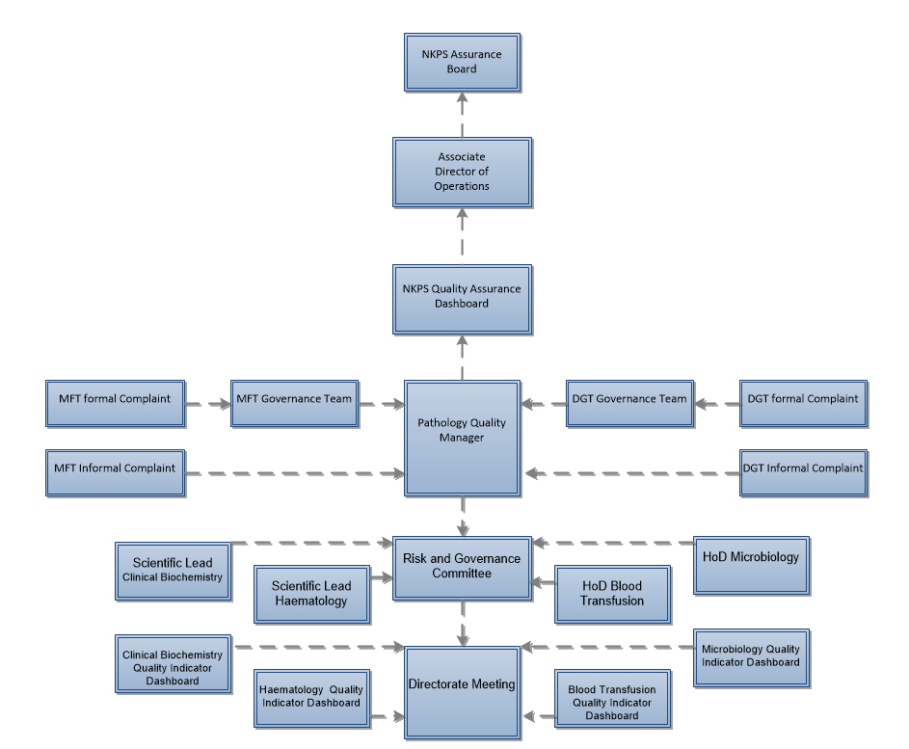

## Identification and Control of Non-Conformities

Non-conformities can occur in all processes within the laboratory including: Pre-examination, examination and post-examination processes. NKPS ensures that these non-conformities are effectively identified and managed to minimise risks to users. All non-conformities are recorded within the QMS. (4.9)

See: POL.PAT.12

NKPS has established a procedure for the identification and control of non-conformities and includes:

* The individual responsibility and required authorities for handling non-conformities have been designated.
* Any immediate actions required to be taken have been defined.
* The extent of the non-conformity has been determined.
* When non-conformities have been identified, any examinations are halted and reports withheld as necessary.
* The medical significance of any non-conforming examinations are considered and if applicable, the requesting clinician or authorising individual responsible for using the results are informed.
* The results of any non-conforming or potentially non-conforming examinations that have already been released are recalled or appropriately identified.
* The individual responsibility for the authorisation of resumption of examinations.
* Any non-conformities identified are appropriately recorded.
* Non-conformities are reviewed to identify trends and ensure corrective action occurs for each event.

See: SOP.PAT.24

## Corrective Action

NKPS ensures that action is taken to eliminate the root cause of the non-conformity. It includes an investigation into identifying the root cause of an incident to ensure the true root cause has been identified. Once the action needed to eliminate the root cause has been identified, it is assigned to a member of staff to complete. (4.10)

See: POL.PAT.12

NKPS has established a procedure for determining and implementing corrective actions that includes:

* Non-conformities are reviewed.
* Ensuring that the true root cause of non-conformities is determined.
* Corrective actions are evaluated to ensure that non-conformities do not reoccur.
* Ensuring that the corrective action needed is correctly determined and implemented.
* The result of any corrective action taken is recorded.
* The effectiveness of corrective actions implemented is reviewed.

See: SOP.PAT.25

## Preventive Action

This is the action or possible action that could be taken to prevent a possible non-conformity from occurring. It can be identified indirectly in an audit, from a risk assessment, from spot checks or sporadically. (4.11)

See: POL.PAT.12

NKPS has established a procedure for the identification and implementation of preventive actions that includes:

* Reviewing laboratory data and information to determine where potential non-conformities exist.
* Ensuring that the true root cause of any potential non-conformities are determined.
* Preventive actions are evaluated to ensure that they prevent the potential non-conformities.
* Ensuring that the preventive action needed is correctly determined and implemented.
* The result of any preventive action taken is recorded.
* The effectiveness of preventive actions implemented is reviewed.

See: SOP.PAT.25

## Continual Improvement

NKPS maintains a Quality Improvement Programme that is formulated and documented by the Pathology Directorate Management Team. The programme is implemented by all departments and is directed by their quality representatives. (4.12)

See: POL.PAT.12

Quality improvement can be implemented from non-conformities identified by:

* Immediate action implemented in response to non-conformities within agreed timescales.
* Investigation of Root Cause Analysis of non-conformities and recording of results.
* Determination, implementation and monitoring of corrective actions taken within agreed timescales.
* Implementation of preventive action for potential non-conformities within agreed timescales.
* Ensuring that preventive actions taken are effective, recorded and submitted for management review

In addition, quality improvement suggestions can arise from a number of sources including:

* Feedback from User Engagement i.e. surveys/ meeting forums/ interactions
* Adverse incident reporting
* Identification of nonconformities
* Documenting and investigation of complaints
* Audit (Internal and External)
* Internal and external quality assurance programs
* Inspections
* Monitoring
* Exit interviews
* Recommendation from an external source e.g. NICE Guidance

Quality improvement suggestions are reviewed by the departmental Quality Representative and the Pathology Quality Manager where applicable

Suggestions for preventive action and quality improvements may be made at the AMR when senior management review the laboratory’s performance and develop quality objectives for the following year. This information is recorded in the AMR and discussed at staff meetings.

The results of the Quality Improvement Programme are included in staff meetings and form part of the development, training and education of all staff within NKPS.

## Control of Records

Each department has established procedures for controlling process and quality records in accordance with the Department of Health and Social Care’s “Records Management Code of Practice for Health and Social Care 2016” as well as in line with the RCPath Guidelines: “Retention and Storage of Pathological Samples and archive in Pathology Laboratories, 5th Edition”. These have been incorporated into the NKPS Control of Records Policy and include: (4.13)

* Identification and indexing
* Security
* Retention
* Storage and Retrieval
* Disposal

See: POL.PAT.17

## Evaluation and Audits

Evaluation and improvement processes are an essential part of ensuring the service provided by NKPS meets the needs and requirements of its users (4.14.1). The processes used include internal and external quality assurance schemes, internal quality control, assessment of user feedback (4.14.3) including complaints and compliments, staff suggestions (4.14.4), internal audit (4.14.5), risk management (4.14.6), departmental specific quality indicators (4.14.7) and reviews by external organisations (4.14.8) alongside continual quality improvement mechanisms. These are reviewed at the monthly pathology quality meetings, and discipline specific senior meetings and when significant deviations occur escalated to the pathology risk and governance meeting.

Outcomes of the evaluation and improvement process are reviewed as part of the AMR and can form the basis of departmental objectives for the coming year. At the AMR a formal review for continuing suitability of the department’s requests, examinations provided and the sample requirements is undertaken (4.14.2): intermittent reviews may occur when triggered by user feedback, staff suggestions or quality improvements.

Staff suggestions contribute to the development of the QMS and can occur via documental change requests, at a staff communication forum (huddle/ meeting) or use of the staff suggestion or quality improvement (QI) CAPA wizard on Q-Pulse.

The internal departmental audit schedules are designed by the Pathology Quality Manager to ensure continual review of the pre-examination, examination, post-examination and supporting processes. (4.14.1a)). In addition, there is a QMS audit calendar which assesses processes which affect all disciplines e.g. Organisational requirements. Non-conformities identified as part of the internal audit programme are managed as per SOP.PAT.25. The process for planning, conducting, evaluating, monitoring and reviewing the audit are described in SOP.PAT.17

All processes within pathology (pre-examination, examination and post examination stages) are risk assessed using the DGT template to identify potential hazards and put in place effective mitigation steps. Risks that cannot be successfully mitigated are placed on discipline risk registers and are reviewed until an agreed residual risk rating (usually classed as between 1-3) has been achieved. This is monitored at the Risk and governance meetings.

See SOP.PAT.40

Quality indicators are reviewed for appropriateness at the AMR for monitoring achievement of QO’s, examination processes (pre-examination, examination and post examination), compliance to the QMS and human resources requirements to give a picture of overall discipline performance and therefore the relationship to effective patient care. These are monitored on a monthly basis within disciplines and any identified issues are managed as risks and where appropriate are discussed with users.

See SOP.PAT.43

The pathology department is subject to assessment through a variety of external organisations i.e. assessment bodies (both regulatory and accreditation). Annual assessment occurs from the HTA and MHRA via submission of a self-assessment tool which may prompt a desktop or on-site assessment. UKAS conducts annual assessments using a four-year cycle of three surveillance visits and one full assessment for each discipline. For all of the above organisations additional assessments can occur through significant change in practice or organisation or in response to a serious incident. Any non-conformity identified through these visits are managed as per SOP.PAT.25 and a quality improvement with assessment report, findings and response to findings retained electronically. It is important to note that pathology is also subject to review by the Health and Safety Executive (HSE), Human Tissue Authority (HTA), Care Quality Commission (CQC), Environment Agency (EA), National Institute of Clinical Excellence (NICE), Public Health England (PHE), Royal College of Pathologists (RCPath) and the Institute of Biomedical Science (IBMS). POL.PAT.20

Results of evaluations and improvements are made available to all staff through staff meetings and other Pathology committee meetings minutes. Users are informed by Pathology representation at various user meetings. The analysis and recording of evaluation and improvement processes form a standard agenda item at departmental AMRs.

## Management Review

The management team within each department conducts an annual review of the QMS including review of trends of incidents, quality improvements, the quality policy and QO set the previous year. Discipline specific examination activities are also reviewed to ensure continuing suitability, adequacy, effectiveness and support of patient care (4.15.1).

The management review considers the following: (4.15.2)

1. The periodic review of requests, and suitability of procedures and sample requirements
2. Assessment of user feedback
3. Staff suggestions
4. Internal audit
5. Risk management
6. Use of quality indicators
7. Reviews by external organisations
8. Results of participation in inter-laboratory comparison programmes
9. Monitoring and resolution of complaints
10. Performance of suppliers
11. Identification and control of non-conformities
12. Results of continual improvements including current state of corrective actions and preventive actions
13. Follow up actions from previous management reviews
14. Changes in the volume and scope of work, personnel, and premises that could affect the QMS
15. Recommendations for improvement, including technical requirements

Reports are written by disciplines and are reviewed formally with records comprising of these reports and minutes of the meetings. From the reports, QO’s and QI’s are reviewed for achievement, to carry forward or to discontinue. New QOs may arise from discussion at the AMR and can be fed into the forthcoming business plan (4.15.3). Dissemination of the AMR report and minutes are made to staff via use of the distribution list in Q-Pulse document module and staff can be made aware they are available through the huddles and newsletter. All AMR objectives and expected outputs (4.15.4) are discussed at discipline senior meetings and are monitored and reviewed formally every quarter.

See: SOP.PAT.43

# SECTION 5 – TECHNICAL REQUIREMENTS

## Personnel

Pathology complies with all HR policies provided by the Trust and has an internal policy for personnel management. (5.1.1)

See: POL.PAT.30

Pathology has a HR business partner, assigned by the Trust, to assist with personnel issues.

### Personnel Qualifications

The pathology management team ensures that staff have the required education and training in order to meet the demands of the service. Registration of staff is in accordance with current national legislation and regulations. Records of applications including personnel qualifications are kept by the Workforce department within a staff member’s personnel file. (5.1.2)

### Job Descriptions and Contracts

All staff job descriptions are created using the Agenda for Change template and accepted by the HR department prior to advertisement. Job descriptions are discussed annually at personal development reviews and are kept within a staff members’ personnel file. All staff members are issued a contract of employment on entering service within Pathology and copies of these are held centrally by the Trust personnel department and by the individual employee. All medical staff contracts are held by the Medical Staffing HR department. (5.1.3)

### Introduction to the Organisational Environment

All new staff are required to attend the Trust mandatory induction programme. Copies of induction records are kept by the Trust education department. In addition, new staff are also required to participate in a local Pathology induction. (5.1.4)

See: POL.PAT.14

### Training

Pathology has designated training representatives within each department, who together with the Pathology Quality manager, are the foundation of the Training and Education Committee.

Training covers all aspects of working in Pathology that each member of staff is required to carry out or participate in, including examination procedures, quality management, the LIMS system, health and safety and governance.

All staff have access to education and training in line with their needs and position within Pathology. Training plans are identified at annual review as part of the personal development plans. All healthcare scientist trainees are supported by a designated mentor within the department and follow guidelines described by the Institute of Biomedical Sciences Training Portfolios.

The Pathology Directorate has no dedicated financial resources to provide education and continual professional development for staff. All education and training requests are submitted to the education and training committee for consideration and approval prior to submission to the Trust training department. There are comprehensive library facilities available to staff within the Trust and all personnel have access to the internet in order to access scientific resources. Training records for all staff are kept within training folders by each department. (5.1.5)

See: POL.PAT.14

### Competence assessment

Competency is assessed using a variety of approaches including; direct observation, assessment of problem solving, observation of equipment use, monitoring of records and re-examination of samples. Competency to perform assigned tasks (5.1.6) is assessed following training and periodically thereafter (but not in excess of 2 years) with additional retraining and reassessment occurring when necessary. Records of competency assessments are kept in staff training records. The Department Training leads co-ordinate the training of all trainee BMS which includes laboratory based training and the completion of appropriate portfolios.

See: POL.PAT.14

### Reviews of Staff Performance

All staff within Pathology participate in annual appraisals in line with the Trust appraisal policy. Staff appraisals include a joint review of:

* Trust Objectives
* Department Objectives
* The Staff member’s job description
* The Staff member’s personal objectives
* Training and development needed by the Staff member
* CPD

Only staff that have attended the Trust training programme for appraisers can perform an appraisal and the process is explained to all participating staff members. Records of all appraisals are stored electronically on the Trusts website: ADAGIO. (5.1.7)

### Continuing Professional Development

All staff undertake CPD as required by all registered healthcare professionals. All staff have access to CPD activities such as lunch time meetings, journal based learning and internal courses. External courses can be attended but if they require funding, then applications are made for training time and budget; review is made of potential benefits to the department (or specific discipline) and consideration given to other requests. All CPD is undertaken, recorded and maintained by staff. (5.1.8)

### Personnel Files and Staff Records

Staff records and evidence of appropriate professional qualifications are held securely by the appropriate Head of Department/Scientific Lead within each discipline. Each staff member has a local personal file and a file held by the Trust which are continuously maintained. Additional records are held by Trust departments as appropriate: (5.1.9)

* Trust Education Department – Induction and Mandatory Training Records
* Occupational Health Department – Occupational Health Records

## Accommodation and Environmental Conditions

Pathology is dedicated space within both DVH and MMH in order to provide a quality, safe and efficient service to its users and allow staff adequate space to perform their duties. (5.2.1)

### Laboratory and Office Facilities

Pathology provides staff with accommodation and conditions in order to facilitate proper performance of their duties in accordance with statuary regulations and guidelines. There is controlled access to the department and any office that stores confidential information is locked when not in use. The laboratory areas are separated so as to reduce and eliminate cross contamination where appropriate. Areas that contain equipment and reagents that may be affected by environmental factors (i.e. temperature or humidity) are continually monitored. Health and safety audits are frequently undertaken to ensure that there are safety facilities and devices available for use. (5.2.2)

### Storage Facilities

Separate storage facilities are located throughout both laboratory sites with separate, external storage for the storage of flammables, in accordance with Health and Safety requirements. There is temperature controlled storage space available for reagents, samples and other materials that require these conditions and they are stored in a manner that prevents cross contamination. The temperature controlled storage spaces ensure that validated, non-validated and quarantined material is stored separately. All storage facilities that store blood and blood products meet the requirements as described by MHRA and BSQR. (5.2.3)

### Staff Facilities

There are adequate facilities available to staff at each hospital site which include: (5.2.4)

* Toilet and shower facilities
* Rest area with catering facilities
* Staff dining room
* Changing rooms
* Secure storage for personal belongings
* Shops

### Patient Sample Collection Facilities

There are patient sample collection facilities for general use in the out-patient’s phlebotomy area at DVH, the pre-assessment clinic at QMH and in Eliot ward at MMH. These facilities are maintained and monitored by the respective hospital sites and are not managed by Pathology. (5.2.5)

### Facility maintenance and environmental conditions

The laboratory is designed to provide effective separation between non-compatible examinations where required. This includes the use of a containment level 3 room and separate areas for specialist testing. Any factors that may affect the quality of results or working conditions are constantly monitored using thermometers, anemometers and formalin monitors where appropriate.

It is Trust policy to ensure that a safe and healthy working environment is provided and maintained for all employees and visitors in order to comply with the Health and Safety at Work Act 1974. The Pathology Health and Safety Manual ensures that there are procedures available for:

* Model rules for visitors.
* Actions to be taken in the event of a fire.
* Actions to be taken in the event of a chemical spillage.
* Actions to be taken in the event of a clinical material spillage.
* Action to be taken in the event of an inoculation accident.
* The disinfection processes.
* Decontamination of equipment.
* Chemical handling.
* Storage and disposal of waste.

Staff are made aware of their responsibilities for health and safety within their job descriptions, at their induction training and through the acknowledgement of the Pathology Health and Safety manual. (5.2.6)

See: MAN.PAT.4

## Laboratory Equipment, Reagents and Consumables

Pathology reviews the quality and capacity of the service and ensures that these meet the needs of its users. This is monitored through the review of quality indicators such as turnaround times. (5.3)

### Equipment

Pathology has a procedure for the management of equipment and associated records (see POL.PAT.28) which adhere to DGT procurement and national policies.

All equipment is verified when it is installed to ensure that it is capable of meeting the required level of performance. This is outlined in the Pathology Validation policy. All equipment used has a unique serial number that is used as an independent identifier. (5.3.1.2)

See: POL.PAT.1

All equipment in use within the laboratory has a SOP that has been developed from the manufacturer’s instructions for use. All relevant staff are trained to use the equipment in line with the SOP to ensure it is used appropriately. Staff will only be permitted to use equipment unsupervised when an appropriate member of staff has established that they are competent and confident to do so. This will be documented accordingly in the individual’s training record. (5.3.1.3)

Use of precision pipettes, automated and semi-automated analysers, centrifuges, balances, fridges, freezers, incubators and timers are an essential part of pathology procedures. They are used to produce accurate test results and therefore must be regularly calibrated to ensure ongoing traceability of the results they produce. The frequency and subsequent reports for equipment calibration is detailed within their equipment records. The metrological traceability of the calibration standard used is recorded within the Monitoring of Measuring Systems policy. (5.3.1.4)

See: Pathology 1428

All equipment is maintained in accordance to the maintenance schedule outlined in the manufacturer’s instructions for use. Where appropriate, equipment will be regularly maintained by hospital engineers or through a maintenance contract with external engineers. When it is necessary for equipment to be verified or calibrated prior to use, this will be carried out either in-house or by a relevant body ensuring metrological traceability. Certificates of traceability will be received from external maintenance suppliers in order to record ongoing traceability of the equipment.

Electrical safety checks are carried out according to the Trust PAT testing policy and all applicable equipment is marked, identifying the last inspection date and when the next inspection is due.

When a piece of equipment experiences a fault, the equipment is decontaminated prior to engineer intervention and personal protective wear of made available for their use. If a piece of equipment requires removal from the laboratory to correct the fault, the equipment is re-verified prior to being returned to use within the laboratory. (5.3.1.5)

Any incident that is directly caused by a piece of equipment is recorded as an asset non-conformance and linked to the asset on Q-Pulse. The cause of the incident is investigated and where required, reported to the manufacturer for resolution. (5.3.1.6)

See: SOP.PAT.24 and SOP.PAT.25

There is an inventory of equipment (5.3.1.7) held on Q-Pulse within the Asset module and the Asset record includes:

1. The Identity of the piece of equipment
2. The manufacturer, model and serial number
3. The contact information for the supplier or manufacturer
4. Date of receipt and date entered into service
5. Location within the laboratory
6. Condition when received
7. The manufacturer’s instructions for use (where possible)
8. Equipment maintenance records
9. The validation documentation
10. Ongoing acceptability for use records
11. Details of damage or repair

The certificates or reports detailing maintenance or calibrations performed on equipment are stored within these records along with the next schedule date for completion.

### Reagents and Consumables

The service annually works with the finance team to create a budget for the following year. This ensures that there is funding and the availability of adequate and suitable materials required to provide a quality service to users. The reception, storage, acceptance and inventory management of reagents and consumables within Pathology is outlined in the Management of Reagents and Consumables policy.

See: POL.PAT.36

On receipt of reagents and consumables, Pathology ensures that they are stored in order of expiry according to the manufacturer’s instructions. (5.3.2.2)

All reagents and consumables are verified once delivered to ensure that they still perform as expected. Acceptance testing can comprise of a number of techniques however the most standardised approach utilised by Pathology is using validated IQC on the new reagent to gain a pass or fail. Each department has their own procedure that is followed to ensure the acceptance testing on newly delivered reagents and consumables is completed. (5.3.2.3)

Each department performs a frequent stock check to ensure that reagent and consumable levels do not fall below an established limit. These reagent and consumables stock levels ensure there is always enough reagent and consumables to process incoming requests until the next delivery arrives. They also establish the optimum level to prevent over ordering which could potentially cause wastage of reagent or consumables. The reagents are clearly segregated to ensure that those that have not yet been accepted or have failed acceptance testing are stored separately from accepted reagents. (5.3.2.4)

Manufacturer’s instructions for use include package inserts for reagents and consumables and the most current version of these are stored on Q-pulse as an external document. They are reviewed frequently by checking the inserts that come with new deliveries or the manufacturer’s website. (5.3.2.5)

Any incident that is directly caused by a reagent or consumable is recorded as a supplier non-conformance in the CA/PA module on Q-Pulse. The cause of the incident is investigated and where required, reported to the manufacturer for resolution. (5.3.2.6)

See: SOP.PAT.24 and SOP.PAT.25

Change control is utilised when changing equipment to ensure that validation is performed and procedures are written that include COSHH and risk assessments.

see SOP.PAT.20.

Records are kept of all reagents and consumables that contribute to any examination performed by Pathology. These records include the following information: (5.3.2.7)

Q-Pulse is utilised to hold equipment and supplier records:

1. Identity of equipment (5.3.1.7a) (Asset module)
2. Manufacturer, model and serial number (5.3.1.7b) (Asset module)
3. Contact information for supplier or manufacturer (5.3.1.7c) (Supplier module)
4. Date of receipt and date entered into service (5.3.1.7d) (Asset module)
5. Location (5.3.1.7e) (Asset module)
6. Condition when received (5.3.1.7f) (Asset module)
7. Manufacturer’s instructions (5.3.1.7g) (Document module via use of manual)
8. Validation documentation (5.3.1.7h) (Asset module)
9. Equipment maintenance records (5.3.1.7i) (Asset module)
10. Acceptance for use records (5.3.1.7j) (Asset and/or document module)
11. Details of damage or repair (5.3.1.7k) (Asset and/ or CAPA module)

## Pre-Examination Processes

### Information for Patients and Users

User information can be found within the User Handbook for each department within Pathology. These User Handbooks are made available to all users on the Internal and External Internet pages of the Dartford and Gravesham NHS Trust website and the Medway Foundation Trust website. The User Handbooks provide information for users including the laboratory location, departmental opening times, full test repertoire, instructions for completing request forms and sample delivery to the laboratory. Key personnel contact information and availability of clinical advice and interpretation is also included. (5.4.2)

See: MAN.PAT.2

See: MAN.PAT.5

See: MAN.PAT.7

See: MAN.PAT.9

See: MAN.PAT.10

### Request form Information

Requests for examinations can be received by the laboratory both through electronic ordering (OrderComms) or by paper request forms accompanying the sample. All request forms, electronic or paper, have been designed to provide all relevant information required to provide a safe and meaningful report. These request forms have satisfied minimum laboratory requirements and are audited to ensure ongoing suitability.

Request forms / Ordercomms provide space for:

* Sufficient information to allow unequivocal identification of the patient (5.4.3a)
* Identification of the location and of the requesting individual (5.4.3b)
* Type of specimen and anatomical site of origin if relevant. (5.4.3c)
* Investigation required (5.4.3d)
* Relevant clinical information (5.4.3e)
* Date and time of specimen collection (5.4.3.f)
* Date and time of receipt of sample by the laboratory (5.4.3g)

The type of request form received by the laboratory differs depending on the requester’s location and this is summarised below:

* Dartford, Gravesham and Swanley ICP GP surgeries have OrderComms requests and these are submitted electronically.
* DGT inpatient and outpatient requests are received through PAS OrderComms and these are submitted electronically. Blood Transfusion has a separate request form that meets the necessary BSQR requirements.
* When paper request forms are required to be used for DGT or Dartford, Gravesham and Swanley ICP GP practices, there is a combined DGT Blood Sciences paper request form for Haematology, Clinical Biochemistry and Immunology requests. Microbiology has a separate dedicated paper request form in these instances.
* Medway and Swale ICP GP surgeries have OrderComms requests and these are submitted electronically.
* MFT inpatient and outpatient requests are received on paper request forms and these are received on a MFT multi part request form which include: Haematology, Clinical Biochemistry, Microbiology and Immunology requests. Blood Transfusion has a separate request form that meets the necessary BSQR requirements. Roll-out of DartOCM has started and some out-patient services are using order comms instead of paper.
* When paper request forms are required to be used for Medway and Swale ICP GP Practices, they have their own version of the MFT multi-part form that they can print from their GP systems. Antenatal booking bloods have a dedicated form. Other Antenatal requests are to be requested on the MFT Multi-part form.
* Any requests for Histopathology or Non-Gynaecological Cytology examinations are received on dedicated paper request forms.
* There is a national request form used for any samples for the Cervical Screening Program.

Instructions for how to complete electronic and paper request forms can be found within the User Handbooks. (5.4.3)

See: MAN.PAT.2

See: MAN.PAT.5

See: MAN.PAT.7

See: MAN.PAT.9

See: MAN.PAT.10

Verbal add on requests are can be accepted by the departments, subject to meeting the acceptance criteria for the test being requested. The requestor should send on a paper request or Ordercoms label to enable a full audit trail.

### Primary Sample Collection and Handling

The laboratory provides a recommended Primary Sample Collection and Handling SOP to its users for the correct procedure to use when collecting patient samples.

See: (SOP.PAT.6)

All procedures that are carried out on a patient require informed consent from the patient. In the case of most laboratory procedures, consent is inferred when a patient presents themselves with a request form and willingly allows the usual collection procedures to take place. For some more specialised procedures, including those that are more invasive or have an increased risk of complication, a more detailed explanation and written consent may be required. (5.4.4.1)

The laboratory provides instructions for pre-collection activities which are included within the User Handbooks for each department and the Primary Sample Collection and Handling SOP. These include: (5.4.4.2)

In addition to this, they include instructions for the collection activities (5.4.4.3)

See: MAN.PAT.2

See: MAN.PAT.5

See: MAN.PAT.7

See: MAN.PAT.9

See: MAN.PAT.10

### Sample Transportation

Information for how samples are transported to Pathology is available to users within the User Handbook for each department. (5.4.5)

* How samples should be packaged
* Time frames for sample delivery to ensure optimum sample conditions for analysis
* Any assay requirements

See: Pathology 2888

#### Transport of Hospital Samples

There are two main methods of sending samples to the laboratory from internal hospital locations at both MMH and DVH. These are:

* Pneumatic Tube System
* Hand delivery by Portering or other Hospital staff

The Pneumatic Tube System is available in certain areas at both Hospital sites and delivers samples straight to the laboratory.

The following samples and items are not suitable to be transported by the Pneumatic Tube System:

* Blood / Bone Marrow Glass Slides
* Blood Gases
* Blood Units and Blood Products
* Large Volume Urine Samples (i.e. 24hour Urine collections)
* Post
* Histology Specimens in formalin preservative
* Swabs
* CSF Fluid
* Category A samples or suspected Category A samples

The Outpatient department at MMH have a dedicated porter or phlebotomist that collects samples and delivers them to a designated secure location within the laboratory. Any Outpatient samples collected offsite for DGT are collected directly from that area by courier and delivered directly to the main laboratory at DVH for processing.

#### Inter-site Transport Service

There is a regular inter-site transport service that is provided by Delta and internal trust services and transports samples directly between the two laboratories.

An information document is available to all drivers and portering staff that out-lines the correct way to transport samples to the laboratory. It also includes the correct process to follow if there is a spillage during transportation of the sample.

See: POL.PAT.11

#### Transport of Samples External from the Hospital

All samples that come from an external source to MMH or DVH are considered external samples. This includes all GP surgeries, the phlebotomy service provided at Gravesend and North Kent Hospital and other external Pathology service users. There is a dedicated transport service that is provided by Serco to collect samples from the Dartford, Gravesham and Swanley ICP areas. In addition, MFT transport department provide the same service to the Medway and Swale ICP areas. Samples that are collected at QMH are transported using a dedicated transport service provided by Delta couriers and this transport is schedule Monday to Friday. All samples that are referred to other laboratories are transported by a variety of means, all of which conform to legislative regulations.

All samples must be packaged according to the Packing Instructions 650: Packaging Provisions for Biological Substances, Category B, Clinical Specimens, Diagnostic Specimens – UN 3373. If a sample is identified to be Category A, Infectious substances then these samples must be packaged in accordance to the Packing Instructions 620: Packaging provisions for Infectious Substances, humans – UN 2814.

The packaging, marking labelling and documentation requirements for Category B Biological Substances are available from the World Health Organization on regulations for the Transport of infectious substances 2005

### Sample Reception

All samples are received into CSR on each laboratory site. Samples are then identified and distributed to the departments accordingly. Samples for Blood Transfusion are processed entirely within the Blood Transfusion department on each site. Cytology and Histopathology samples are received and dispatched accordingly by the CSR team for processing by referral laboratories. Microbiology, Serology and Immunology samples are all distributed to the Microbiology department for processing or referral as appropriate.

The Sample Acceptance and Rejection Policy outline the criteria for sample acceptance within the departmental laboratories. It is supported by departmental procedures for the reception of all samples. These cover the following elements: (5.4.6)

* Ensuring the sample can be linked to the request form (Paper or electronic)
* Pre-defined acceptance criteria used to compare each sample and request form (Paper or electronic) to ensure they meet the requirements for processing.
* If a sample does not meet sample acceptance criteria, a report is issued to clearly indicate the reasons for sample rejection.
* Entry of sample receipt onto the LIMS including the date and time.
* Instructions for how to process samples that are marked as urgent.

See: POL.PAT.27

### Pre-examination Handling, Preparation and Storage

The laboratory ensures that all samples are stored in suitable locations within the laboratory to prevent sample deterioration. These include temperature controlled and monitored storage locations which utilise methods to ensure samples are easily retrievable when required. Pathology is appropriately secured using controlled access to ensure that loss or damage does not occur to samples within the laboratory.

The User Handbooks for each department with Pathology includes time limits for requesting additional examination or further examinations on the sample primary sample. (5.4.7)

See: MAN.PAT.2

See: MAN.PAT.5

See: MAN.PAT.7

See: MAN.PAT.9

See: MAN.PAT.10

## Examination Processes

Examination procedures within Pathology are selected to ensure that there are suitable assays available to meet User requirements for both diagnoses and monitoring of patients which meet the Royal College of Pathologists minimum standards.

The Blood Transfusion procedures have been established to ensure that they are suitable for the safe selection of blood and blood products in line with the Blood Safety and Quality Regulations. The procedures used within the mortuary have also been established to ensure that they meet all of the requirements of the HTA conditions of License.

All examination procedures used within Pathology have been validated or verified for use prior to their implementation. Any examination that is used without modification is verified by the laboratory and information is obtained from the manufacturer or method developer in order to confirm the assays performance characteristics. (5.5.1.2)

A method validation is required when an examination procedure has been either:

* Derived from a non-standard method.
* Designed or developed by the laboratory.
* Uses a standard method outside of its intended scope.
* A previously validated method that has been subsequently modified.

These examination procedures will be extensively validated to confirm that the specific requirements for its intended use have been met. (5.5.1.3)

All validations or verifications of examination procedures shall be fully documented and includes completion of a design qualification, installation qualification, operational qualification and performance qualification.

See: POL.PAT.1

All methods used in examination procedures are assessed to identify areas that have the potential to introduce variation. Control measures are applied where appropriate in order to reduce any uncertainty to the consistency and accuracy of results and individual assays calculated uncertainties. (5.5.1.4)

See: SOP.BIO.41

Biological reference ranges and critical decision values are determined using national and international guidelines, manufacturer’s instrument recommendations as well as using local data based on in house testing. The full list of examinations and their associated biological reference ranges and critical decision values are listed within the User Handbooks for each department within Pathology. (5.5.2)

See: MAN.PAT.2

See: MAN.PAT.5

See: MAN.PAT.7

See: MAN.PAT.9

See: MAN.PAT.10

Pathology incorporates all instructions for methods and processes used in the QMS and for examinations (including pre and post stages) in Standard Operating Procedures (SOPs) which are available to pathology staff electronically on Q-Pulse and with hard copies where required. Technical SOPs conform to the SOP template designed to incorporate the requirements as listed in (5.5.3) A management (non-technical) SOP template is also available for use when documenting non-technical tasks/ methods

All standard operating procedures are documented in a standardised format via a document controlled template in Q-Pulse

See: POL.PAT.17

## Ensuring Quality of Examination Results

There are discipline specific procedures in place in each discipline for internal quality control (IQC)/ internal quality assurance (IQA) to be processed to ensure the quality, validity and reproducibility of results before release. (5.6.2)

EQA procedures are in place for all assays where schemes are available and are suitable for use. (They reflect a patient sample and can be tested using the standard operating procedures for the assay.) By participating in EQA schemes, the performance of the assays used by the departments can be reviewed against set criteria and presented to show how the department compares to other laboratories using the same technology and against other suppliers. (5.6.3)

Where EQA schemes are not available or are not suitable, the quality of results is ensured by one or more of the following methods:

* Certified reference materials.
* Comparing results gained against previously examined samples.
* Exchange of samples with other laboratories.

All departments have established processes to ensure that there is comparability of patient results throughout clinically defined ranges. These ensure that comparability is established for all equipment that produces a result of an assay across both sites. (5.6.4)

Results of IQC, EQA and sample comparability are made available to all staff and are discussed at departmental staff meetings. Discrepancies are recorded and investigated when results fall outside limits set by test algorithms.

## Post-Examination Processes

All laboratory processes ensure that results are reviewed by authorised personnel prior to release in accordance with departmental standard operating procedures. These processes would ensure that results have been accepted as valid by the use of IQC and maintenance procedures. When results are used to monitor a patient’s condition, a review of historical results is also mandatory to ensure that significant changes are identified and can be further investigated by the laboratory or clinician. Where any result is automatically validated, the review criteria are validated prior to use. (5.7.1)

See: SOP.PAT.34

All departments in Pathology adhere to the appropriate processes for disposal of clinical waste as outlined by their standard operating procedures. The Mortuary and Microbiology departments have additional procedures in place that observe the legal requirements of the Human Tissue Act 2004. (5.7.2)

## Reporting of Results

The results of all examinations produced within Pathology are reported in a clear, unambiguous manner in accordance to any specific instructions set out in the examination procedures. The report shall contain all the sufficient information for the user to interpret the results. (5.8.1)

The reporting of results with the Pathology includes:

* The report.
* The telephoned report.
* The revised report.
* Clinical advice and interpretation.
* Mechanisms for informing the requestor if there is a delay to an examination that could compromise patient care.

The report is also used when a sample is rejected and can relate to sample suitability against sample acceptance and rejection criteria or when the sample quality can affect the results produced. (5.8.2)

The report contains the following information where applicable (5.8.3):

* Examination procedure identification (5.8.3a)
* The name of the laboratory issuing the report (5.8.3b)
* Identification of the laboratory that issued the report (5.8.3c)
* Unequivocal identification of the patient and location on each page (5.8.3d)
* Name and contact details of requestor (5.8.3e)
* Date of sample collection (5.8.3f)
* Type of sample (5.8.3g)
* Measurement procedure (5.8.3h)
* SI units (5.8.3i)
* Biological reference intervals and clinical decision values (especially critical results) (5.8.3j)
* Result interpretation (5.8.3k)
* Additional cautionary or explanatory notes (5.8.3l)
* Identification of examinations undertaken by research where no measurement performance is available (5.8.3m)
* When possible, the identity of the authoriser (s) of the report (5.8.3n)
* Date of report (5.8.3o)
* Page number to total number of pages (5.8.3p)

## Release of Results

The release of results can occur both by manual validation and automatic validation. Where manual validation is used, the procedure states how to authorise the results of the assay based on certain characteristics and this is only performed by trained authorised personnel. The procedural documents highlight the clinical decision values where results must be immediately communicated to the requesting clinician. The relay of this information is recorded on the LIMS. (5.9.1)

When results are released by automatic validation, the laboratory ensures that the criteria are set using biological reference intervals and are understood by staff. For assays where standard interpretative comments are added, these are automatically placed onto the report. In cases where sample interference may affect the result produced, a comment is added to the report automatically detailing this from applicable analytic platforms. Where automatic validation is used, it can be suspended when there are IQC failures or queries over the quality of results produced. (5.9.2)

The issue of results as an interim report or when given verbally are always confirmed by the issue of a final report by the laboratory on the LIMS. They are relayed to the clinician to ensure that they have correctly understood the results. The laboratory advises clinicians that when receiving an interim report, they should not make any clinical decisions based on this and should wait for the final report where possible.53

When a report that has been issued requires amendment, a revised report is issued (5.9.3) and ensures:

* The revised report is clearly identified as a revision and includes reference to the date and patient’s identity in the original report.
* The user is made aware of the revision of the report.
* The revised report shows the date and time of the change and the person responsible for the change.
* The original report entries remain in the record when revisions are made.

See: POL.PAT.19

## Laboratory Information Management

Pathology department has an IT team who are responsible for the management of patient data used to provide a service for pathology users, with the exception of APEX utilised by Blood Transfusion at MMH, which is managed by the Medway Foundation Trust IT department. Pathology utilises a laboratory information system (LIMS) to record and store patient information. Access to electronic data is controlled and restricted by individual password security and assigned privilege rights, thus maintaining confidentiality and data protection. The system is backed up daily with this information held safely and securely by the Trust IT department.

See: Pathology 2887

Pathology adheres to the following regulations were possible:

* The General Data Protection Regulation
* The Caldicott Principals
* The Freedom of Information Act