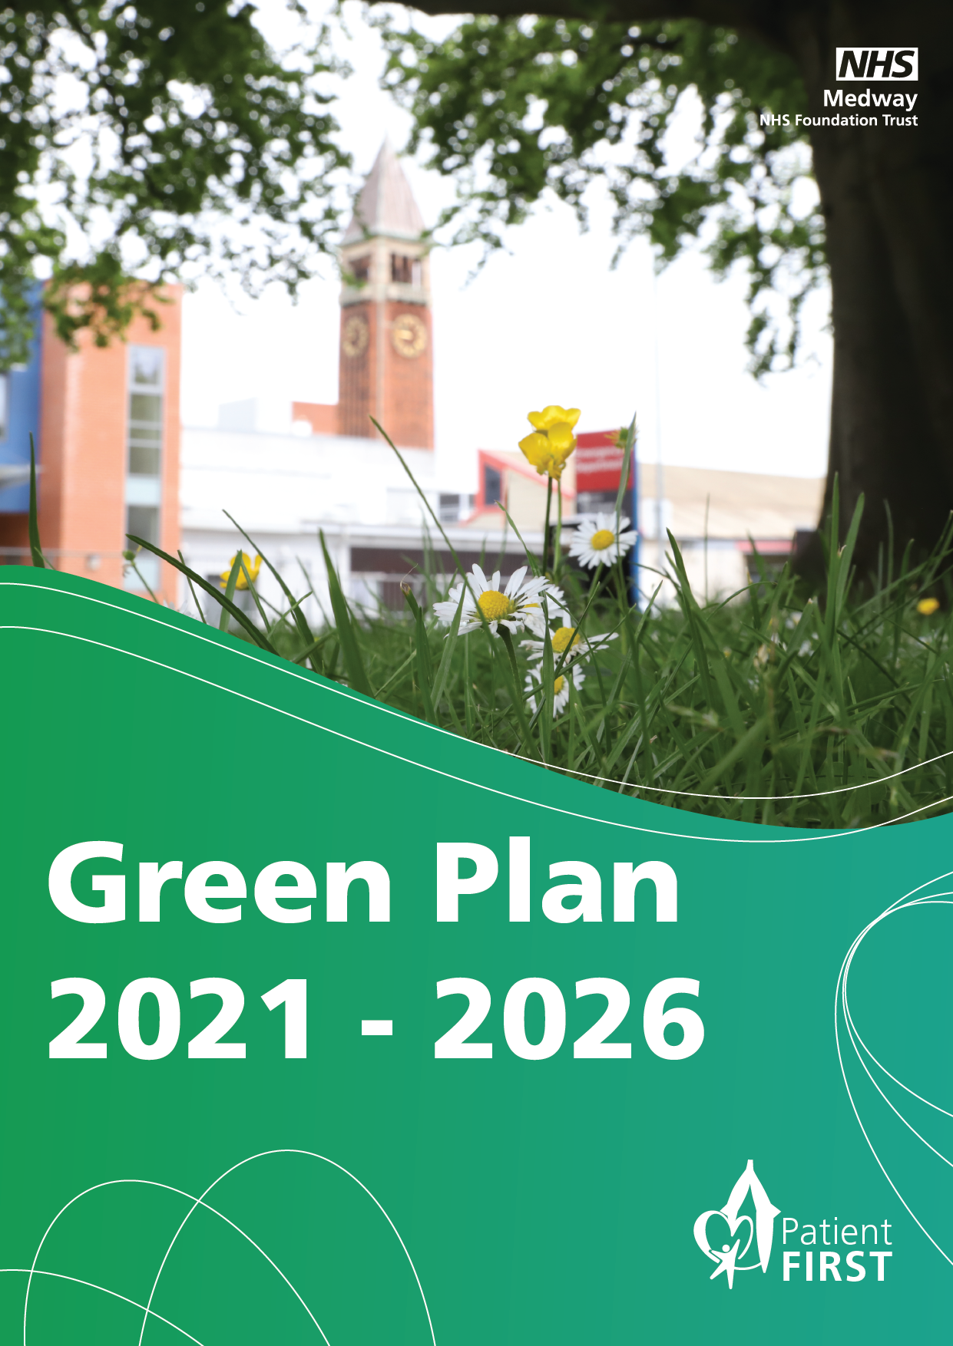

Green Plan 2021 to 2026

Introduction

As the largest and busiest hospital site in Kent and Medway, Medway NHS Foundation Trust (MFT) consumes a significant quantity of resources, resulting in a large carbon footprint that contributes to climate change. We recognise the importance of addressing our environmental impact and integrating sustainability into our core operations.

Drivers for change

Sustainability at MFT is guided by financial, environmental, social and legislative factors, including the Greener NHS Programme’s target of achieving net zero carbon by 2040 set in 2020.

Our vision

Our Green Plan offers a comprehensive strategy outlining our actions for 2021 to 2026, aligned with our vision and objectives. We encourage everyone involved with MFT to actively participate in embedding sustainability throughout our organisation and the wider community.

This plan aims to fulfil our commitment to more sustainable healthcare, improving the quality of care while enhancing our resilience, sustainability and wellbeing in preparation for future pressures and challenges.

Key measures to be implemented by 2026

To achieve our targets, we have has outlined five key actions:
- Develop and implement net zero strategy
- Implement an Energy Performance Programme
- Develop and implement a Green Travel Plan
- Enhance Employee engagement
- Develop and implement a Sustainable Procurement Plan

Areas of focus

Our Green Plan is based on ten areas of focus:
- Corporate approach
- Asset management and utilities
- Travel and logistics
- Adaptation
- Capital projects
- Greenspace and biodiversity
- Sustainable care models
- Our people
- Sustainable use of resources
- Carbon and greenhouse gases
Each area has a nominated lead who is responsible for setting, reviewing, and updating, as required, the agreed objectives.
The plan introduces a Sustainability Steering Group (SSG) and Green Champions network within the Trust. These bodies will drive sustainable changes and behaviours at MFT and ensure continuous progress. The main risks associated with this plan have been identified, and the Trust will undertake measures to manage all risks related to sustainable development and climate change.

The future

While we have made progress in reducing emissions across these scopes, we acknowledge that more needs to be done to achieve net zero carbon by 2040 and ensure sustainable healthcare.
For a copy of our full Green Plan please email: medwayft.sustainability@nhs.net

