A person holding a baby holding a light torch looking into the baby's mouth

Description generated with high confidence

**Table of Contents**

Part 1: Chief Executive’s Foreword 2

Performance Overview: Introduction to the Quality Account 2023/24 3

Part 2: Priorities for Improvement and Statements of Assurance from the Board 4

2.1 Priorities for Improvement 2024/25 4

2.2 Quality Priorities 2024/25 5

2.3 Progress against our 2023/24 Quality Account Priorities 14

2.4 Statements of Assurance 2023/24 38

2.5 Reporting Against Core Indicators 20

2.6 Other Quality Information 32

Annex 1: Statements from Commissioners, Local Healthwatch Organisations and Overview and Scrutiny Committees 42

Annex 2: Statement of Director’s Responsible for the Quality Report 48

Annex 3: National and Local Clinical Audit Participation 53

Glossary 63

# Part 1: Chief Executive’s Foreword

As a provider of healthcare services to the local community, the Trust is committed to delivering safe, effective, and compassionate care to all patients. This Quality Account provides an opportunity to reflect on our achievements over the past year and to set out our priorities for the coming year aligned to our Patient First Strategy. We have worked hard to engage with our patients, staff, and stakeholders to ensure that we are delivering high-quality services that meet the needs of our local population.

Our focus on quality improvement is at the heart of everything we do, and we are constantly striving to improve the care we provide. Since our last Quality Account was produced, the Trust, and the NHS as a whole, has seen continued system pressures with high demands for our services, and the ongoing challenge of discharging medically fit patients continuing to have an impact. Our staff have worked hard to manage those challenges and ensure that safe care can be provided consistently.

Through our innovative Patient First programme we continue to see improvements in the care we provide, and I’m pleased to say that, despite the pressures, we have seen some excellent performance against statutory targets such as cancer waiting times. We were also pleased to launch our new Acute Medical Model at the Trust. This initiative is supported by NHS England and brings a new model to the Trust for patients with an acute medical need. Following the introduction of the model, we have seen an immediate improvement in ambulance handover times.

We continue to expand the rollout of Patient First across the organisation, with more and more colleagues getting involved. As a Trust we are proud of our participation in national clinical audits and research, ensuring that we continue to be at the forefront of innovation across healthcare and implementing evidence-based treatments and models of care which improve outcomes for patients. We are one of the leading Trusts in Kent, Surrey and Sussex for patients participating in research studies and have been recognised both nationally and internationally. By taking part in research, we have the ability to offer our patients pioneering treatments.

Making care more accessible for our patients remains a key focus for the Trust and this year we were proud that we have continued rolling out initiatives which provide care closer to home for our patients. We have also introduced a number of new projects to improve the patient experience, including initiatives promote dignity, respect and compassion.

We continue to learn from the experiences of our staff and we receive feedback in a number of ways including monthly pulse surveys and the national staff survey. Following the last staff survey we have introduced a range of initiatives including new staff networks, opportunities to share improvement ideas and staff wellbeing checks. While we have seen progress towards our quality priorities, we recognise that there is still much to do to ensure we are delivering the best of care every day.

This Quality Account sets out our ambitious plans for the future as we continue in our aim to deliver compassionate, high quality and effective services which meet the needs of our community.

Jayne Black

Chief Executive

## Performance Overview: Introduction to the Quality Account 2023/24

NHS Organisations are required under the Health Act 2009 and subsequent Health and Social Care Act 2012, and the National Health Service (Quality Account) Regulations 2010, to produce an annual document detailing information in relation to the quality of services provided to local communities, any achievements and/or improvements made and any areas where further improvements may be required for each financial year. The Quality Account is therefore a key mechanism to enhance the Trust’s accountability to the public and its commissioners, providing demonstrable evidence of measures undertaken in improving the quality of the Trust’s services, and what further improvement is required. Quality accounts are therefore both retrospective and forward looking.

As part of the development of the Quality Account all Foundation Trusts are required to identify measurable priorities that are mapped against the three Darzi headings of Safe, Effective and Patient Experience. The purpose of the account is to:

* promote quality improvement across the NHS
* increase public accountability
* allow the Trust to review the quality of care provided through its services
* demonstrate what improvements are planned
* respond and involve external stakeholders to gain their feedback including patients and the public.

Operational performance at Medway NHS Foundation Trust is measured against its existing strategic objectives and improvement plan, which sets out the key quality elements of areas where focus on quality care delivery will be made.

The Trust’s overall vision is to continually improve our services and provide the ‘Best of Care through the Best of People’. We have made a commitment that by 2028, our ambition is to deliver outstanding care outcomes through exceptional people and be a leading partner within the integrated health and social care system, providing patient experience without boundaries. At Medway, the delivery of a high quality care has always been placed at the heart of decisions taken by the Board. Our quality priorities are also a call to action for everyone to make a difference and be part of the Medway quality improvement journey. Our priorities have been mapped against the Trust’s Patient First Strategy to ensure alignment with patient safety, clinical effectiveness and patient experience as well as initiatives at national and regional level; this forms an important part of its implementation. It is both ambitious and aspirational by design.

For the completion of this quality account, NHS England has confirmed that NHS providers are no longer expected to obtain assurance from their external auditors in the preparation of their quality account, however the trust has undertaken its own internal review to provide assurance that the required elements have been met (See Annex 2).

# Part 2: Priorities for Improvement and Statements of Assurance from the Board

## 2.1 Priorities for Improvement 2024/25

The quality of the care that we provide and the safety of our patients are the top priorities for the Trust. Our vision, to deliver our true north of ‘Patient First’ gives us the direction to achieve an organisational culture that empowers our staff to take the initiative and make lasting changes that benefit patients accessing our services and the community at large.

Aligned to our ambitious Patient First strategy are our 2024/25 quality priorities that are a building block to a longer-term approach to transform the way we deliver our services for the better. Patient First is a process of continuous improvement that gives frontline staff the freedom to identify opportunities for positive, sustainable change and the skills to make it happen. Patient First is also a programme based on standardisation, system redesign and ongoing development of care pathways, built on a philosophy of incremental and continuous improvement led by front-line staff empowered to initiate and lead positive change.

The Medway NHS Foundation Trust Board recognises that the foundation of excellent care delivery lies in the skill, enthusiasm and innovation our staff bring to their individual roles and their teams. Through our staff we have set out to achieve five quality priorities over the next 12 months that are strongly aligned with the Trust’s Quality Strategy and mission statement to provide the best of care by the best of people, providing excellent care every time.

Our 2024/25 quality priorities have been developed in collaboration with our patients and our staff and represent the highest priority areas for the population that we serve. They have also been endorsed by both our external and internal stakeholders including the Kent and Medway Integrated Care Board and Governors. As part of our development of the Trust’s 2024/25 quality priorities, a members’ event was held on 10 January 2024 to inform our governors, staff and patient group representatives of the progress made against last year’s (2023/24) quality priorities and to discuss the priority areas for quality improvement for the upcoming year (2024/25).

This successful event enabled our stakeholders to pose questions and gain an understanding of our Patient First Programme. Themes shared on the day were used to support the development of, and reach agreement on, the priority areas for the year ahead, as highlighted below:

## 2.2 Quality Priorities 2024/25

### 10% reduction in the total number of unwitnessed inpatient falls (including the emergency department).

**Domain: Safe**

Reduce harm and create a culture of safety

**Breakthrough Objective**

Excellent outcomes, ensuring no patient comes to harm and no patient dies who should not have.

**Measurement for success**

No more than 621 (i.e. a 10% reduction compared to 2023/24) unwitnessed in–patient falls in 2024/25.

**Rationale for Priority**

In 2023/24 the Trust reported 691 inpatient falls that were unwitnessed by staff. It is essential that patients who are at risk of falling are recognised early and risk assessed accordingly. By doing this, the appropriate falls prevention measures can be put in place, such as ensuring the patient’s call bell is in reach and encouraging them to use it when asked, using a falls alarm/sensor pad if the patient is unable to use a call bell, placing a patient in the most suitable bed space i.e. either a bed that is observable by staff at all times or nearer a toilet, providing enhanced nursing observations, early referrals to physiotherapy and occupational therapy and the provision of the most appropriate walking aid and well-fitting anti-slip footwear. If risk assessed appropriately, the likelihood of a patient falling is reduced and the potential for the patient to experience harm as a result will be minimised.

The decision to focus on unwitnessed falls is based on a recognition that some patients, even if medically optimised, will at times unfortunately fall or slip or trip.

Preventing falls must be balanced with patients’ rights to dignity, privacy, independence, rehabilitation and their choices about the risks they are prepared to take. Taking these person-centred factors into account can equate to limited opportunities for learning and improvement.

MFT has made excellent progress over the last year with reducing the number of inpatient falls and aims to continue this success further by focusing efforts on reducing unwitnessed falls, and particularly focusing on where the patient lacks capacity.

We will therefore be prioritising reducing the number of unwitnessed inpatient falls this year by 10%, to a total of no more than 621. This priority also aligns with our 2024-27 quality strategy where we have set out how we will achieve a 10% reduction each year over the three-year period, so that by March 2027 we will have achieved no more than 502 unwitnessed inpatient falls.

**How we will achieve this priority:**

We will achieve this through the introduction of a number of falls prevention strategies including;

* Increasing the number of falls specialist nurses and falls link nurses, delivering on the recommendations of the National Audit of Inpatient Falls and by embedding the learning from incident investigations into patient falling
* Monitor data related to unwitnessed falls by day of week and time of day to observe for themes and trends to align quality improvement focus
* Ensuring the wards have all the necessary falls prevention equipment by working with our engineering partners to formulate a clearer process for tracking and monitoring equipment to enable prompt use
* Training staff in recognising patients at risk of falls and how to prevent falls from occurring by ensuring the falls CRASH bundle is promptly implemented (known key elements to falls prevention)
* Zero tolerance to corridor care in the Emergency Department
* Participating in quality improvement initiatives for preventing falls in the Emergency Department by providing dedicated falls alarms, promotion of assistance alert wristbands with patients’ mobility status clearly identified and providing bespoke training on falls prevention and post fall care
* Recruiting more enhanced care support workers to improve fill rates of enhanced care shifts for our most vulnerable patients
* Unwitnessed falls can occur whilst a patient is using the toilet or bathroom. During ward refurbishment periods, auditing our toilets and bathrooms and making recommendations to optimise patient safety and ergonomics i.e. ensuring enough grab rails are in situ and in the right position will be made
* Commencing ‘Decaff Project’ and noting any impact on unwitnessed falls that occur whilst a patient is rushing to the toilet which may be related to over stimulation of the bladder from caffeinated drinks.

### Reducing complaints and PALS relating to staff attitude

**Domain: Patient Experience**

To provide the best experiences of care for our patients, families and carers and respond appropriately when we get this wrong

**Breakthrough Objective**

Providing outstanding, compassionate care for our patients and their families every time.

**Measurement for success**

Reduction in the proportion of complaints and PALs where staff attitude is a theme, as a percentage of all complaints and PALs, compared to last year. Complaints 12.3% and PALS 5.1%.

**Rationale for Priority**

* In 2023/24 the Trust received 148 complaint letters that made at least one reference to a negative staff attitude and received 272 concerns via the Patient Advice and Liaison service (PALS) where negative staff attitude had resulted in a patient, family member or friend contacting the Trust.
* The Trust recognises that complaints about staff attitude are a poor indicator of patient experience, which is one of the three elements of high-quality care, alongside patient safety and clinical effectiveness, and that this number is too high.
* Over the next year, through introducing a range of improvement measures, the Trust is aiming to receive no more than 12.3% of complaints and 5.1% of PALs concerns making reference to a negative staff attitude.
* We will aim to achieve this by embedding the learning from any themes within complaints, identifying higher volume areas and speaking with staff and managers of those areas, working with staff to demonstrate the Trust’s values and behaviours including all new starters via our Trust induction programme, endorsing positive examples during staff training with a focus on empathy and compassion, and recognising and sharing examples of best practice across the organisation.

#### How we will achieve this priority:

* 16 ward managers covering one out of hours shift each month will provide cross cover, support, check and challenge when poor attitude is witnessed or reported and will be role models of staff behaviours.
* This will be supported by the Matrons who will provide additional out of hours cover for weekend shifts ensuring any negative staff behaviours are challenged.
* Focused support and training from senior leaders will be offered to the highest reporting areas of poor staff attitude and behaviours
* The ‘Fundamentals of Care’ work (for nursing staff) being rolled out in 2024/25 incorporates ‘delivering compassionate care’ which includes staff attitudes and behaviours
* Senior Nursing and Medical staff met to discuss the impact of ‘not my patient’ and the commitment to promoting ‘our MFT patient’. This message is promoted and reinforced in all forums such as divisional governance meetings, staff operational huddles etc.
* Daily and nightly staff operational huddles include comments from patients via the Friends and Family Test and staff are asked to recommend one action to improve feedback. These recommendations and suggestions are collated monthly and reviewed in the divisional governance meetings.
* The Patient Experience Team will attend ward manager’s meetings, divisional governance meetings and Grand Rounds to facilitate open discussion with staff around staff attitude and behaviours, to promote ‘our MFT patient’ and to raise the profile of the role of the patient experience team

### Earlier recognition of the dying person and commencement on an end of life care individualised care plan.

**Domain: Patient Experience**

To provide the best experiences of care for our patients, families and carers and respond appropriately when we get this wrong.

**Breakthrough Objective**

Providing outstanding, compassionate care for our patients and their families every time.

**Measurement for success**

Improvement in the NACEL summary scores from 4.9 (Families’ and Others’ experience of care) and 4.3 (Needs of families and others) to 6.3 and 5.5 respectively (Round 4; 2022/23 England and Wales summary scores)

Improved completion of bereavement survey to 25%

Where clinically appropriate, increase in the percentage of patients made EoL between 06:00 – 18:00 from 50% (2022/23 NACEL data) to 60%.

**Rationale for Priority**

* + Early recognition of when a patient is close to end of life and commencement on an individualised end of life care pathway is recognised as an opportunity to give a patient and their families the best experience of death. Early recognition enables a patient to get the right care that they need, without undergoing unnecessary tests and investigations when the priority should be on making them comfortable and affording them protected time with their family and friends.
  + The national audit of care at the end of life (NACEL) 2022/23 found that families’ and others’ experience of care and the needs of families and others being met were below national averages. By improving these scores, we will be able to demonstrate a better experience of dying for both the patient and their families. Furthermore, we will aim to gather more feedback from families using our own bereavement survey so that we can better understand where families feel that care and the experience of dying could be improved so that we can make improvements.
  + The 2022/23 NACEL audit also highlighted that 50% of decisions to make a patient for end of life care are made outside of the hours of 6am to 6pm. We recognise that for many patients, this decision could have been made earlier in the day, by the clinical team looking after them, rather than by the overnight or on-call team who are less familiar with the patient’s personal needs and wishes.
  + This is why we will be prioritising earlier recognition of when a patient is at the end of their life and increasing the number of times this decision is made between 6am and 6pm and by the treating clinical team. By achieving this we will afford patients earlier individualised end of life care plans that are aligned to their wishes and a better experience of dying for all involved.
  + We will aim to achieve this by increasing the training for clinical teams to be able to recognise the signs of when a patient is at the end of their life earlier and using the feedback from families around their experiences to make changes and improvements. We will be raising the profile of the bereavement survey via multiple platforms and leading to a ‘you said, we did’ campaign.

#### How we will achieve this priority:

* + Education: Training programmes- for all levels of staffing including consultants, to enhance their skills in recognising end of life care and commencing individualised care plans (a Quality Improvement Plan (QIP) is currently in development). Workshops/seminars will also be rolled out to highlight the importance of early recognition of the dying patient
  + Communication: Patients, and those important to the patient, being educated on the condition and made aware of support services available, empowered decision making earlier in the patient journey, and Implementation of effective communication to enable better discussions with patients and their families about end-of-life care preferences.
  + Protocols: Patients referred as ‘likely to deteriorate in the next 24 hours for EOLC’ will have clearer criteria of exactly what the deterioration needs to be to commence EOLC. Currently out of hours this may be delayed due to staff not knowing what the criteria is. - This will be addressed by changing the current protocol including an interim EOLC decision order by ART/Specialists if the criteria for expected deterioration is clear
  + Screening- we will introduce the use of the SPICT Tool- Supportive and Palliative Care Indicator Tool- which will help identify patients with deteriorating health due to advanced conditions of serious illness and prompt holistic care and better future care planning
  + Community Engagement: As part of the Kent and Medway Programme Board we will better collaborate with community organisations and hospice services to ensure more joined up transitions for patients requiring specialised end-of-life care outside of the hospital setting.
  + We will raise awareness in the community about the importance of early recognition of dying and the benefits of having and individualised care plan in place.

### 50% of all GIRFT improvement programmes referenced within the clinical strategy to benchmark within the top 25% Nationally (using the model health system data set)

**Domain: Clinical Effectiveness**

To provide evidence based and best practice care

**Breakthrough Objective**

Excellent outcomes, ensuring no patient comes to harm and no patients dies who should not have.

**Measurement for success**

50% of all GIRFT improvement programme national specialty report recommendations, referenced within the Trust clinical strategy, actioned and benchmarked within the top 25% nationally

**Rationale for Priority**

* **Getting It Right First Time (GIRFT) is a national programme designed to improve the treatment and care of patients through in-depth review of services, benchmarking, and presenting a data-driven evidence base to support change.** The programme undertakes clinically-led reviews of specialties, combining wide-ranging data analysis with the input and professional knowledge of senior clinicians to examine how things are currently being done and how they could be improved.
* GIRFT is embedded across the organisation and aligned to the clinical strategy for the next 3 years.
* The Trust clinical strategy 2024-27 references nine clinical specialties where GIRFT reviews have produced best practice recommendations. These specialties are: Paediatrics, Urology, Rheumatology, Emergency and Acute Medicine, Cardiology, Diabetes, Neonatology, Respiratory and Trauma & Orthopaedics.
* Where recommendations of best practice have been made, the Trust will undertake an analysis of whether it is achieving the recommendation, and if not, we will seek to undertake a series of actions to be able to achieve and embed the GIRFT recommendation.
* By benchmarking 50% of all GIRFT recommendations within the top 25% nationally (for the nine relevant clinical specialties), we will be able to demonstrate that we are an organisation that provides care and treatment in line with nationally recognised best practice standards.

### Improve from 26% to 95% of applicable National Clinical Audit (NCA) reports having an established delivery and improvement action plan within 90 days.

**Clinical Effectiveness & Outcomes**

To provide evidence based and best practice care

**Breakthrough Objective**

Excellent outcomes, ensuring no patient comes to harm and no patients dies who should not have.

**Measurement for success**

Improve from 26% to 95% of all applicable National Clinical Audit reports in 2024/25 having an established delivery and improvement action plan within 90 days of publication.

**Rationale for Priority**

* National Clinical Audits and their respective reports provide an opportunity to benchmark the Trust against other health care providers, identify when it is not meeting best practice standards and put improvements in place to meet national recommendations for improving clinical outcomes for patients.
* Having an efficient system and process in place in order to be able to do this in a timely manner i.e. within 90 days of publication, means that the Trust is able to identify where it falls below national averages, recognise where it needs to improve, and develop a series of actions that will bring about improvements in patient care and outcomes.
* In 2023/24 the Trust achieved the 90-day target in 26% of published NCA reports. Medway NHS FT recognises that earlier engagement of clinical teams in the findings and recommendations of the reports has the potential to bring about earlier improvement opportunities and achieve better outcomes for our patients. That is why this year we have made this a key priority and set an ambitious target of achieving this for 95% of published NCA reports, which will equate to approximately 40 out of 45 anticipated reports having an improvement action plan in place within 90 days of publication.

#### How we will achieve this priority:

* Via our Clinical Effectiveness and Outcomes Group (CEOG) we have outlined a workplan for the year ahead which includes presentation dates for all audit leads to present the findings and actions from NCA reports within 90 days of the anticipated publication date.
* We will provide each care group with individualised audit reports :
  + Detailing a list of any reports outstanding
  + Listing the current annual audits taking place and identifying any issues to submission or reporting of outcomes and actions
* 30, 60- and 90-days reminders being sent to clinical audit and project leads
* 1-2-1 meetings with the clinical audit / project leads to improve engagement with clinicians and support the embedding of improvement actions
* Quarterly updates for each audit on progress against its improvement actions

## 2.3 Progress against our 2023/24 Quality Account Priorities

### To reduce the number of avoidable 2222 cardiac arrest calls to no more than 12/year (<1 / month) and the reduce the number of peri-arrest calls by 30% from 50 calls (2022/23) to 35 calls (<3 / month) by April 2024

Reducing avoidable cardiac arrest calls is crucial for patient safety and effective healthcare. Earlier recognition helps improve patient outcomes and survival rates. Monitoring vital signs and acting promptly on abnormal parameters can prevent avoidable emergencies.

Based on the Trust data between April 2023 and March 2024, there were 13 avoidable 2222 cardiac arrest calls against a target of 12 (<1 / month). Over the same time period there were 22 avoidable peri-arrest calls against a target of 35 (< 3/month). The total number of avoidable calls reported this year was 35 compared to a total of 83 in 2022/23, a reduction by over 50% from the previous year.

This result is a tremendous achievement and reflects all of the improvement work around this quality priority to reduce avoidable 2222 calls in the Hospital.

The steps taken to achieve this quality goal in 2023-24 were:

* a continuation of a process of collaborative A3 meetings between our resuscitation, outreach, emergency, and acute medical multidisciplinary teams, a root cause analysis identified our primary causes of avoidable 2222 calls as failure to recognise, failure to escalate, and gaps in clinical planning. This was triangulated with both quantitative and qualitative data to ensure validity and targeted interventions.
* Quality Improvement methodology was used to process map and audit the responses to high national early warning scores (NEWS), carried out by the Acute Response Team (ART).
* a qualitative thematic analysis of incident reports, and performed a root cause analysis to triangulate causes of avoidable 2222 calls.
* The Acute Response Team (ART) continued to respond to escalated High NEWS scores of patients displayed on our existing EPR system tracking board so that they could directly monitor this, and then could “trigger” and treat unwell patients early.

In addition, during this time, it could be concluded that we completed tasks such as escalations on board rounds, NEWS alert training, and critical drugs list training. The established weekly huddles attended by clinicians and executives to review performance and drive continuous improvement, supported by A3 meetings with wider groups of frontline teams was deemed impactful.

The efforts of our outreach team are commendable.

In addition, we launched an initiative called “Call 4 Concern,” which encourages patients and relatives to activate an outreach review when they feel a patient’s clinical condition has declined or is declining. We are continuing to co-produce this service with patients, service users, and relatives. This service has already shown success in escalating deteriorating patients early when used in other trusts as it recognises service users as assets (a core principle of co-production), and utilises their knowledge, skills, and time to help identify deteriorating patients.

We have also developed a safety culture of continuous improvement by introducing annual NEWS training and ward based, twice daily safety huddles, discussing high NEWS patients and their escalation status. This has resulted in frontline, staff led changes, including ward safety huddles, electronic track and trigger of high NEWS, patient co-produced “Call 4 Concern”, and an acute medical model.

The graph below shows the primary themes

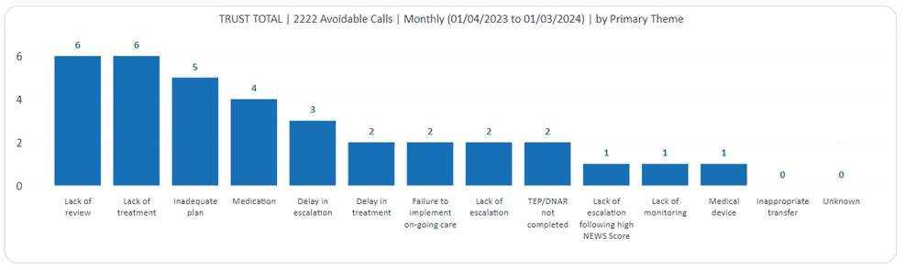

#### Overall position for cardiac and peri- arrest calls from April 2023- March 2024

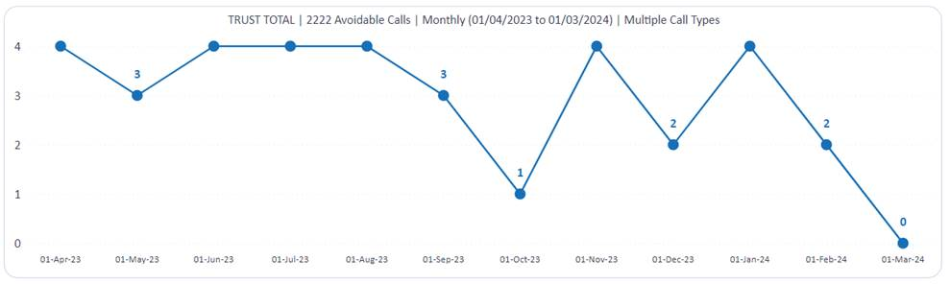

#### Cardiac arrest calls from April 2023- March 2024

Avoidable cardiac arrest calls = 13 (Target <1 /month) (Not achieved)

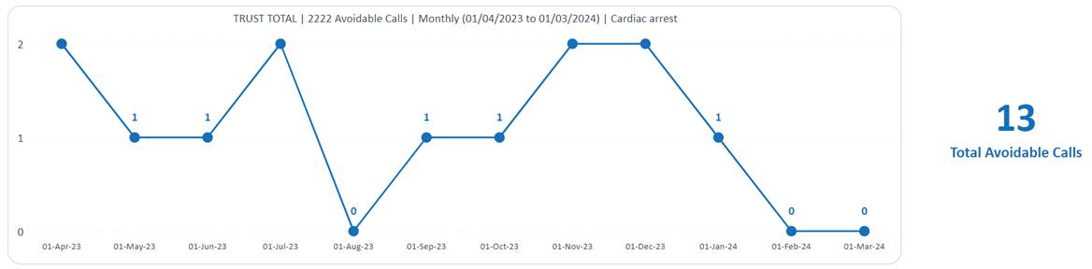

#### Peri-arrest calls from April 2023- March 2024

Avoidable Peri-arrest calls = 22 (< 3/month) (Achieved)

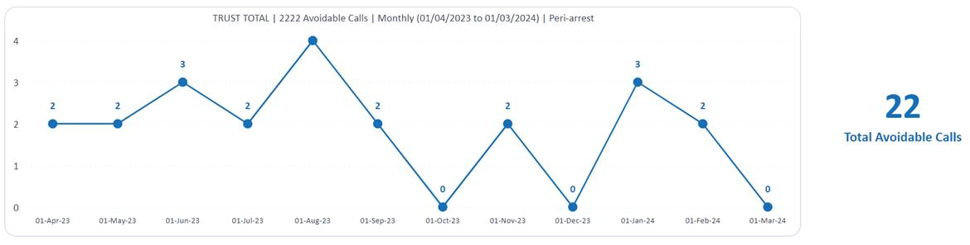

### Improve patient outcomes through having lowest possible quartile mortality rate

A low mortality rate indicates a better quality of care. When patients experience fewer adverse outcomes, it reflects positively on the healthcare system’s effectiveness and safety. Lower mortality rates lead to higher patient satisfaction, trust and confidence in the healthcare provider.

To improve, the Trust has held educational sessions across specialties around the importance of clinical documentation, comorbidity recording, palliative care recording and accurate primary diagnoses. Improvements to EPR have provided support to clinicians with accurate clinical documentation and educational and informative posters and communication tools have been produced to share learning across the Trust. Improvements in both depth of coding and average Charlson comorbidity scoring has been sustained over the last year.

Improvements have been seen in HSMR over the last year however, both SHMI and HSMR remain within the ‘higher than expected’ banding.

To help us achieve the priority we carried out the following:

* Task and finish group set up between May 2023 - Sept 2023
* Improvements made to EPR for easy input of comorbidities and clear working diagnosis
* RIP validation process initiated
* Palliative care recording made visible on EPR for coding purposes
* Education around TEP form completion
* Task and finish group for the reduction of avoidable 2222 calls to improve patient safety
* Ensured robust SJR and deep dive process to ensure timely reviews are undertaken where there are concerns raised regarding a death
* Appointed a clinical Learning from Deaths Lead
* Embedded positive change and improved communications with clinical and other relevant colleagues through shared learning on mortality and learning from deaths - newsletters, weekly flash reports
* We nationally benchmark the mortality rate against the indicators to ensure we are “within” expected. For SHMI it is 1, for HSMR it’s 100.

Education to specialities on clinical documentation will continue for the next year. The Mortality review processes are currently under review to ensure robust systems are in place to highlight issues in care and learn from deaths to improve patient outcomes.

The graph below shows the SHMI position for 2023/24.

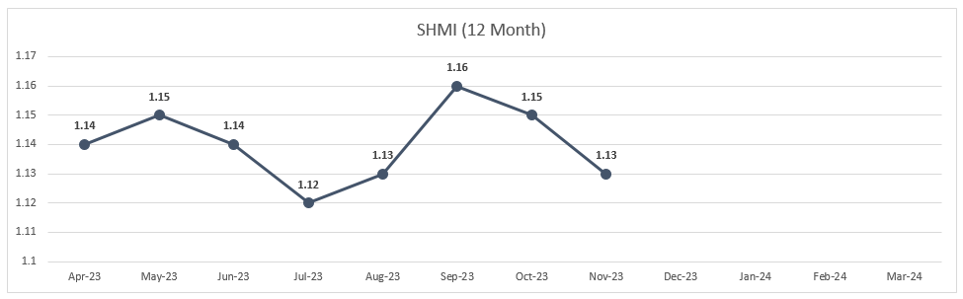

The graph below shows the HSMR position for 2023/24.

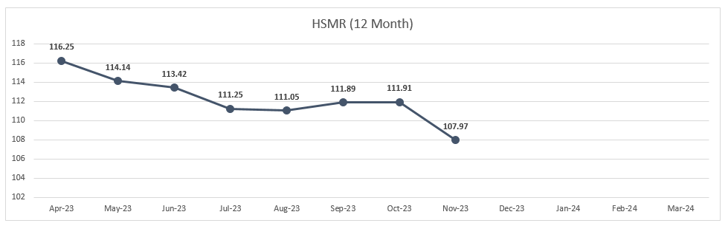

### All patient referral to treatment (RTT) pathways to be completed within 65 weeks

Ensuring that all patient referral to treatment (RTT) pathways are completed within 65 weeks is crucial for patient wellbeing and improved outcomes. Delays can exacerbate medical conditions, cause distress to patients and impact upon quality of life. Earlier treatment initiation can lead to better outcomes and that is why the Trust set a target of zero patients waiting over 65 weeks before commencing treatment from the point of referral.

Despite the hard work and continued efforts of the Trust, at the end of 2023/24 the Trust had reported a total of 232 patients waiting over 65 weeks to commence treatment.

The total patient treatment list (PTL) size was 44,646. A breakdown of the speciality position as at 31 March 2024 is shown below:

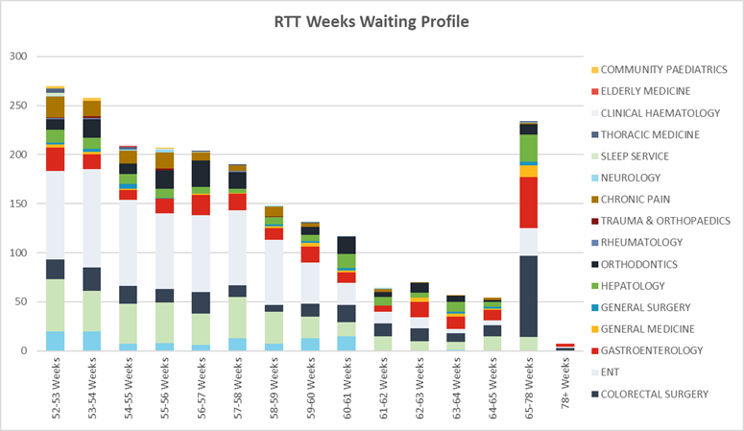

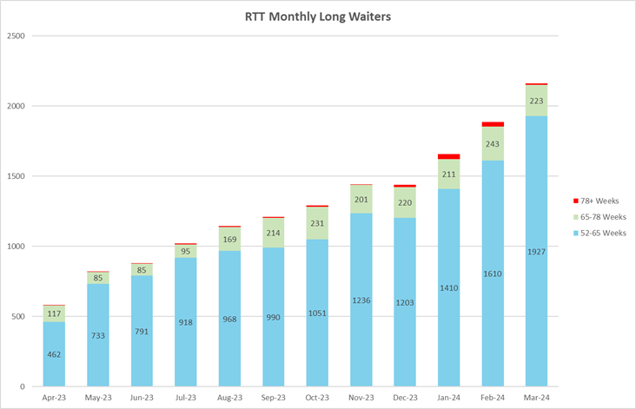

**Top contributing areas to the RTT performance:**

Gastroenterology/colorectal/Hepatology

* Top contributor to long waits is the available Endoscopy capacity.
* The Trust has been utilising mutual aid from Dartford and Gravesham NHS Trust to increase capacity and this is to continue into 2024/25 with potential of 2025/26.
* It has also been agreed that the Trust will be leasing a mobile endoscopy unit situated on the Acute site and this will further increase the capacity by around 400 per month – mobile unit ordered May 2024

Cardiology

* Top contributor are continuing issues is cardiac testing capacity, leading to delays.
* Task and finish group set up with operational and clinical stakeholders
* Outsourcing capacity is being investigated
* Job Description is being finalised for an Imaging Consultant.
* Ad hoc additional clinics are also being booked to try and create additional capacity

ENT

* Superclinics underway to cover larger cohort of patients
* High Volume/Low complexity theatre lists now running to increase activity
* Weekly PTL meetings with general managers are now in place to review positions and plans to improve the performance along with an outpatient transformation programme to drive initiatives around Patient Initiated Follow-up (PIFU) and virtual clinics.
* New Artificial Intelligence proof of value project underway within Patient Service Centre to automate telephone systems. We expect this to lead to a reduction in call drops and increases the ability for patients to cancel and/or rebook clinic appointments which should lead to a reduction in Did Not Attend (DNA) rates to support clinic utilisation and also drive up performance.

### Work with ePR and PAS to review and redesign clinical systems, to enable a patient to be taken off the clock correctly.

Throughout 2023/24 electronic patient records (EPR) were introduced to the Emergency Department which enabled a transition from Symphony to Sunrise (EPR). This has allowed the ED notes to be integrated into the Trust electronic patient record.

2023/24 has remained a challenge for ED, however, there have been improvements across the care group throughout the last 12 months. Performance has seen a rise of 12% on 2022/23, with our four-hour non-admitted performance achieving national recognition in October 2023 and again in March 2024. There have been several new pathways launched, including our 111 direct access, Single Point of Access (SPOA) with the South East Coast Ambulance Service and the introduction of an Acute Medical Model. All of these have helped support the drive in improvement in our performance and contributed to patient safety & experience within the department.

To help us achieve this priority and achieve the 4-hour ED wait target we carried out the following:

* Senior Staff presence within the emergency department daily
* Live validation of wait times
* Increased awareness of wait times with clinical staff
* Increased use of Area 3
* Increase in Clinical Decision Unit utilisation
* 111 direct access pathway
* Secamb pathway
* Acute Medical Model

Emergency Care – total EC 4 Hour Performance %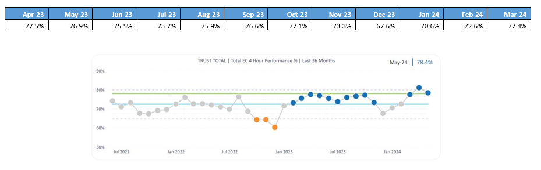

### FFT- Percentage of Patients who would recommend

The Friends and Family Test (FFT) is an important feedback tool that supports the fundamental principle that people who use NHS services should have the opportunity to provide feedback on their experience. Listening to views of patients and staff helps identify what is working well, what can be improved and how. The FFT asks people if they would recommend the services they have used and offers a range of responses.

Over 2023/24 the Trust’s FFT results have seen continued improvement with the recommend rate rising significantly within in-patient areas and is almost on target. The 45% response rate has been achieved within in-patient areas, which has been a great achievement for the clinical teams to hear the voice of patients in our care.

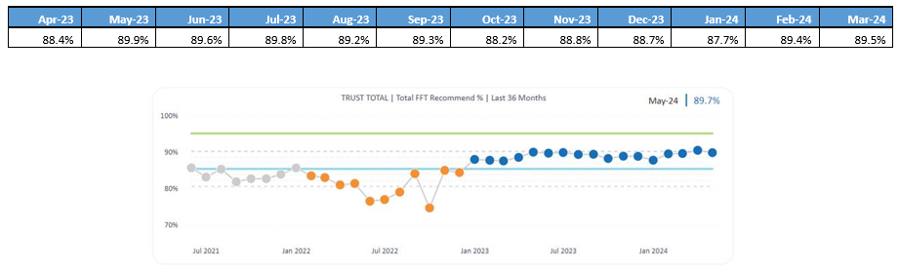

The focus on improvements have been directly in response to patient feedback. The themes and trends are identified and discussed with the Chief Nurse and senior teams during the weekly breakthrough huddles. Through the driver huddles and catch ball meetings, clinical teams engage with their feedback and respond quickly to concerns and share and celebrate the fantastic feedback they receive. As an organisation, staff attitude will be a focus for celebration and improvements over the next six months. The emergency department feedback will be a specific focus for improving response and recommend rates. Projects have been initiated to improve the challenges around flow and quality in the ED, the first quality week is scheduled to be held at the end of May 2024.

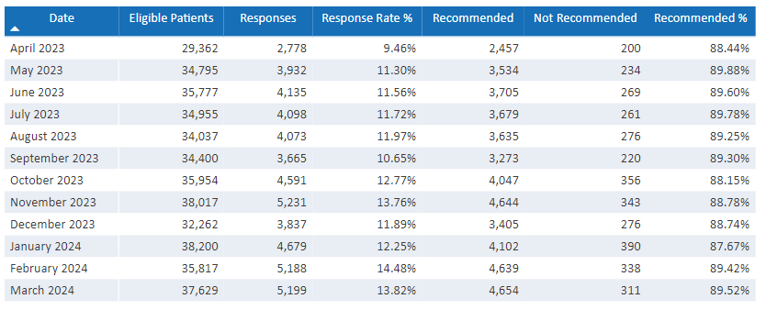

#### ‘You said, we did’

#### Patients were telling us that information wasn’t always clear or available following their day case surgery

* Surgery and anaesthetics have set up a service whereby staff call all patients who were discharged following their elective day surgery the day before. This allows patients to follow up with any questions or concerns once they are at home. This also allows us to capture their feedback

#### Consistent issues with care, communication and quality in the ED

* Started a full programme of work to support and improve the care within the ED. ‘Quality week’ commenced week of the 20th May. All staff engaged with daily improvement huddles, provided ideas to improve the care we provide and were supported by senior teams and consultants. Pop up teaching was provided in situ. This is in line with patient first improvement methodology. Feedback from all staff was very positive. Going forwards we will keep momentum going with regular support from the senior team at the daily huddle, to hear the staff voice. CNS teams will be asked to support regular in situ teaching going forwards

#### Induction of Labour

* Patients often getting mixed messages about the induction of labour process, which results in poor communication, frustration etc. alongside our normal service review processes and patient feedback. An A3 commenced to understand the root causes for delays in inducing labour which showed that these were related to pathways of care, however the communication process has improved, which in turn has reduced the number of concerns raised. Maternity have been achieving 98-100% positive feedback week on week.

#### Food for partners - Maternity

* Patients and their partners in maternity were not able to readily get a meal whilst in maternity. Food can now be provided to birthing parents no matter what time following a discussion and agreement at the patient experience group.

#### Food for carers – paediatrics

* Parents of children were not able to leave the paediatric area to get a meal. Now they are offered food at mealtimes with their children again with agreement from all teams

#### Lights at night

* Patients were telling us that the lights were left on at night or the night lights were too bright.
* Estates are addressing these issues to replace lights with cost saving energy efficient lighting
* Senior nurse teams are supporting night staff out of hours (early mornings and late evenings) to ensure staff are aware of issues such as light and noise so that we can address them

#### Care different at night vs day

* Patients are telling us that care is different from staff day vs night. Ward managers and Matrons now work a rota of nights and out of hours to ensure staff are supported at all times. To also monitor and check care quality out of hours and staff attitude.

#### Information provided on appointment letters

* Patients are telling us that when they receive appointment letters, they are not able to directly contact the relevant team to ask a question, rearrange etc. not all letters have a direct phone number on them which causes frustration and further PALS contacts. Their phone calls are going to switch board who are unable to help. A working group has been stood up to address this, service managers, patient records, complaints and patient experience are leading this work, we will be asking patients to join to co-design the letters going forwards.

#### Access to visiting for carers

* We hear that patient carers are not always able to gain access to their loved ones outside of visiting times. We know that patients who are vulnerable, have a diagnosis of dementia or who have a learning disability benefit from having their carer with them. We have developed a carers card for those people as an easily recognisable tool for them to access the site, a reduced rate of parking and a free meal.

## Patient Safety Incident Response Framework (PSIRF)

In addition to the Trust’s quality priorities, Medway NHS Foundation Trust has committed to fully implementing PSIRF (Patient Safety Incident Response Framework) which the Trust launched in February 2024. This framework determines how the organisation responds to patient safety incidents and sets out the NHS’s approach to developing effective systems and processes for responding to patient safety incidents, with a focus on truly understanding how incidents happen and identifying learning and improvement.

Before going live with PSIRF, we developed comprehensive Quality Improvement Plans (QIPs) for Falls and Tissue Viability which were signed off by the ICB. It was then agreed that we would no longer report falls and pressure ulcers under the SI framework from December 2023. This gave us the opportunity to trial the new process and learning response tools such as SWARMs and After Action Reviews (AARs). We then included prompts and other information to ensure the learning responses captured the right information.

The aims of PSIRF are:

1. Compassionate engagement and involvement of those affected by patient safety incidents
2. Application of a range of system-based approaches to learning from patient safety incidents
3. Considered and proportionate responses to patient safety incidents
4. Supportive oversight focused on strengthening response system functioning and improvement

PSIRF is ultimately a cultural change and this will not happen overnight. We need to shift the focus from “blame and retrain” and a single root cause, and instead look at how systems have allowed incidents to occur and, as humans are fallible, how we can minimise the human factors involved.

Instead of a list of incident types that must be investigated, there are a reduced number of national reporting requirements and the Trust has created a PSIRF plan, based on data analysis, to focus our investigation efforts where we can make the biggest difference to patients, their families and staff. This plan is designed to be updated and changed as needed. If we start to see that a current priority’s improvement work is making a measurable difference, and we are starting to see a different theme arising, the plan can be updated. This allows the Trust to focus on learning and improvement, rather than focussing on outcomes and levels of harm, which means we are no longer just focusing on the most serious incidents, and are now looking at near misses, no harm and low harm.

We have started to embed the principles of PSIRF into our incident review groups and patient safety groups and we rolled out a comprehensive communications package for staff so that they were as informed and ready as possible for when we went live.

As part of the roll out we have also made Patient Safety Syllabus training level 1 mandatory for all staff, with a request to make level 2 mandatory for certain staff groups currently in progress. Relevant staff were also encouraged to undertake the HSSIB training prior to going live. The Patient Safety team have provided further training to staff where required. We have also procured accredited training for 20 Patient Safety Learning response leads which will take place in early 2024/25.

PSIRF has given us the opportunity to create better relationships both internally and externally; this has widened knowledge within the team, has allowed staff to be more comfortable when involved in an incident, which in turn will result in better investigations and learning from incidents. The systems thinking approach enables us to see gaps quickly and more easily, which then makes it simpler to identify recommendations. PSIRF has allowed us to look at incidents more holistically with the option to undertake more proportionate learning responses so that learning can be identified more quickly, and mitigations put in place to prevent recurrence. PSIRF also enables us to share information and learning more effectively, with greater opportunities to recognise good care which can also improve learning.

## Learning from Patient Safety Events (LFPSE)

LFPSE is the new national system for recording patient safety events, that replaces the NRLS (National Reporting and Learning System)

All healthcare staff in England, including those working in primary care, are encouraged to use the system to record any events where:

1. A patient was harmed, or could have been harmed
2. There has been a poor outcome but it is not yet clear whether an incident contributed or not
3. Risks to patient safety in the future have been identified
4. Good care has been delivered that could be learned from to improve patient safety

LFPSE was implemented in the Trust on 11th December 2023.

Consequently, the Trust’s incident reporting system has been revised to provide earlier opportunities for staff to report incidents and to investigate and learn from what has happened.

LFPSE adds a number of new incident reporting questions which focus the reporter and investigator on the impact of the incident and the opportunities for learning.

As part of the transition to LFPSE the Patient Safety team has provided training sessions to staff and procedural guidance has been created and shared.

The information uploaded to LFPSE will aid learning and support with the identification of national patient safety priorities.

## Achievements in Quality

* **NJR Data Quality Provider**
  + In August 2023, the Trust was awarded the National Joint Registry (NJR) Quality Data Provider for the fourth consecutive year.
  + 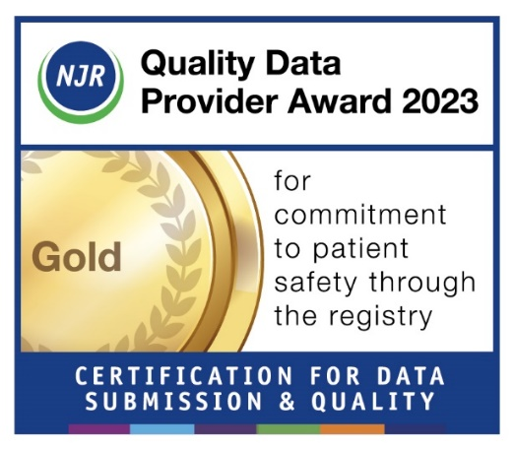The NJR Quality Data Provider scheme has been devised to offer hospitals public recognition for achieving excellence in supporting patient safety standards through compliance with the mandatory NJR data submission quality audit process.
* **Accreditation awarded to Endoscopy Services**
  + The Endoscopy Team, which was recently awarded the Joint Advisory Group (JAG) Accreditation following an assessment of the service.
  + Accreditation is awarded to services which have demonstrated they meet best practice quality standards covering all aspects of an endoscopy service including quality and safety, patient experience and the workforce.
  + It’s a prestigious accreditation for any trust to have and colleagues in our Endoscopy Team, which carried out more than 10,000 procedures last year, are rightly proud to have it affiliated to their service.
* **Royal College of Anaesthetists (RCoA) Anaesthesia Clinical Services Accreditation**
  + The Anaesthetic Department at Medway Maritime Hospital has received the prestigious Royal College of Anaesthetists (RCoA) Anaesthesia Clinical Services Accreditation (ACSA) – demonstrating a commitment to patient safety and high-quality care.
  + Medway is just the second NHS Trust in Kent to be presented with the accreditation, which promotes quality improvement and the highest standards of anaesthetic service. To receive it, departments are expected to demonstrate high standards in areas such as patient experience, patient safety and clinical leadership.
* **Improving Quality in Liver Services (IQILS) accreditation - supported by the Royal College of Physicians**
  + The Trust’s Hepatology Service has attained the Improving Quality in Liver Services (IQILS) registration.
  + This achievement, supported by the Royal College of Physicians, confirms our liver services work is of a high quality, and is tailored to the needs of our patients, putting them at the heart of the service.

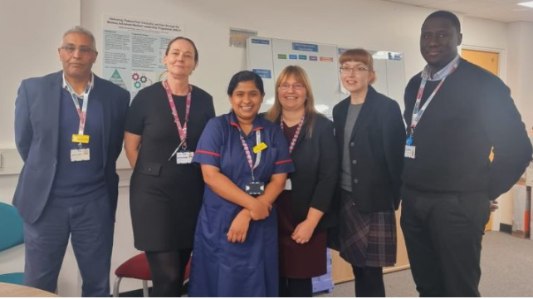

* **Royal College of Midwives (RCM) annual awards for 2023**
  + Sarah-Jayne Ambler, Clinical Research Manager in Midwifery has been recognised for her work in improving maternity care for people with learning disabilities.
  + Sarah won the Excellence in Midwifery for Research category in the Royal College of Midwives (RCM) annual awards for 2023.

Picture of Sarah-Jayne Ambler, Clinical Research Manager in Midwifery

* **New Frailty Unit** 
  + To help the Trust increase its access to care for patients across Medway and Swale and with the support of system partners and colleagues, Sheppey Frailty Unit was opened in January 2023.
  + The unit, based in Sheppey Community Hospital, means patients in Sittingbourne and Sheppey will now be cared for closer to home. This will allow the Trust to increase its capacity to treat more elective patients.



* **Innovative Pharmacy project shortlisted for major award**
  + Our Pharmacy Department has been shortlisted in the Medicines, Pharmacy & Prescribing Initiative of the Year category at the prestigious HSJ Awards 2023 for their work implementing an innovative electronic prescribing and administration system that enables clinical pharmacists working remotely to screen discharge prescriptions for inpatients, improving the timely supply of medicines and contributing to better care and faster discharge for our patients.
* **New surgical robot**
  + We became the second trust in the UK to adopt the newest robotic-assisted surgery (RAS) device called Hugo.
  + It is our second surgical robot, following the introduction of the Da Vinci robot in 2017 which has so far carried out over 1,500 urology and colorectal procedures.
  + Thanks to the introduction of Hugo, from March, we can expand robotic surgery to include more urology and colorectal procedures, and also start offering robotic gynaecology procedures, creating a multi-specialty robotic service that will benefit more patients.

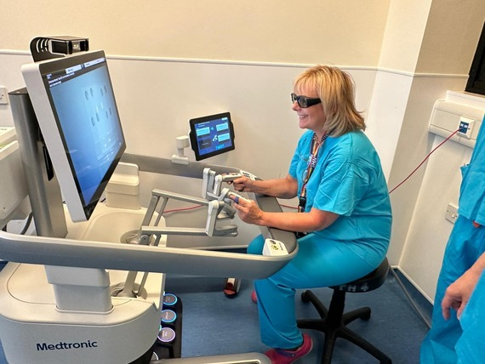

* **Patients Know Best launched**
  + Patients at Medway NHS Foundation Trust are now able to manage their own hospital appointments with the launch of a new online patient engagement portal Patients Know Best.
  + Introduced by the Trust to improve patient care, it is accessible on a range of devices and at any time. People can view appointments and medical letters with more functionality to come in the next few months.
  + Since the portal’s launch in October 2023, almost 10,000 new registrations have been made with more than 120,000 people registered to access their healthcare through Patients Know Best across Medway.
* **Patient First In the Spotlight**
  + The first Patient First In the Spotlight sessions have started and comments from patients included:
    - "It’s good to see that you are not afraid to say in public when mistakes have been made. Everybody makes mistakes and it’s good to see there’s learning from them.”
    - “I think it’s a really good idea because it’s public and you are not afraid to talk about what you are doing to improve things. It’s nice to hear what’s going on.”
    - It is encouraging to receive good feedback from people who are using services in the hospital.

Patient First: In the Spotlight is held in the hospital main entrance every Thursday around 8.15am, and is open to everyone.

* **National recognition for healthcare support workers** 
  + Four of our healthcare support workers (HCSWs) have received an NHS England Chief Nursing Officer Award for their compassion and vital contribution to the NHS.
  + The awards aim to reward and recognise the vital contribution made by HCSWs in England to nursing and midwifery practice. Only a few are awarded each year.

## Patient First: The First Year

Patient First is our improvement programme to help us improve the care and services we provide to the people of Medway and Swale. We began to introduce it across the Trust, in a phased way, in 2022, to help us deliver long-term change over time, by making small changes that have a big impact quickly.

Patient First is:

* A recognised and proven system for delivering significant long-term change within the NHS
* Identifies key areas for improvements and the root cause of problems
* Provides tools, techniques and a standard approach to identifying and tracking improvement needed
* Gives staff clarity about what they need to do, every day, and empowers them to make change happen in any areas of the Trust where they work
* Sets outs very clear and specific targets about what needs to be achieved in a fixed timescale



Targeted teams of colleagues have completed classroom-based, interactive training and coaching sessions to help them understand and successfully deliver the behaviours that Patient First seeks to instil.



A cohort of staff undertook a ‘fast-track’ approach through the PFIS Fundamentals and PFIS for Leaders and Manager Programme to begin using Patient First more quickly, with a focus on a specific target where they could make a big difference quickly.

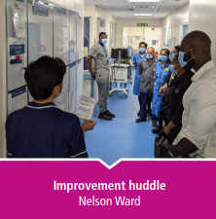

Improvement huddles for frontline teams have become routine for a constantly growing number of wards and services. An improvement Huddle is a standing meeting which takes place around an improvement board and lasts for 10-15 minutes, to identify, prioritise and action daily improvement ideas linked to set priorities.

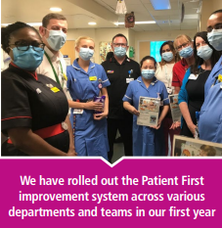

We were very proud of the first four frontline teams who led the way with Patient First and who have been fantastic examples for the colleagues who follow them of how to embrace and embed Patient First in their areas. • Arethusa Ward • Penguin Assessment Unit • Same Day Emergency Care • Nelson Ward



We know that Patient First gives our staff the skills, tools and confidence to make small changes that matter most. All colleagues play their part, whether they are out on the wards, in other clinical areas or providing essential support services. A perfect example of this was a success story from our Neurology Department, where the team managed to reduce 40- week Referral To Treatment (RTT) waits for first appointments from 374 patients in August 2022, to two patients in the week beginning 16 January 2023.

The Trust has significantly improved access to care for cardiology patients waiting for their first appointment, thanks to the efforts of colleagues in the department who have been running intense outpatient activity and applying Patient First methodologies to their work. The improvements, which were boosted by central funding from the Elective Recovery Fund (ERF) after the Covid-19 pandemic, meant that waiting times for a first cardiology appointment fell dramatically in six months, from an average of 64 weeks in October 2022 to 39 weeks by the end of April 2023. A targeted campaign to address pressure within Cardiology started in October 2022 and ran until March 2023. During this time, extra funding and training allowed three new locum consultants to run seven to eight extra clinics a week resulting in bringing down the patient list from approximately 3,100 patients to 2,200.

In addition, the number of patients waiting more than 40 weeks for an appointment fell from roughly 600 to 60 patients. The number of patients waiting more than 52 weeks for an appointment fell from 144 to 17.



A Patient First-led project to improve the care of deteriorating patients and reduce avoidable 2222 arrest calls (‘Crash Team’ calls) was named South East regional winner at the prestigious NHS Parliamentary Awards 2023 in the ‘Excellence in Urgent and Emergency Care’ category. In line with the Breakthrough Objective to better recognise the deteriorating patient and reduce avoidable cardiac arrest calls, this multidisciplinary team project saw colleagues record a sustained reduction in avoidable cardiac arrest calls across acute and emergency care from an average of five calls per month to just one.

This improved early identification and treatment of unwell patients was made possible through collaborative, frontline-led changes to the Trust’s intelligence, systems and culture.

This included:

* Proactive identification of avoidable 2222 calls, and an expert review and staff huddles on these cases.
* An initiative empowering nurses in escalating concerns of patients and relatives to a doctor in a timely fashion.
* An electronic track and trigger system enabling early identification of deteriorating patients
* A new medical model to reduce ambulance handover delays.

The project was nominated by local MP Rehman Chishti and was also shortlisted for two other major healthcare awards hosted by the Health Service Journal (HSJ) in the Quality Improvement Initiative of the Year category and Deteriorating Patients and Rapid Response Initiative of the Year category.

## 2.4 Statements of Assurance 2023/24

### Review of our Services

During 2023/24, Medway NHS Foundation Trust provided (and/or sub-contracted) 46 relevant health services to the people of Medway and Swale.

|  |  |  |  |  |  |
| --- | --- | --- | --- | --- | --- |
| **Activity 2023/24** | **Q1** | **Q2** | **Q3** | **Q4** | **TOTAL** |
| Outpatient Appointments | 85,558 | 87,238 | 88,215 | 91,812 | **352,823** |
| Total Discharges - Elective & Non-Elective | 12,951 | 12,914 | 13,304 | 13,784 | **52,953** |
| Total Discharges – Day case & Regular Day Attenders | 8,599 | 9,090 | 9,008 | 9,152 | **35,849** |
| Total Deliveries (Confinements) | 1,133 | 1,160 | 1,118 | 1,070 | **4,481** |
| Babies Born (includes multiple births) | 1,151 | 1,176 | 1,142 | 1,083 | **4,552** |
| Home Births | 24 | 41 | 21 | 18 | **104** |
| Emergency Attendances - Type 1 | 24,804 | 25,261 | 25,525 | 26,842 | **102,432** |
| Emergency Attendances - Type 3 | 23,730 | 24,107 | 23,597 | 23,992 | **95,426** |
| Emergency Admissions | 3,767 | 3,519 | 3,659 | 3,535 | **14,480** |
| Ambulance Arrivals | 8,548 | 8,481 | 8,936 | 9,010 | **34,975** |
| Occupied Bed Days (G&A) | 44,890 | 46,238 | 45,439 | 44,581 | **181,148** |
| Beds Open (G&A) | 49,711 | 51,761 |  |  | **101,472** |
| Bed Occupancy % (G&A) | 90.3% | 89.3% |  |  | **89.8%** |
| Beds Occupancy % (Critical Care) | 59.6% | 57.2% |  |  | **58.4%** |

*Q3 and Q4 excluded due to Tele Tracking data (TOTAL field manually adjusted for Q1 and Q2 only)*

*Q3 and Q4 excluded due to Tele Tracking data (TOTAL field manually adjusted for Q1 and Q2 only)*

*Q3 and Q4 excluded due to Tele Tracking data (TOTAL field manually adjusted for Q1 and Q2 only)*

### 

### Board Structure

### 

### Participation in National Clinical Audits (NCA) and National Confidential Enquiries into Patient Outcome and Death (NCEPOD)

The Trust’s participation in National Clinical Audits and National Confidential Enquiries into Patient Outcome and Death enables us to benchmark the quality of the services that we provide against other NHS Trusts. It also highlights best practice in providing high quality patient care and drives continuous improvement across our services.

During 2023/24 there were 74 mandatory national clinical audits on NHS England’s Quality Account List, of those listed, 21 were not applicable to the Medway NHS FT. Of the remaining 53 audits, the Trust participated in 51, i.e. 96% participation in eligible audits.

The two eligible audits that we did not participate are as follows:

1. National Clinical Audit of Seizures and Epilepsies for Children and Young People (Epilepsy12) – Medway has been unable to submit clinical data to Epilepsy12 for Cohort 5 due to the service being new and the process still embedding. Instead, it was agreed with the Royal College of Paediatrics and Child Health that it would be more beneficial for Medway to start entering Cohort 6 patient data onto the new platform.
2. Perioperative Quality Improvement Programme (PQIP) – following the pausing of the audit data submission due to COVID-19 and subsequent staffing changes, the Trust experienced a delay in identifying a Principal Investigator for the audit which resulted in a failure to submit data within the audit data submission period. The Trust has reviewed the PQIP submission timeline and responsibilities of those involved and put a plan in place for 2024/25 submission with the audit lead.

The list of national clinical audits and number or registered cases submitted for each audit are detailed in Annex 3 (page 75). Some areas have been marked as ‘in progress’ which means that the data is still being collated for the 2023/24 reporting period. Annex 3 also contains a summary of some of the key audit achievements and planned actions for improvement.

### Local Audits

Clinical audit drives improvement through a cycle of service reviews against recognised standards and then provides a baseline for implementing change as required. We also use audit to benchmark our care against local and national guidelines so we can put resources into areas requiring improvement; this is part of our commitment to ensuring best treatment and care for our patients.

Local clinical audits are selected on the basis of various priorities and requirements including annual audit cycles, commissioning requirements, emerging incident themes, risks or complaints, trust priorities and many others.

In 2023/24 a decision was made to align 100% of registered local Clinical Audits/QI projects to a Patient First breakthrough objective or a Trust Quality Priority under the following domains:

* People
* Quality
* Systems and Partnerships
* Sustainability

The data below shows that in 2023/24 the number of registered local audits increased by 2% however, the number of audits that were seen through to completion has decreased. To address this ‘ongoing’ local clinical audits registered on the Local Audit database will be monitored through Divisional and Care Group and overdue audits will be escalated through the Clinical Effectiveness and Outcomes Group.

In the year, 2020/21 there were 201 projects with 164 projects being completed, 36 were abandoned and 1 was rejected.

In the year, 2021/22 there were 222 projects with 201 projects being completed, 20 abandoned and 1 is still in progress.

In the year 2022/23 there were 228 projects with 205 projects being completed, 10 abandoned, 4 rejected and 9 are still in progress.

In the year 2023/24 there were 245 projects with 84 projects being completed, 2 abandoned, 1 rejected and 153 are still in progress.

#### Surgical & Anaesthetics (SA) and Women, Children’s and Young People (WCYP) Divisions

There is currently a combined total of 121 registered Local Audits in the Surgical & Anaesthetics (SA) and Women, Children’s and Young People (WCYP) Divisions. Out of these, 42 projects have been completed, with 21 in each division.

At present, 71 projects are in various stages of completion, with a significant majority of 49 in the SA and 22 in the WCYP.  Additionally, 6 projects have been presented and are awaiting further action, evenly divided between the two Divisions.

This data emphasizes a strong emphasis on ongoing efforts, with the majority of projects actively being worked on, and a substantial number already completed.

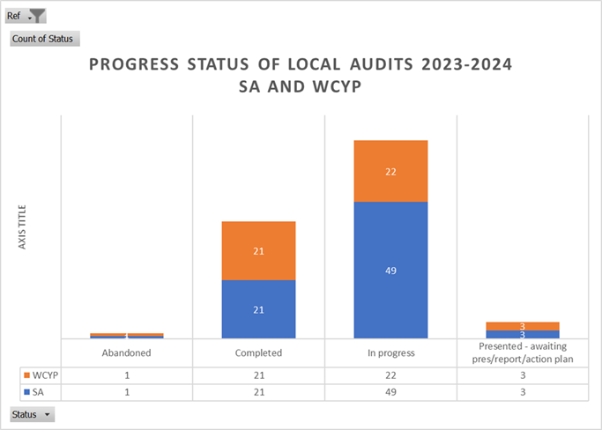

#### Medicine and Emergency Care (EC) and Cancer and Core Clinical Services (CCCS) Divisions

There is currently a combined total of 123 registered Local Audits in the Cancer and Core Clinical Services (CCCS) and Medicine and Emergency Care (MEC) Divisions. Out of these, 43 projects have been completed, with 12 in CCCS and 31 in MEC.

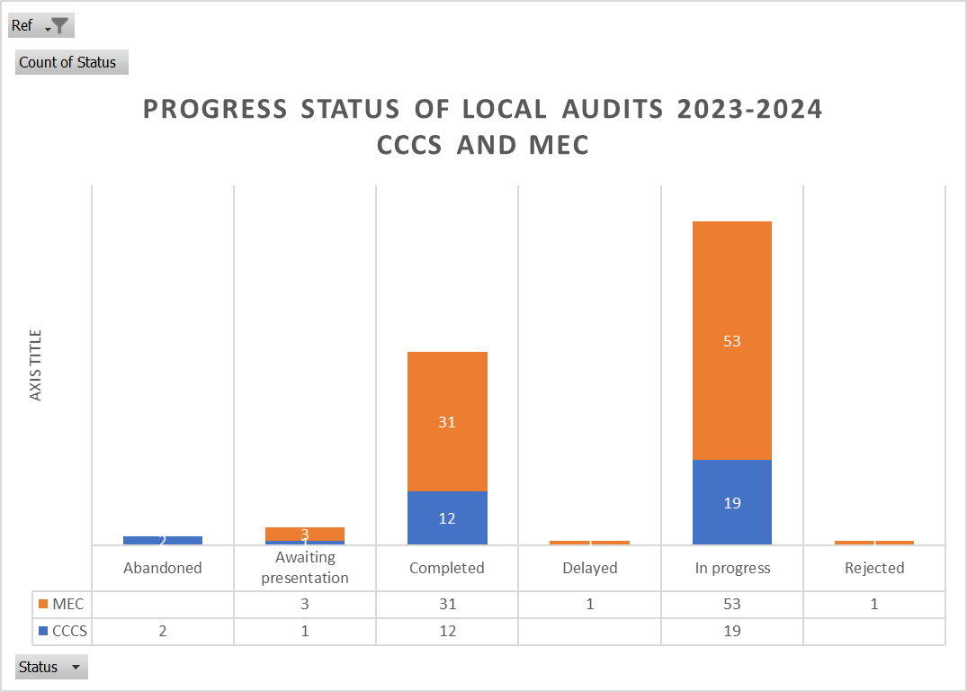At present, 72 projects are in various stages of completion, with a significant majority of 53 in the MEC and 19 in the CCCS, with one delay in MEC.  Additionally, 4 projects are still awaiting presentations with 2 projects abandoned.

### Patient Led Assessment in the Care Environment (PLACE)

The Trust undertook its annual PLACE assessment on 4th and 5th October 2023. Elements of the PLACE criteria include cleanliness, condition and appearance, dementia, disability and access, privacy, dignity & wellbeing and food.

The 2023 PLACE assessment results show a significant improvement in all criteria compared with the PLACE assessments carried out in 2022.

Areas of improvement are:

Cleanliness + 2.78%,

Combined Food + 4.13%,

Privacy, Dignity and Wellbeing + 21.84%

Condition Appearance and Maintenance + 10.6%

Dementia + 18.94%

Disability + 15.48%

Results compared to other trusts.

| Medway Foundation Trust compared Locally | |  |  |  |
| --- | --- | --- | --- | --- |
| Domain | Medway 2023 | East Kent 2023 | Dartford  2023 | Maidstone Tonbridge Wells 2023 |
| Cleanliness | 95.71 | 98.91 | 95.9 | 99.54 |
| Combined Food | 90.37 | 91.10 | 92.02 | 92.11 |
| Organisational Food | 86.81 | 94.29 | 93.62 | 91.67 |
| Ward Food | 91.27 | 89.93 | 91.57 | 92.30 |
| Privacy, Dignity and Well being | 90.84 | 83.26 | 90.09 | 94.72 |
| Condition Appearance & Maintenance | 94.84 | 97.67 | 92.97 | 98.41 |
| Dementia | 82.73 | 79.04 | 81.86 | 88.85 |
| Disability | 84.56 | 81.22 | 87.79 | 87.89 |

Results compared from 2022.

| **Domain** | **2022%** | **2023%** | **Difference %** |
| --- | --- | --- | --- |
| Cleanliness | 92.93 | 95.71 | +2.78 |
| Combined Food | 86.24 | 90.37 | +4.13 |
| Organisational Food | 80.05 | 86.81 | +6.76 |
| Ward Food | 87.25 | 91.27 | +4.02 |
| Privacy, Dignity and Well being | 69 | 90.84 | +21.84 |
| Condition Appearance & Maintenance | 84.24 | 94.84 | +10.60 |
| Dementia | 63.79 | 82.73 | +18.94 |
| Disability | 69.08 | 84.56 | +15.48 |

Following the results of the 2023 PLACE audit a comprehensive review of outstanding actions from the 2019 and 2022 audits have now been undertaken for Estates, Facilities & Nursing areas and progress against these actions will be monitored by a PLACE Lite Actions Group.

### Participation in Clinical Research

The Trust has committed to undertaking research as a driver for improving the quality of care and patient experience and is actively involved in research supported by the National Institute for Health and Care Research (NIHR). Furthermore, our Research and Innovation (R&I) strategy is heavily linked to specialty priorities agreed by the Department of Health (DoH) and NIHR. During 2023/24 the capacity of clinical services to support research delivery has remained challenged due to national workforce and workload issues as services continue to recover from the various challenges the past year has shown. This however has not discouraged services engaging in research activity and has led to a year end position of 5,462 participants recruited, exceeding our recruitment target of 3,278.

The comparative data below shows the National Institute for Health and Care Research (NIHR) requirement target and the actual recruitment figures for Medway NHS Foundation Trust and shows that the Trust continues to exceed its recruitment targets.

Chart1. the annual recruitment target and the actual number of patients recruited into the NIHR adopted studies between 1 April 2013 and 31 March 2023.

In 2023/24 Medway Foundation Trust was the highest performing organisation in terms of participant recruitment to clinical trials in the Kent, Surrey and Sussex region.

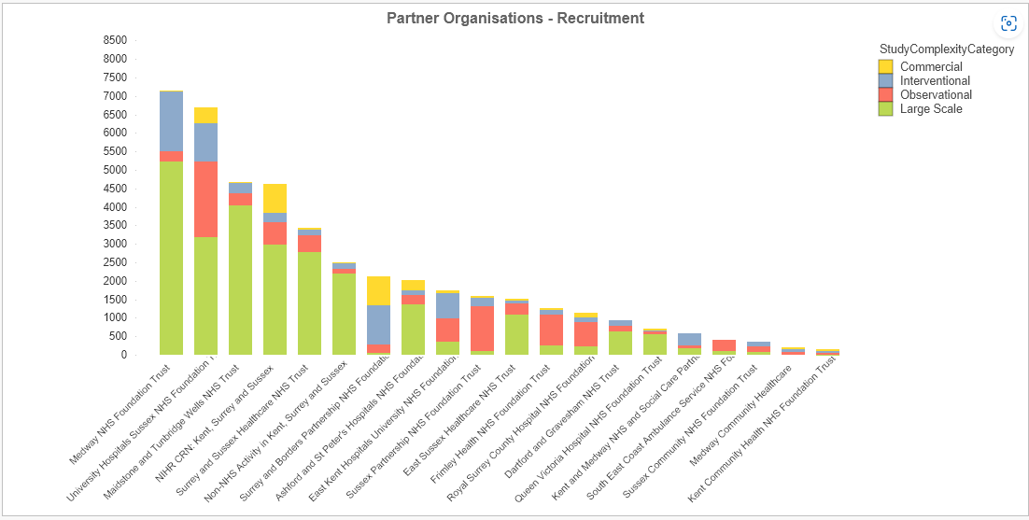

Chart.2. Medway NHS Foundation Trust performance compared to other Trust across Kent Surrey and Sussex Local Clinical Research Network

Trust staff are able to keep abreast of the latest treatment possibilities through active participation in many different types of research, which has led to successful patient outcomes.

For the period 2023/24, there were a total of 125 research studies conducted at the Trust, including staff undertaking MSc final year dissertations. For the same period, the Trust took part in 104 NIHR supported studies, including thirty-six cancer specialty studies.

Chart.3. the number of studies that Medway NHS Foundation Trust participated in between 1 April 2013 and 31 March 2024.

Conducting research requires commitment from staff and this commitment is evidenced by the number of clinical staff participating in research across various fields. There were approximately 182 clinical staff participating in research approved by the Health Research Authority at the Trust between 1 April 2020 and 31 March 2024 resulting in over 71 publications in peer reviewed journals.

Staff participating in research cover 18 disease specialties, including studies looking into urgent Public Health research.

Chart 4 Number of Studies Conducted Per Disease Speciality at Medway NHS Foundation Trust during 01 April 2020-31 March 2024**.**

**\*Studies outside of clinical speciality for example educational studies or research into overall patient experience.**

Since the slowdown of the COVID-19 pandemic which itself brought new challenges, there has been a keen interest shown by staff to participate in the majority of leading global trials. Being able to offer up-to-date, novel treatments to the patient is at the forefront of the Trust agenda.

With the ambition of becoming a ‘University Trust’, Medway has established a portfolio of its own research (so-called ‘home grown’) in collaboration with local universities. In the last three years we have registered 21 ongoing ‘home grown’ studies.

Chart 5. Number of Home grown since 2021.

The following are examples of research undertaken in 2023/24 which have resulted in a change for the population locally and nationally.

#### The ELSA Study:

The ELSA study screens children aged 3-13 for Type 1 Diabetes (T1D) risk. Participants are recruited from the general population via various community channels. The initial test is a finger stick dried blood spot (DBS) checking for islet antibodies (IAA, IA2, GAD, ZnT8). Those positive undergo confirmatory venous blood testing. Negative results prompt text/email notification, ending follow-up. Single/double antibody positives receive phone/email notification, with double positives invited for oral glucose tolerance testing. All positive children attend an education session about T1D risk and potential research participation. Stage 3 individuals start insulin therapy and receive research study information.

#### CEREBRAL:

The CEREBRAL study, a retrospective case-control analysis, compared patients aged 60 and over with and without traumatic intracranial haemorrhage (tICH). Conducted by the South East Coast Ambulance Service (SECAMB), it assessed ambulance staff's ability to identify high-risk tICH cases at the scene of a head injury. Out of 2111 patients taken to multiple Emergency Departments, only 76% underwent head CT scans, revealing tICH in 10% (162 patients). Findings suggest the need to reconsider current guidelines for hospitalization of older adults following head injuries, particularly those without apparent symptoms of tICH. Further research is warranted to determine appropriate triage protocols for this age group

#### HER2-RADiCAL Study:

The aim of the study is to reduce the burden of treatment and the risk of serious long-term side effects for some patients with the HER2-positive type of early breast cancer. HER2-RADiCAL is trying to find out if they can adjust the amount of drug treatment given to patients after surgery according to the way the cancer initially responds to the drug treatment before surgery.

#### BOPPP Trial (Beta-blocks or placebo for primary prophylaxis):

Cirrhosis is a significant healthcare issue in the UK, affecting 60,000 individuals annually and causing approximately 11,000 deaths due to complications like bleeding from varices in the oesophagus or stomach. While beta-blockers are known to treat large varices, their efficacy for small varices remains uncertain. This study aims to determine if beta-blockers can reduce the risk of bleeding from small varices by half over three years, potentially saving NHS costs. Approximately 25 centres will enrol patients with small varices, randomly assigning them beta-blockers or placebos and monitoring them biannually for three years for complications and medication side effects. General practitioners will assist in monitoring and adjusting doses. The study will also evaluate treatment impact on mortality and quality of life using Quality Adjusted Life-Years (QALY) and a mathematical model to estimate long-term outcomes and cost-effectiveness.

No single hospital site can bring all the expertise to develop and validate medical innovations. The Trust collaborates with health, academic, scientific and industry organisations; these partnerships and collaborations help us deliver high quality clinical trials, and develop practice-changing research.

### Commissioning for Quality and Innovation (CQUIN)

NHS England identified a number of clinical quality priorities where improvement is expected across 2023/24 covering a range of different specialities. Medway NHS Foundation Trust committed to achieving eight of the scheme’s targets for improvement in the quality of its services and the results outlined below show that we exceeded the minimum target in seven out of the eight priority areas:

The table below details the 2023/24 CQUIN scheme.

| **CQUIN Description** | **Minimum CQUIN Target** | **Maximum CQUIN Target** | **Qrt 1**  **% CQUIN Compliance** | **Qrt 2**  **% CQUIN Compliance** | **Qrt 3**  **% CQUIN Compliance** | **Qrt 4**  **% CQUIN Compliance** | **Status at end of Qtr 4** |
| --- | --- | --- | --- | --- | --- | --- | --- |
| **CQUIN01** Flu vaccinations for frontline healthcare workers | 75% | 80% | - | - | 39.5% | 39.9% |  |
| **CQUIN02** Supporting Patients to drink, eat and mobilise after surgery | 70% | 80% | 83% | 92% | 82% | 87% |  |
| **CQUIN03** Prompt switching of intravenous (IV) antimicrobial treatment to the oral route of administration as soon as patients meet switch criteria | 60% | 40% | 44% | 36.94% | 27% | 38.46% |  |
| **CQUIN05** Identification and response to frailty in emergency departments | 10% | 30% | 64% | 59% | 43.24% | 64% |  |
| **CQUIN06** Timely communication of changes to medicines to community pharmacists via the Discharge Medicines Service | 0.5% | 1.5% | 3.39% | 3.29% | 2.37% | 2.83 % |  |
| **CQUIN07** Recording of and appropriate response to NEWS2 score for unplanned critical care admissions | 10% | 30% | 83% | 77% | 78% | 83% |  |
| **CQUIN11** Achieving high quality Shared Decision Making (SDM) conversations in specific specialised pathways to support recovery Qtr 2/Qtr4 | 65% | 75% | - | 95% | - | 92% |  |
| **CQUIN12** Assessment and documentation of Pressure Ulcer risk | 70% | 85% | 58% | 71% | 73% | 80% |  |

Where the Trust was not able to meet the CQUIN target in 2023/24 a review was undertaken and areas of improvement identified which have been introduced for 2024/25.

**CQUIN01 Flu vaccinations for frontline healthcare workers**

The NHS routinely combats seasonal influenza, with vaccinations being the primary defence. It is advised that NHS employers vaccinate all frontline health and social care workers to prevent transmission and protect staff, their families, patients, and inpatients.

Starting in 2024/25, Medway’s Occupational Health service aims to oversee the flu vaccination campaign, focusing on maximising staff vaccination uptake. While inpatient vaccination is beneficial, increasing staff vaccination rates is crucial to reduce flu infections among patients and staff, thereby promoting public health.

**2023/24 Staff Seasonal Flu Campaign Evaluation:**

Post-pandemic, there has been a significant drop in NHS staff receiving flu vaccinations. Our Trust’s uptake was approximately 50% in 2023/24, based on pharmacy records. This figure may not account for staff vaccinated elsewhere, but it is the most accurate estimate available. Medway FT recognises that it is vital to increase vaccination rates to safeguard our staff and patients.

**2024/2025 Staff Seasonal Flu Campaign Plans:**

A well-coordinated vaccination program is essential for timely delivery, ensuring protection before the flu season peaks.

Planning for the flu immunisation programme is ongoing, with additional guidance on COVID-19 booster shots and potential co-administration with the flu vaccine forthcoming.

An action plan will be released in July 2024, and a dedicated Flu group will be established to foster inter-departmental collaboration. We will follow the JCVI’s advice for the 2024/25 National flu immunisation programme, ensuring early vaccine availability and the setup of satellite clinics for frontline staff convenience. Peer vaccinators will be utilised to provide vaccines on demand.

The forthcoming flu plan will detail recommended vaccines, their composition, and suitability for various groups, supplier details, delivery schedules, and vaccination locations. Information on access, delivery, and potential staff incentives will also be provided.

**CQUIN02 Supporting Patients to drink, eat and mobilise after surgery**

The Trust have consistently met all elements of CQUIN02. Element 3 of the CQUIN had lower scores, however this was often due to patients being too unwell to mobilise on day 1 post operatively, declining to sit out or requiring assistance of more than one member of staff.

Areas for improvement: teams to ensure reasons patients weren't mobilised, or did not eat or drink post operatively are clearly documented.

**CQUIN03 Prompt switching of intravenous (IV) antimicrobial treatment to the oral route of administration as soon as patients meet switch criteria**

Comparison with other Trusts where the prompt switching of IV to oral has been effective his identified the importance of engagement from more members of pharmacy, nursing and clinical teams in the promoting, raising awareness and sustaining the prompt switching of IV to oral switch rather than just the responsibility of the antimicrobial stewardship team.

The other challenge faced was access to doctors looking after surgical patients, which was difficult and as a result we weren’t always able to review patients with surgical doctors to encourage this prompt switching. The surgical care group consumes a significant quantity of IV antibiotics and patients could have been switched earlier.

In completing the CQUIN we also discovered that the doctors did not always take the responsibility for the prompt switching and our presence on the ward was not always seen as a positive one to some of the junior doctors. To improve on this if one or more of the junior doctors were involved in the audit, this will raise more awareness of the importance of prompt switching of IV antibiotics and feedback will be accepted more by their peers and could improve our consumption of IV antibiotics.

Nursing staff engagement will also help improve the prompt switching of IV to oral antibiotics.

The EPMA system is not set up at the moment to support prescribers in reviewing their patients after 48 hours to encourage the prompt switching of IV to oral antibiotics, which could have contributed positively to the prompt switching of IV to oral antibiotics.

**CQUIN05 Identification and response to frailty in emergency departments**

The Trust have consistently met all elements of CQUIN05. There were some areas of improvement identified which included more accurate completion of clinical frailty scores (CFS) so as to get a better outcome and frailty nurses ensuring CFS is done for all patients that come under the service.

The challenges faced were if staffing for frailty nurses is low and the demand is high, some patients CFS may not be done by the nurses and so they get missed. Some patients are admitted overnight but get transferred to ward before the frailty nurses review them in the morning. Hence why we are encouraging the doctors to also fill this data in for all patients seen.

**CQUIN06 Timely communication of changes to medicines to community pharmacists via the Discharge Medicines Service**

Medway NHS FT was an early implementer of the TCAM initiative (Transfer of Care Around Medicines), designing an electronic solution allowing the direct transfer of discharge information to a nominated community Pharmacy of the patient’s choice by creating a direct messaging link from the existing Teleologic Electronic Discharge Notification (eDN) system through PharmOutcomes to community Pharmacy. A process to utilise the system was designed, documented and trained out.

The introduction of the Alcura Electronic Prescribing and Administration system included the transfer of the TCAM functionality.

Internally the Pharmacy team promotes the application of sharing discharge information with community pharmacy and works with the Local Pharmaceutical committee (LPC) team to stimulate uptake amongst community pharmacy members to ensure that relevant information can be used to support the national Discharge Management Service (DMS) and enable post discharge medication review in community pharmacy.

Metrics are collected monthly in Pharmacy to track referral rates, and collated nationally from PharmOutcomes returns, which is then used to report the CQUIN.

The national target is set between 0.5-1.5%. MFT regularly delivers greater than 2.5% and is the highest performing Trust in Kent & Medway.

**CQUIN07 Recording of and response to NEWS2 score for unplanned critical care**

**admissions**

CQUIN07 has been successfully completed over the last year; this was the second successive year. The main focus of the CQUIN was looking at time of deterioration, time of escalation following a deterioration, and time of response following an escalation.

There have been themes relating to lack of clear documentation and documenting in real time, which have identified gaps in care plans and communication surrounding the deteriorating patient.

Whilst the trust is currently working on these themes using a patient first approach, the data and themes that have emerged have helped to provide supportive data to develop counter measures for our deteriorating patients. Such measures include a connected clinical observation workflow project, auditing referrals and responses to critical care and better flow of communication between the emergency department and critical care to expedite the process of referral for our sickest patients.

This CQUIN has fed into the Trust’s breakthrough objective of reducing the number of avoidable 2222 calls across the trust with the trust starting to see a sustained reduction.

**CQUIN11 Achieving high quality Shared Decision Making (SDM) conversations in specific specialised pathways to support recovery Qtr 2/Qtr4**

SDM Q9 data was collected for patients who attended a SDM clinic within Cancer Services. There have been 20 patients who were deemed as high-risk patients who have an extended discussion about whether to proceed with surgery or not.

In addition, we collected SDM Q9 data from around 40-50 patients who attended CPET (Cardiopulmonary Exercise Test) and prehab.

**CQUIN12 Assessment and documentation of Pressure Ulcer risk**

CQUIN 12 looked at whether the pressure ulcer risk assessment was completed within six hours of admission and if appropriate reviewed after 30 days and if there was an appropriate care plan in place.

The trust achieved 58% of patients having all the criteria in place in Q1. By Q4 the Trust had achieved 80% of completed risk assessments.

### Care Quality Commission

The CQC conducted a site assessment of our Urgent and Emergency Care at Medway Maritime Hospital on 21 February 2024. The CQC team spoke with staff, patients and other health representatives such as ambulance staff, reviewed patient documents and observed the environment, equipment and patient flow. As part of this assessment process, they also carried out an assessment of feedback they had received from service users. The Trust are awaiting the full investigation report at the time of publication.

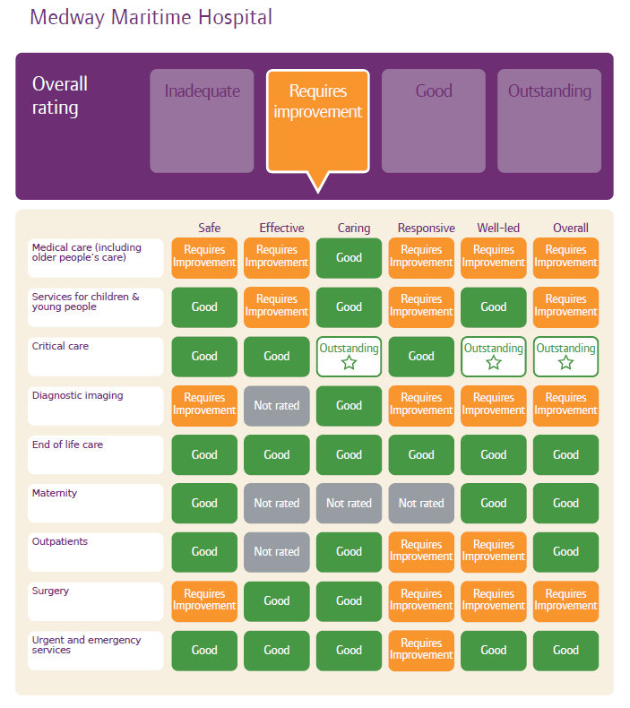The table below shows the CQC current ratings table for MFT however does not reflect ratings from the Maternity inspection that took place in November 2016 where they achieved ‘Good’ for Effective, ‘Outstanding’ for Caring and ‘Good’ for Responsive giving them the overall rating as ‘Good’. Diagnostic Imaging and Outpatients were not rated previously under the Effectiveness domain.

The trust aims to achieve a Good rating across all services and in all domains by:

* Strengthening its internal assurance by relaunching a programme of Internal Assurance Visits focused on identifying and improving all areas assessed as requiring improvement. The approach is based on the continuous improvement principle of standardisation, recognising, sharing and consistently applying best practice in the interests of patient care.
* Improving access to data by further rolling out the data collection system ‘‘Gthr’ which will enable staff to access real time data on the Trust’s performance against important indicators thus supporting the trust’s mission to provide excellent care every time.
* Transforming the way we deliver joined up patient care by continuing to introduce Electronic Patient Records (EPR) throughout the hospital as we move to a fully digitised organisation.
* Embedding the findings from external governance reviews to strengthen the Trust’s assurance and accountability framework.

### Internal Quality Assurance Programme

In 2023/24 the Trust approved a programme of Internal Assurance Visits (IAVs) as part of a rolling internal quality assurance programme to assess the core services as defined by the Care Quality Commission (CQC) and set the foundations for developing a ward accreditation scheme.

The purpose of the quality assurance visits is to assure that all fundamental standards are being complied with. These visits also improve local service provision, understanding and offer opportunities to discuss service developments. On visiting a ward or department for an internal assurance visit the panel are looking for the following Key Lines of Enquiry (KLoE):

|  |  |  |
| --- | --- | --- |
| SAFE | Incidents  Safeguarding  Patient Risk  Staffing levels (Nursing)  Staffing levels (Medical)  Operational leadership  Staff training and Supervision | Falls  Medication  Records  Infection control  Environment and equipment |
| EFFECTIVE | Evidence based care and treatment and patient outcomes  Mental Health  Nutrition | Pain relief  MDT working – flow and discharge  Seven-day services – Patient First |
| CARING | Compassionate care | Consent, mental capacity act and DOLs |
| RESPONSIVE | Service delivery to meet | Learning from complaints and concerns |

The internal assurance visits have received positive feedback from staff as a mechanism through which change and improvement can be expedited. The trust uses the intelligence it gathers to shine a light on areas of excellence and also areas that require additional support and resource.

### Reporting to Secondary Users Service (SUS)

The Secondary Uses Service is designed to provide anonymous patient-based data for purposes other than direct clinical care such as healthcare planning, commissioning, public health, clinical audit and governance, benchmarking, performance improvement, medical research and national policy development.

The Trust submitted records during 2023/24 to the Secondary Uses Service for inclusion in the Hospital Episode Statistics and these have been included in the latest published data.

The percentage of records in the published data, which included the patient’s valid NHS number, was:

* 100% for admitted patient care
* 100% for outpatient care
* 100% for accident and emergency care

The percentage of records in the published data, which included the patient’s valid General Medical Practice code, was:

* 99% for admitted patient care
* 99% for outpatient care
* 99% for accident and emergency care

### Information Governance

The Data Security and Protection Toolkit (DSPT) is an online self-assessment tool that allows organisations to measure their performance against the National Data Guardian’s 10 data security standards.

All organisations that have access to NHS patient data and systems must use this toolkit to provide assurance that they are practising good data security and that personal information is handled correctly.

In 2022/23, the Trust obtained ‘Approaching Standards’.

In this year’s submission, 2023-24, the Trust is aiming for ‘Standards Met’ by achieving all 108 mandatory evidence items. This will assure partner organisations (for example, in research projects) of our compliance with data security.

There are 45 auditable items within the mandatory items. An independent external audit were carried out between 25th March 2024 and 12th April 2024, with a final report submitted to the Audit & Risk Committee in May 2024.

The deadline for final submission, after SIRO review, is 30th June 2024.

### Clinical Coding

The Trust undertakes an annual clinical coding data quality audit to determine how accurately our coded clinical data reflects documented diagnoses and procedures in the patient’s record.

|  | 2023/24 | Previous year (2022/23) |
| --- | --- | --- |
| Primary diagnosis | 90.00% | 90.24% |
| Secondary diagnosis | 84.25% | 81.34% |
| Primary procedure | 90.12% | 90.77% |
| Secondary procedure | 93.37% | 93.75% |

* The figures for **primary diagnosis** meet the standard 90% attainment level outlined in Data Security and Protection Toolkit Standard One Data Quality.
* The figures for **secondary diagnoses** meet the standard 80% attainment level outlined in Data Security and Protection Toolkit Standard One Data Quality.
* The figures for **primary procedure** meets the standard 90% attainment level outlined in Data Security and Protection Toolkit Standard One Data Quality.
* The figures for **secondary procedures** exceeds the 80% attainment level and meets the upper 90% attainment level outlined in Data Security and Protection Toolkit Standard One Data Quality.

In 2023/24, the results show that Clinical Coding met three and exceeded one of the four attainment level metrics.

### Data Quality

High quality information leads to improved decision making, which in turn results in better patient care, wellbeing and safety. We continued to focus on improving the quality of our performance data, and the Trust is taking the following actions to improve data quality:

* Ensuring automated data flows become essential
* Investigating the implementation of two-way PTS (Patient Tracking Solution) within our PAS/EPR System
* Raising awareness of poor data quality and focusing attention on areas which need support, with embedded Data Quality Champions in each area
* Continuation and improvement of a Data Quality Steering Group with key lines of investigation and escalation.

### Learning from Deaths

The Trust is committed to learning and this includes learning from when patients die within our care or shortly after receiving hospital treatment. As a result, the trust has established a Structured Judgement Review (SJR) panel that is a multidisciplinary, multi-professional panel consisting of patient safety leads from medicine, nursing, governance, end of life care, and resuscitation. The panel averages four SJRs each week and together, review the care the patient received during their last admission, judging each phase of care and whether the patient achieved excellent, good, adequate or poor care.

The cases presented for SJR review are primarily highlighted by the Medical Examiner who scrutinises every patient death, although referrals for a SJR can be received from any clinical team or staff with concerns around the care of a patient. There is also a random selection of cases reviewed for quality assurance purposes and any cases that have been highlighted from specialty mortality and morbidity meetings.

**Deaths which occurred in 2023/24**

During 2023/24, 1533 Medway NHS Foundation Trust adult patients died; this comprised the following number of deaths, which occurred in each quarter of stated reporting period. This compares with 1,605 adult deaths reported in 2022/23.

|  |  |  |  |  |  |
| --- | --- | --- | --- | --- | --- |
|  | Qrt.1 | Qrt.2 | Qrt.3 | Qrt4. | Total 2023/24 |
| Total number of deaths (adult) | 355 | 318 | 404 | 456 | 1533 |

Between April 2023 and March 2024, 134 structured judgement reviews were completed. 16.4% of cases were rated to have received good or excellent care for overall assessment with positive learning identified; Good communication with next of kin regarding end of life care, fast transfer from Emergency Department to Critical Care, well documented decisions with specialist teams, DNAR and Treatment Escalation Plans appropriately completed and prompt decisions regarding end of life care.

|  |  |  |  |  |  |
| --- | --- | --- | --- | --- | --- |
|  | Qrt.1 | Qrt.2 | Qrt.3 | Qrt4. | Total 2023/24 |
| Number of structured judgement reviews carried out | 33 | 32 | 33 | 36 | 134 |

94 cases were identified for further review to identify any additional learning or problems in care.

The number of deaths in each quarter for which a structured judgement review required a further review was:

|  |  |  |  |  |  |
| --- | --- | --- | --- | --- | --- |
|  | Qrt.1 | Qrt.2 | Qrt.3 | Qrt4. | Total 2032/24 |
| Number of further reviews undertaken | 16 | 27 | 25 | 26 | 94 |

The Hogan score of preventability is used to determine if a death was potentially avoidable. Reviewers are asked to judge the review as either:

* Definitely not avoidable
* Possibly preventable (less than 50%)
* Possibly preventable (greater than 50%)
* Slight evidence of preventability
* Strong evidence of preventability

Since April 2023, three deaths were identified as being possibly preventable and three deaths were graded as slight or strong evidence of preventability, representing 0.4 per cent of the patient deaths during the reporting period.

|  |  |  |  |  |  |
| --- | --- | --- | --- | --- | --- |
|  | Qrt.1 | Qrt.2 | Qrt.3 | Qrt4. | Total 2023/24 |
| Number of deaths judged as potentially avoidable | 1 | 1 | 0 | 4 | 6 |
| Percentage of all deaths | 0.3 | 0.3 | 0 | 1.1 | 0.4 |

Of the six cases judged as possibly preventable, two of these are being investigated as Serious Incidents (SIs), two cases were locally reviewed by the teams and closed and one case underwent a rapid review and was closed. One case is currently undergoing PSIRF local investigation and a standard local review.

The Trust has identified areas of learning from structured judgement reviews and has taken actions to address these gaps.

**Key learning and action points are:**

* Medication errors whereby patients with penicillin allergy or allergy status unknown were administered penicillin now forms part of a workstream in the Medication Safety Strategy. Risks around Electronic Prescribing and Medication Administration (EPMA) and incorrectly recording allergy status were highlighted and resolved with actions taken for incorrect selection of penicillamine instead of penicillin on allergy status on EPMA.
* Failure to escalate increasing NEWS scores and failure to document NEWS scores accurately was noted as a theme during SJR reviews and is recognised as part of Trust’s Patient First Breakthrough Objective of improved recognition of a deteriorating patient, reducing the number of avoidable cardiac arrest calls and for Medway to be in the top 25% for low mortality rates during the week and at the weekend. Mandatory NEWS training and ensuring appropriate escalation of elevating scores are amongst some of the actions underway to improve this. The Trust is business case planning and looking at investing in a connected clinical observation work flow that would ensure that observations are documented and recorded in real time, allowing clinicians to have live updates surrounding NEWS and observations. This connects with the work that is underway in developing a deteriorating patient dashboard, that connects with our Electronic patient record and gives our leaders and service users information relating to the compliance and completion of NEWS allowing focus responses to areas who may be failing to reach the required trust standards.
* Clear guidance around completion of DNACPR forms and the importance of relevant conversations around revoking DNACPR forms were relayed back to the teams along with awareness around consent forms and the importance of completion of Treatment Escalation Plans (TEP) forms.
* Key themes identified from cases which were highlighted as having problems in care included; problems with communication with families and carers, problems with documentation, problems with communication between clinical teams, delays in referral to palliative and end of life care and issues with bed capacity. These cases were flagged for further review and fed back to the relevant specialty lead to discuss cases at their speciality Mortality and Morbidity (M&M) meetings.
* There is no national standard or requirement to complete a certain amount of reviews; the Trust aim for 10% which is a sufficient amount whilst we ensure the quality of SJRs isn’t compromised.

A recent review of the Structured Judgement Review process has identified a need to make the process more robust and focus on the learning of reviews to drive improvements in care. As a result, the Trust are currently reviewing the SJR process with additional training to be provided to a wider pool of reviewers which will include Nurses and Allied Health Professionals. A wider selection of cases will be referred for SJR from multiple teams within the Trust where potentially learning has been identified. A stage two process will be introduced to review cases of poor or very poor care with a focus on themes identified from reviews and to monitor actions to drive improvement.

### Health and Safety Executive Incidents

There were no health and safety incidents investigated by the Health and Safety Executive during 2023/24.

**RIDDOR reportable incidents**

There were 32 notifiable incidents under the Reporting of Injuries, Diseases and Dangerous Occurrences Regulations (RIDDOR) in 2023/24, up from 22 in 2022/23. There were two notifiable incidents relating to the public.

A reportable incident is one that is work related and results in a death, a specific type of injury or results in a staff member being incapacitated for over seven consecutive days. The Trust must also report certain specified injuries to members of the public on Trust grounds.

The RIDDOR incidents by type reported in 2023/24 were:

|  |  |  |
| --- | --- | --- |
| Type of RIDDOR incident | 2022 | 2023 |
| Slips, trips and falls | 6 | 3 |
| Physical Assault | 5 | 7 |
| Moving and handling | 3 | 12 |
| Struck by | 3 | 3 |
| Sharps | 0 | 2 |
| Exposure to hazardous substances | 1 | 2 |
| Other | 2 | 3 |
| Total | 22 | 32 |

**Key Health and Safety Trends /Themes**

A significant increase on notified incidents is visible this year with overall notifications increasing to 512 for the year, as opposed to 245 last year. This is largely due to the reconfiguration of the Datix form by the Patient Safety Team and a daily cleanse being undertaken by the Safety Team to identify incorrectly categorised incidents

**Violence and Aggression**

Violence and aggression continues to be an issue, particularly within our Medicine and Emergency Care division which has seen an increase since last year, with 247 physical assault incidents notified this year, compared to 150 incidents notified last year, an increase of 65%, with seven incidents meeting RIDDOR criteria this year as opposed to five meeting RIDDOR criteria last year.

Learning point: The Trust is providing prevention and management of violence and aggression (PMVA) training to staff. The Security, Violence and Aggression Group monitors all violence and aggression incidents at the Trust and has pushed for the reporting of incidents by departments onto Datix. A Yellow and Red card system is implemented for repeat offenders with 90 yellow cards being issued to service users between April 2023 and February 2024. Body worn cameras have been trialled since November 2023 and user survey data is currently being compiled by the Security, Violence and Aggression Group.

**Moving and Handling**

Moving and handling injuries are a high-risk area within health care.

Moving and handling continues to be an issue with an increase since last year, with 37 incidents notified this year, compared to 19 incidents last year, an increase of 95%, with 12 incidents meeting RIDDOR criteria this year compared with three meeting RIDDOR criteria last year, which were reportable as over seven -day injuries.

Learning point: The Trust continues to work to reduce moving and handling incidents, ensuring that risk assessments are suitable and sufficient, and that training is tailored to staff groups. The daily cleanse undertaken by the Safety Team is also identifying incidents that otherwise would not have been identified. Analysis is currently being undertaken to better understand the processes involved in over seven -day reporting by the Trust.

**Staff Slips, Trips and Falls**

Slips trips and falls (staff) notifications have seen an increase since last year, with 37 incidents notified this year, compared to 36 incidents last year, an increase of 3%, with three incidents meeting RIDDOR criteria this year as opposed to six meeting RIDDOR criteria last year.

Learning point: Key areas to focus on in the working environment are: good housekeeping to ensure trip hazards are removed from corridors and work areas, damage to flooring is reported, and repairs implemented quickly, chair castor selection to ensure they are correct for the type of flooring they are used on.

**Sharps Injuries**

A new significant entry that requires mention this year are sharps injury notifications, with 105 incidents notified this year, with two incidents meeting RIDDOR criteria this year.

Learning point: A Sharps Group reporting into the Health Safety and Security Group has been established with the inaugural meeting held in March 2024. The Sharps Group will be reviewing and reporting on the management of sharps to drive improvement going forwards.

## 2.5 Reporting Against Core Indicators

### Summary Hospital Level Mortality Indicator (SHMI)

The Summary Hospital-level Mortality Indicator (SHMI) is the ratio between the actual number of patients who die following hospitalisation at the Trust and the number that would be expected to die on the basis of average England figures, given the characteristics of the patients treated there. It covers all deaths reported of patients who were admitted to non-specialist acute trusts in England and either die while in hospital or within 30 days of discharge.

The expected number of deaths is calculated from statistical models derived to estimate the risk of mortality based on the characteristics of the patients (including the condition the patient is in hospital for, other underlying conditions the patient suffers from, age, gender and method of admission to hospital).

The SHMI has been ‘higher than expected’ banding for the majority of 2022/2023. The 10 diagnosis groups included in the SHMI are the diagnosis groups most indicative of Trust performance. The nature of these groups is such that they are often higher risk with higher patient activity. The Trust is within the ‘as expected’ band for nine of the 10 diagnosis groups but remains ‘higher than expected’ for the Acute Bronchitis diagnosis group.

|  |  |  |  |  |  |  |
| --- | --- | --- | --- | --- | --- | --- |
| Reporting Period | SHMI | Observed | Expected | Banding | Observed deaths (in hospital) % | Observed deaths (out of hospital) % |
| Apr 2022 – Mar 2023 | 1.14 | 1704 | 1496.26 | Higher than Expected | 71.9% | 28.1% |
| May 2022 – Apr 2023 | 1.14 | 1716 | 1499.83 | Higher than Expected | 72.5% | 27.5% |
| Jun 2022– May 2023 | 1.15 | 1724 | 1503.29 | Higher than Expected | 71.9% | 28.1% |
| Jul 2022 – Jun 2023 | 1.14 | 1706 | 1498.34 | Higher than Expected | 71.8% | 28.2% |
| Aug 2022 – Jul 2023 | 1.12 | 1677 | 1491.49 | As Expected | 71.5% | 28.5% |
| Sept 2022 – Aug 2023 | 1.13 | 1685 | 1486.49 | Higher than Expected | 71.5% | 28.5% |
| Oct 2022 – Sept 2023 | 1.16 | 1688 | 1458.50 | Higher than Expected | 72.2% | 27.8% |
| Nov 2022 – Oct 2023 | 1.15 | 1691 | 1475.00 | Higher than Expected | 72.2% | 27.8% |

*© NHS Digital.  All rights are reserved. No further copying, reproduction or publication of this information is permitted without consent from NHS Digital.*

### Hospital Standardised Mortality Ration (HSMR)

The Hospital Standardised Mortality Ratio (HSMR) is a calculation used to monitor death rates in a Trust. The indicator is produced and published monthly, three months in arrears. The data is published nationally by Dr Foster, Telstra Health UK. It is the ratio of the observed number of in hospital deaths to the expected number of in hospital deaths (multiplied by 100) for 56 diagnosis groups (which give rise to 80% of in hospital deaths). The national benchmark for the HSMR is 100 – meaning that the number of expected deaths and the number of observed deaths are exactly the same.

|  |  |  |  |  |
| --- | --- | --- | --- | --- |
| Reporting Period | HSMR | Crude rate % | Expected rate % | Banding |
| *Apr 2022 – Mar 2023* | 115.8 | 4.3% | 3.7% | Higher than Expected |
| *May 2022 – Apr 2023* | 116.2 | 4.3% | 3.7% | Higher than Expected |
| *Jun 2022 – May 2023* | 114.2 | 4.3% | 3.8% | Higher than Expected |
| *Jul 2022 – Jun 2023* | 113.4 | 4.3% | 3.8% | Higher than Expected |
| *Aug 2022 – Jul 2023* | 111.2 | 4.2% | 3.7% | Higher than Expected |
| *Sep 2022 – Aug 2023* | 111.0 | 4.2% | 3.7% | Higher than Expected |
| *Oct 2022 – Sep 2023* | 111.8 | 4.2% | 3.8% | Higher than Expected |
| *Nov 2022 – Oct 2023* | 111.9 | 4.2% | 3.8% | Higher than Expected |
| *Dec 2022- Nov 2023* | 108.0 | 4.1% | 3.8% | Higher than Expected |

*© Dr Foster.  All rights are reserved. No further copying, reproduction or publication of this information is permitted without consent from Dr Foster.*

The Trust’s HSMR for December 2022 to November 2023 was 108.0 and ‘higher than expected’. Improvements have been since in the Trust’s HSMR over the past year with the most recent value being the lowest HSMR value in the rolling 12-month trend.

The Trust has taken a proactive approach to monitoring outliers and focusing deep dives to understand the potential contributing factors to the rise in SHMI and HSMR. There are a number of potential drivers that are causing the rise in SHMI and HSMR. For these reasons, the Trust is actively looking at a number of different areas of improvement. One area of focus has been the downward trend in the expected death rate which could be due to the quality of documentation issues and palliative care coding, both of which will affect the calculated mortality risk of a patient and therefore have an impact on the expected rate. Another focus for the Trust is to improve the mortality review process by ensuring reviews focus on learning and actions are improvement driven.

Diagnosis groups that have alerted consistently over recent months are being monitored and undergoing deep dives. It is important to note that the rise in SHMI and HSMR is not indicative of quality of care. To date, all clinical reviews undertaken have not revealed any failings in care or that the deaths under the diagnosis groups were avoidable deaths.

For the most recent reporting period of December 2022 to November 2023, Dr Foster highlighted the following diagnosis groups as being outliers.

* Chronic Obstructive Pulmonary Disease and Bronchiectasis
* Other Liver Diseases
* Respiratory failure, insufficiency, arrest (adult)
* Other disorders of stomach and duodenum
* Intrauterine hypoxia and birth asphyxia
* Other perinatal conditions

Other perinatal conditions and Intrauterine hypoxia and birth asphyxia diagnosis groups are monitored via the well-established Mothers and Babies: Reducing Risk through Audits and Confidential Enquiries across the UK (MBRRACE-UK) programme, as well as through the National Neonatal Audit Programme. Dr Foster have confirmed that HSMR is not a good measure of performance and risk for this cohort and advise that crude numbers are reviewed rather than focus on outlier status.

Cases from these outlier groups have been selected for deep dive reviews, and are reported to the Trust Mortality and Morbidity Surveillance Group for monitoring and identifying any improvements.

The Trust considers that this data is as described for the following reasons:

* The data is extracted directly from Dr Foster’s Mortality data for English NHS acute trusts’ documents. Dr Foster is an independent, established and recognised source of data nationally
* The data is reviewed regularly through the Trust’s Mortality and Morbidity Surveillance Group.

The Trust has taken the following action to improve these indicators, and consequently the quality of its services:

* The Trust Mortality and Morbidity Surveillance Group monitors the HSMR and SHMI and undertakes necessary actions to review and identify areas for improvement
* A weekly Structured Judgement Review Panel reviews all cases that trigger a review and cases are escalated appropriately and promptly.
* A review of the Structured Judgement Review process is underway to strength the process and focus on learning from the outcomes of reviews to drive improvements.
* The drive to improve documentation and capture of comorbidities and palliative care for clinical coding is ongoing. Presentations on the importance of wording and documentation have been delivered to specialty teams and presentations to Junior Doctors will be facilitated throughout the year.
* The Trust will be working with community partners to ensure that patients who wish to die at home are not admitted unnecessarily.
* All specialties hold mortality and morbidity meetings and undertake a number of mortality reviews to identify learning points and actions for improvement. The process of mortality and morbidity meetings is currently being reviewed to further strengthen this process to ensure actions are improvement driven and learning is disseminated across the Trust.
* Every specialty will be working to ensuring accuracy of mortality data with coders.

### Patient Reported Outcome Measures (PROMS) (EQ-5D Index Score)

PROMs use a standardised tool as a measure of health outcomes. It is applicable to a wide range of health conditions and treatments and provides a simple descriptive profile and a single index value for health status.

|  |  |  |  |  |  |  |  |
| --- | --- | --- | --- | --- | --- | --- | --- |
| Type of surgery | Sample time frame | % improved | Trust adjusted health gain | National average health gain | | National highest | National lowest |
| Groin hernia* | Not applicable | | | | | | |
| Varicose veins* | Not applicable | | | | | | |
| Hip Replacement (primary) | Apr 2019 – Mar 2020 | 92.7% | 0.527 | 0.468 | 0.536 | | 0.330 |
| Apr 2020 – Mar 2021 | 83.3% | 0.44 | - | 0.54 | | 0.40 |
| Knee replacement (primary) | Apr 2019 – Mar 2020 | 82.5% | 0.322 | 0.342 | 0.421 | | 0.243 |
| Apr 2020 – Mar 2021 | 58.3% | 0.27 | - | 0.39 | | 0.20 |

*\* Oct 2017 - NHS England has taken the decision to discontinue the mandatory varicose vein surgery and groin-hernia surgery national PROM collections.*

A higher score indicates better health and/or greater improvement in function following an operation. We consider any data received as described because it is extracted directly from NHS Digital, which is an established and recognised source of data nationally

The Trust has taken the following actions to improve this indicator, and so the quality of its services, by:

* Ensuring that there is a robust, consistent and sustainable process in place for making sure that all patients are provided with the opportunity to complete the initial survey pre-procedure
* Ensuring that compliance with the above process is monitored within the appropriate directorates and areas for improvement are identified, acted upon and tested.
* Continuing to make timely PROMS data submission.

### 28 Day Readmissions

|  |  |  |  |  |  |  |
| --- | --- | --- | --- | --- | --- | --- |
| **28 day Readmissions** | **2021-22 (Sept 21 – Aug 22)** | | | **2022-23 (Sept 22- Aug 23)** | | |
|  | 0-15 | 16 and over | Total | 0-15 | 16 and over | Total |
| Discharge | 11,919 | 68,041 | 79,960 | 11,730 | 65,805 | 77,535 |
| 28 day readmissions | 1,256 | 6,789 | 8,045 | 1,230 | 5,465 | 6,695 |
| 28 day readmission rate | 10.6% | 10.0% | 10.1% | 10.5% | 8.3% | 8.6% |

Reducing 28 day readmissions to hospital is an important national indicator across the NHS. Improved discharge processes are key to ensuring patients are discharged to the right place and at the appropriate time in order to prevent the costly effects of re-admitting patients.

The Trust has taken the following actions to improve this indicator, and so the quality of its services, by:

* Ensuring that the Operational Teams validate all readmission data internally
* Ensuring that the data is monitored on a monthly basis at Treatment Function, Care Group, Divisional and Trust level.

### The Friends and Family Test (Responsiveness)

The Friends and Family Test (FFT) is a nationally recognised tool to seek patient and family feedback in regards to their recent experiences of care. This facilitates patient voice and opinion, and allows the organisation to change practice based on recommendations that are provided to them.

The Trust considers that this data is as described for the following reason: the data has been extracted directly from the NHS England data set, which is an established and recognised source of data nationally.

Friends and family feedback continue to be a trust priority as part of the true north domains and as a breakthrough objective. As such, focussed work to hear the patient voice has been driven by the patient first methodology. Vast improvements have been made in many clinical areas, this is a testament to the clinical team working with patients, to make improvements based on their feedback.

**FFT - 2023-24 Emergency Care Inpatients Outpatients Maternity**

**Response Rate %**  8.0% 33.3% 8.5% 30.1%

**Recommend Rate %** 73.3% 92.2% 91.9% 88.8%

*\* Data as at March-23*

The Trust has taken the following actions to improve this indicator by:

* Focused weekly meetings with each division to highlight specific areas requiring improvement and establishing actions in response to responses.
* Clinical staff drilling down into the detail to understand the issues that patients are telling us to address them the right way, the first time.
* Early capture of concerns that patients are telling us about

### Responsiveness to the personal needs of our patients

This data is collated from the national care quality commission survey on friends and family test feedback.

The Trust has seen an improvement in performance figures from 2019 to date:

Medway Performance 2019/20 84%

Medway Performance 2020/21 89%

Medway Performance 2022/23 82%

Medway Performance 2023/24 89%

### Volunteers

Volunteering is a great way of giving something back to your local community, here at Medway NHS Foundation Trust we celebrate our 91 active volunteers who give over 400 hours per week of their time to support patients their families and staff.

Volunteers give their time and support in order to enhance the quality of life for patients and visitors whilst supporting members of staff. The main areas our Volunteers give their time to support include;

* Hospital Wards and Departments
* Meet and greet and wayfinding
* Chaplaincy
* Assisting with patient mealtimes and beverages
* Gardening
* Pets as Therapy
* Pharmacy
* Maternity
* Emergency Department.

Most recently Volunteers have been recruited to enhance the patient’s quality and experience at the newly opened Frailty Unit on the Isle of Sheppey. Using a ‘Buddy’ system, Volunteers have feedback that with a Buddy to guide them when they start, they feel supported and valued in the clinical area. Going forward, this model of working will be utilised in other clinical areas to increase Volunteer provision.

In the last few months, the recruitment of Volunteers has not increased as quickly as we anticipated while we have been reviewing our internal processes. Now resolved, we have generated Volunteer roles in new areas with some exciting plans for our younger people to join the team and to ensure we recruit a diverse and inclusive workforce that represents the community that we serve.

All our Volunteers are Covid Risk Assessed, Enhanced DBS checks, Occupational Health Assessment/Clearance and references are taken up.

### Venous Thromboembolism

The Trust considers the data presented is as described because it has been extracted directly from NHS Digital, which is an established and recognised source of data nationally, and all data is subjected to internal validation.

The Trust has taken the following actions, to improve this indicator, and so the quality of its services, by:

* Supporting colleagues through transition from paper to electronic prescribing and risk assessments
* Supporting ward clerks to maintain logging of VTE risk assessment data,
* Regularly reporting VTE data at governance level so that awareness across the Trust is consistent
* Using Patient First A3 Methodology to improve VTE risk assessment compliance and data logging.

|  |  |  |  |
| --- | --- | --- | --- |
| **VTE assessments** | **2022-23** | **2023-24 (Feb-24)** |  |
| Our Trust | 80.6% | 98.2% |  |
| National average | - | - |  |
| Best performing trust | - | - |  |
| Worst performing trust | - | - |  |
| 2020/21 to date, data not available as national submission has been suspended *Data up to and including February 2024 | | |  |

The interventions have been actioned since a VTE Nurse has been employed in post since the end of June 2023 and from July 2023 to February 2024 the VTE risk assessment compliance has met the 95% rate.

### Clostridium-difficile

In 2023/24 the trust reported a total of 57 cases of C.difficile. This equates to a rate of 25.8 cases per 100,000 occupied bed days. A post infection review (PIR) is undertaken for all Trust apportioned C.difficile infections which identified that in four cases the onset of infection was avoidable.

In order to reduce the number of C.difficile cases the Trust has taken the following actions:

* Working to ensure antimicrobial stewardship (AMS) remains a top priority
* Continue to hold C.difficile PIR’s as a panel to ensure learning is understood for any lapses of care and disseminated.
* Monthly data driven discussions
* The acquisition and standardisation of new easier clean commodes
* Commode cleaning competencies for all staff
* Trust wide commode audits and sluice environmental auditing
* New diarrhoeal assessment tool launched on 3 April 2023
* Link practitioner session on stool chart, stool assessment and associated documentation undertaken.

### Patient safety incidents resulting in severe harm or death as reported to the national reporting and learning system

The Trust encourages all healthcare professionals to report incidents as soon as they occur to ensure timely investigation and outcomes, which are shared to support learning that is reflective of a positive safety culture.

The Trust uses nationally reported and verified data from the National Reporting and Learning System (NRLS) to benchmark its reporting culture against other like performing NHS Trusts. In 2023 the Trust transitioned from reporting incidents to the NRLS to the Learning From Patient Safety Events platform.

Medway NHS Foundation Trust considers that this data is as described in that:

The Trust uses an electronic reporting system DATIX which is used to report nationally and verified data to the (NRLS/LFPSE)

The serious incident data has been extracted directly from the Strategic Executive Information System (StEIS) which is an established and recognised source of data nationally

The Trust has a fortnightly Patient Safety Incident Review Group (PSIRG) and weekly Incident Review Group (IRG), chaired by the Medical Director for Patient Safety and Quality, which explores in detail those incidents that fall within the scope of the terms of reference of the panel.

The table below shows the total number of reported patient safety incidents (PSI) during the period April 2022 to March 2023 and represents the latest nationally published data.

Total number of reported PSIs

.

|  |  |  |  |  |  |  |  |
| --- | --- | --- | --- | --- | --- | --- | --- |
| **Patient safety incidents** | **April 18 – Sep 18** | **Oct 18 – Mar 19** | **April 19-Sep 20** | **Oct 19-March 20** | **April 20-March 21** | **April 21-March 22** | **April 22-March 23** |
| Total reported incidents | 2288 | 2297 | 2173 | 1271 | 3169 | 4563 | 4963 |
| Rate per 1000 bed days | **27.2** | **26.8** | **26.3** | **15.7** | **27.2** | **28.8** | **On hold** |
| National average (acute non-specialist) | 44.5 | 46.0 | 49.8 | 50.7 | 58.4 | 57.5 | On hold |
| Highest reporting rate | 107.4 | 95.94 | 103.8 | 110.2 | 118.7 | 205.5 | On hold |
| Lowest reporting rate | 13.1 | 16.9 | 26.3 | 15.7 | 27.2 | 23.7 | On hold |

The table below presents a summary update of the total number of PSIs which resulted in severe harm or death that were reported across the trust from April 2018 to March 2023.

Number of PSIs resulting in severe harm or death.

|  |  |  |  |  |  |  |  |
| --- | --- | --- | --- | --- | --- | --- | --- |
| **Patient safety incidents** | **April 18 – Sep 18** | **Oct 18 – Mar 19** | **April 19-Sep 20** | **Oct 19-March 20** | **April 20 – March 21** | **April 21– March 22** | **April 22– March 23** |
| Incidents causing severe harm or death | 20 | 42 | 26 | 19 | 56 | 41 | 43 |
| % incidents causing severe harm or death | 0.90% | 1.80% | 1.20% | 1.50% | 1.70% | 0.9% | 0.9% |
| National average (acute non-specialist) | 0.30% | 0.40% | 0.30% | 0.30% | 0.40% | 0.40% | On hold |
| Highest reporting rate | 1.20% | 1.80% | 1.60% | 1.50% | 2.80% | 1.7% | On hold |
| Lowest reporting rate | 0.00% | 0.00% | 0.00% | 0.00% | 0.00% | 0.00% | On hold |

September 2023 update: NHS England have currently paused the annual publishing of this data while they consider future publications in line with the introduction of LFPSE.

The Trust intends to take the following actions to improve this data, and so the quality of its service by:

* Ongoing scrutiny of quality of the serious incident reports, including revision of Trust templates to national standards
* Revision of the Incident Management Policy to incorporate risk assessments and a more systems-based approach in line with the introduction of the Patient Safety Incident Response Framework (PSIRF)
* Continue to educate staff on the importance of improving the reporting of incidents and near misses to support a positive safety culture for our patients
* Revision of the incident management system to provide improved feedback to reporters of incidents and an easier to use system to encourage reporting
* Introducing a dedicated Patient Safety Improvement Team to facilitate and embed Trust-wide learning from incidents and near-misses

NHS England are now publishing this data and the national patient safety incident reports (NaPSIR) once a year rather than every six months.

### Duty of Candour

The Trust is committed to being open and honest with our patients. Undertaking Duty of Candour is a legal requirement for all safety incidents recorded as causing moderate harm, severe harm or death where we will formally apologise to the patient and/or family involved and undertake an investigation into their care.

We will feedback in writing the findings of our review and any actions we are taking to prevent a similar incident from happening again. In 2023/24 formal Duty of Candour was applied to 95 of our reported incidents.

### Serious Incidents

The Trust investigates all patient safety incidents, reported on our incident reporting system, DATIX. Incidents that are deemed serious incidents or never events undergo robust investigation, which involves root cause analysis (a systematic investigation that looks beyond the people concerned to understand underlying causes and environmental context in which the incident happened).

The Trust reported 52 serious incidents to Kent and Medway ICB from April 2023 to March 2024 via StEIS (Strategic Executive Information System - supports the monitoring of investigations between NHS providers and commissioners). An additional two incidents were reported to StEIS, however, following investigation these were downgraded and not recorded as SIs.

The following themes from serious incidents are:

| **SI themes for 2023/2024** |  |
| --- | --- |
| Medical equipment/ devices/disposals incident meeting SI criteria | 1 |
| Abuse/alleged abuse of adult patient by staff | 1 |
| Medication incident meeting SI criteria | 1 |
| Maternity/obstetric incident meeting SI criteria: mother only | 1 |
| Maternity/obstetric incident meeting SI criteria: baby only (this includes foetus. Neonate and infant) | 1 |
| Disruptive/aggressive/violent behaviour meeting SI criteria | 1 |
| Apparent/actual/suspected self-inflicted harm meeting SI criteria | 2 |
| Sub-optimal care of the deteriorating patient meeting SI criteria | 3 |
| Pressure ulcer meeting SI criteria | 4 |
| HCA/infection control incident meeting SI criteria | 4 |
| Diagnostic incident including delay meeting SI criteria (including failure to act on test results) | 5 |
| Surgical invasive procedure meeting SI criteria | 5 |
| Treatment delay meeting SI criteria | 10 |
| Slips/trips/falls meeting SI criteria | 12 | |
| Grand Total | **52** | |

The four most reported serious incident themes which have been reviewed are:

|  |  |
| --- | --- |
| Serious Incidents Themes | |
| *Slips/Trips/Falls meeting the serious incident criteria* | The Trust reported 20 serious incidents within this category.  The most common falls reported were falls resulting in a fracture, with a fractured neck of femur the most common. Other fractures reported include a fall to head injury and fall to fractured humerus. |
| *Sub-optimal care of the deteriorating patient meeting SI criteria* | 18 serious incidents were reported in this criteria.  The most common incidents for this category were failure to escalate a deteriorating patient. |
| *Treatment delay meeting SI criteria* | 17 incidents were reported in this criteria. This included incidents relating to missed diagnosis of fractures and cancerous lesions. |

The Trust is committed to being open and honest with our patients. Undertaking Duty of Candour is a legal requirement for all safety incidents recorded as causing moderate harm, severe harm or death where we will formally apologise to the patient and/or family involved and undertake an investigation into their care.

We will feedback in writing the findings of our review and any actions we are taking to prevent a similar incident from happening again. In 2023/24 formal Duty of Candour was applied to 95 of our reported incidents.

### Never Events

The Trust has reported no never events between April 2023 and March 2024.

### NRLS Explorer Tool

The Learn from Patient Safety Events (LFPSE) platform is a new central service for the recording and analysis of patient safety events that occur in healthcare. LFPSE is replacing the current National Reporting and Learning System (NRLS) and Strategic Executive Information System (StEIS)

LFPSE was launched in December 2023 on the Datix reporting system. The data is accessed weekly by the Patient Safety Team via NHS England. Here they are able to review the incidents that have been submitted in order for us to better understand our local recording practices and culture and to support local improvement work. It allows the trust to view all the reported safety incidents through one dashboard and to continuously improve data quality over time.

## 2.6 Other Quality Information

### Emergency Department (ED) performance

Overall patient attendances from April 2023 to March 2024 were 145,263 compared to 132,954 for the year before, an increase of 10.9%.

The organisation has seen fluctuating but sustained pressure via increased attendances, acuity, workforce pressures and delayed discharges combined with industrial action across staffing groups, reduction in community capacity increasing our length of stay, and numbers of patients within our acute beds that are medically fit for discharge. Across the 12-month period our 4-hour non-admitted percentage has increased by 4.55% to 72.28% and our 4-hour admitted has also increased by 2.97% to 5.79%. Significant improvements have been made in the last 12 months despite this being our most pressured time of year; one of ED’s biggest accomplishments is our Clinical Decision Unit/Area utilisation and the improvement of patients being streamed via this route in ED. Since July 23, CDA utilisation has dramatically increased to 300+ patients on a monthly basis. These numbers fluctuate but are continuing to increase to almost 400 patients in November 23. This has more than doubled the numbers of patients accessing this area from 2022-2023 and is a massive achievement for the department and a credit to the team driving this change.

Despite extreme winter pressures we have sustained a high standard of ambulance handover times and continue to advocate a zero tolerance for delays to our crews. 2022-23 saw a huge improvement with ambulance handover delays and 2023-2024 has shown a further reduction to a total of 158 45+ minute ambulance handover delays. Being a previous outlier for difficulties in offloading ambulances, we are now consistently one of the best performers in the region and have been recognised for such standards by other hospitals who have come to observe our trends and actions to help improve their numbers.

Current developments include a new acute medical model with changes to the way Lister ward functions and the capacity and movement of patients through the unit. SDEC now focuses on a reduction in Decision To Admit’s (DTAs), no bedded patients overnight and regular checks of ED patients that can be streamed through for more appropriate acute care. We have introduced a dedicated Pathway for patients that are referred to ED via 111 (heralded patients). This was introduced with the aim of implementing a direct booking pathway to help maintain non-admitted patient flow and improve patient safety throughout ED. Patients placed on this pathway are assessed by 111 & directed to ED with a designated appointment slot. This service currently operates during the hours of 10:00-1800 Monday-Friday however, we would like to continue to extend this service to become a 24/7 service. This pathway has been functioning since December 23 and has improved front door attendances and reduced pressures on the department.

### Maximum time of 18 weeks from point of referral to treatment (RTT) in aggregate – patients on an incomplete pathway

|  |  |  |  |
| --- | --- | --- | --- |
| ***RTT Incomplete Pathway %*** | ***2021-22*** | ***2022-23*** | ***2023-24*** |
| *Our Trust* | 61.5% | 60.3% | 50.8% |
| *National average* | 70.2% | 64.5% | 57.2% |
| *Best performing trust* | 100% | 100% | 100% |
| *Worst performing trust* | 38.3% | 31.9% | 36.2% |

The trust considers that this data is as described for the following reasons.

• Data is taken direct from the internal source clinical system(s). Validation will occur by the appropriate service (in addition to the Central Data Assurance Team, where relevant) and once complete, is signed off and submitted nationally together with reported internally via dashboards and the Integrated Quality and Performance Report (IQPR).

The Trust has taken the following actions, to improve this indicator, and so the quality of its services, by:

• Increasing the utilisation of current systems

• Increasing operating theatre efficiency and capacity

• Improving the management of GP referrals through advice and guidance and triage

• Creating additional virtual outpatient capacity by introducing a virtual hub

• Working with system partners and using the independent sector for insourcing and outsourcing capacity

### Maximum six-week wait for diagnostic procedures

|  |  |  |  |
| --- | --- | --- | --- |
| ***6-Week Diagnostic Wait*** | ***2021-22*** | ***2022-23*** | ***2023-24*** |
| *Our Trust* | 75.85% | 74.1% | 66.7% |
| *National average* | - | 79.1% | 78.2% |
| *Best performing trust* | 100.00% | 99.4% | 100% |
| *Worst performing trust* | 59.57% | 21.6% | 7.00% |

### 

The Trust considers that this data is as described for the following reasons:

* Data is taken direct from the internal source clinical system(s). Validation will occur by the appropriate service (in addition to the central Data Assurance team, where relevant) and once done, is signed off and submitted nationally together with reported internally via dashboards and the IQPR

The Trust has taken the following actions, to improve this indicator and so the quality of its services, by:

* Using the independent sector to support insourcing and outsourcing capacity for a number of diagnostic modalities
* Additional imaging capacity from two mobile MRI scanner units

### National NHS Staff Survey

The NHS staff survey is an annual, validated survey that provides a robust measure of employee experience. It enables reliable benchmark group comparisons and provides a trend view of longer-term cultural change requirements for organisations’ strategic priorities.

The survey forms part of the national employee listening offering alongside the National Quarterly Pulse Survey and the monthly People Pulse together with local listening activities which together forms a rounded view of employee experience throughout the year.

The survey is aligned with the seven People Promise element and in itself is critical to the promise that we each have a voice that counts. Employee voice is a fundamental enabler for employee engagement. Alignment of the survey with the People Promise elements began in 2021 therefore the 2023 results offers a three-year trend. The Trust was benchmarked nationally against 122 Acute and Acute & Community Trusts.

This year eligibility was extended to active, in-house, bank only workers last year (staff who do not have a substantive or fixed term contract with the organisation). This is the second national data collection for bank only staff.

The 2023 survey achieved a 38% response rate (1,944 completed questionnaires) which is a fall of 2% from 2022 and 7% lower than the national average response rate of 45%. Bank only staff completed the survey which attracted an 17% response rate (164 completed questionnaires). In total, 2,108 individual surveys were completed: 1,894 online and 214 paper. The survey ran between 14 September and 24 November 2023. Table 1 below shows the response trend over the past 6 years.

Overall, the Trust has made improvements across 6 of the 7 People Promise elements and has achieved improved scores for both staff morale and staff engagement.

The seven People Promises:



The Staff Engagement score was 6.65 for 2023 and has increased by 0.02 since 2022. Our target as a Trust (our True North objective) is to move our staff engagement score to the upper quartile of national results by 2025, which is a score of 6.9.

The Staff Morale score was 5.6 for 2023 and has improved by 0.1 since 2022.

The theme indicator scores are based on a score out of 10 for certain questions with the indicator score being the average of those. Scores for each indicator together with that of the survey benchmarking group (acute) are presented below.

| People Promise | 2022 score | 2022 respondents | 2023 score | 2023 respondents |
| --- | --- | --- | --- | --- |
| We are compassionate and inclusive | 7.0 | 1826 | 7.0 | 1934 |
| We are recognised and rewarded | 5.6 | 1817 | 5.7 | 1939 |
| We each have a voice that counts | 6.5 | 1803 | 6.5 | 1910 |
| We are safe and healthy | 5.7 | 1812 | 5.84 1,909 | |
| We are always learning | 5.5 | 1747 | 5.6 | 1858 |
| We work flexibly | 5.9 | 1804 | 6.1 | 1922 |
| We are a team | 6.5 | 1816 | 6.6 | 1930 |
| Themes |  |  |  |  |
| Staff Engagement | 6.6 | 1826 | 6.6 | 1933 |
| Morale | 5.6 | 1826 | 5.6 | 1938 |

### Complaints and Compliments

The Trust welcomes and actively seeks patient and visitor feedback about experiences of care, which can include concerns, complaints, compliments and suggestions for improvement.

The Trust recognises that many patients and visitors wish to share positive feedback about their experience. Compliments are also welcomed and, when received, are shared with the staff or team who have provided the positive experience of care.

163 compliments were registered across the Trust and shared with named staff members, teams and departments whose care has been highlighted for recognition.

In accordance with the Local Authority Social Services and National Health Service Complaints (England) Regulations 2009, this part of the report sets out analysis of the nature and number of complaints in Medway NHS Foundation Trust during 2023/24.

Between 1 April 2023 and 31 March 2024, the Trust registered 336 complaints, averaging around 28 per month, this is a reduction of the average of 40 complaints in comparison with the same reporting period in the preceding year. The information below details themes of complaints for this reporting period.

We recognise that there will be times when care and services fall below the high standard we expect, for the people who use our service, their families and carers, or where we do not always get things right. In these situations, we pledge to support the people who use our services, their families and carers to raise a concern or complaint or provide comments and suggestions so that we can understand what has caused care and services to fall below expectations. In doing this, we promise that this will not affect their ongoing or future care and treatment or impact on the experience they receive

We have the ambition to work in partnership with patients, their families and carers, colleagues and key stakeholders to seek opportunities to achieve the excellent standard of care for patients and services that we strive to provide.

Concerns and complaints are triaged to identify the most appropriate and effective method of handling. It is the Trust’s ambition to resolve concerns as swiftly as possible by either a formal or informal method of resolution.

While handling concerns and providing resolution, we have a focused approach to identifying learning from themes from the feedback we receive which provides opportunity for short term and long-term improvements in relation to patient care and services across the organisation.

We use the feedback we receive to identify any barriers or challenges people face and to strengthen and improve our systems and processes whilst fully embracing the ethos the Trust’s Patient First programme which puts patients at the heart of everything we do.

|  |  |
| --- | --- |
| **Complaint Themes** | |
| Admission, discharge and transfer arrangements | 18 |
| Aids and appliances, equipment, premises, access | 1 |
| All aspects of clinical treatment | 236 |
| Appointments, delay/cancellation (outpatient incl. long waits in Emergency Dept.) | 16 |
| Appointments, delay/cancellation (inpatient) | 2 |
| Attitude of staff | 38 |
| Communication/information to patients | 11 |
| Consent to treatment | 2 |
| Hotel Services | 1 |
| Mortuary and post mortem arrangements | 2 |
| Privacy and Dignity | 1 |
| Patient status, discrimination | 1 |
| Other | 0 |
| Patients' property and expenses | 2 |
| Personal records (incl. medical and/or complaints) | 3 |
| Results | 2 |
| **Total** | **336** |

Every complaint is assessed and managed individually, although issues raised may be similar to others; we recognise the circumstances and experiences are often different for the individual concerned. It is important to remember that not all formal complaints are as a result the Trust failing to provide a good quality service. For example, a complainant may not be happy with the service provided because they consider their needs are different to what the Trust has assessed them as needing or can offer.

Complaints are categorised according to severity and complexity rating system (Blue, Amber, Red). Four complaints were categorised as red complaints (most severe/complex), and 332 were categorised as amber and blue complaints (moderate/less severe)

* 99.2% of all complaints were acknowledged within 3 working days.
* In relation to the Trust’s key performance indicator for responding to complaints, on average, 40.6% of complaints were closed on time
* At the end of March 2024, the Trust had 85 complaints open, 61% of which had breached the Trust’s target response time.

In response to complaints received about clinical care and treatment the following improvement measures have been introduced:

* It is recognised that when patients have complex needs and their care crosses over more than one speciality, one nominated Consultant will take the lead.
* When relevant cases are discussed at Radiology meetings and Governance meetings
* Ad hoc review of observation audits have been completed for assurance purposes
* Ad hoc review of Infection and Prevention Control audits have been completed for assurance purposes
* Ad hoc review of medication charts for assurance purposes
* Ad hoc moving and handling assessment spot checks have been undertaken.
* Practice Development nurses support staff with practice and care competencies
* Pressure ulcer prevention training has been undertaken
* Additional PICC line training has been given to nursing staff
* Tracheostomy care refreshed training has been given
* A paediatric handover form has been introduced for patients transferring to another department
* Experiences of care are discussed in care group and department governance meetings
* Competencies for intramuscular injections has been added
* A review of the bereavement teams process has been undertaken and communicated with ward teams to ensure the correct information is given to families who have lost a loved one.
* Monitoring of the values and behaviours staff demonstrate has been introduced where appropriate
* Adhoc visual infusion phlebitis (VIP) score training has been provided to ensure cannula care meets the required standard and to minimise the risk of a patient developing phlebitis
* Systemic anti-cancer therapy (SATC) trained staff have undergone practical and theory retraining on how to administer injections.
* Additional MUST (malnutrition universal screening tool) training has been provided.
* A review of the patient pathway for ectopic or suspected ectopic pregnancy has been undertaken, ensuring that patients are provided with the contact details for the gynaecology assessment unit (GAU)
* Clinical supervision for relevant staff has been undertaken by their practice supervisor or manager.

### Parliamentary and Health Ombudsman Complaints

Between 1 April 2023 and 31 March 2024, 8 new cases were requested by the Parliamentary and Health Service Ombudsman (PHSO) for assessment and/or investigation. This compares with 15 cases in 2023/24.

During this period 11 cases were closed with the following outcomes:

* Eight complaints were closed with no investigation necessary by the Ombudsman
* One complaint was investigated and partly upheld with a payment of £750 made in recognition of distress for the complainant in regard to an end of life care decision.
* One complaint was partly upheld with no action necessary
* One complaint was upheld due to the Trust’s failure to investigate an event as a serious incident. No action was necessary as the Ombudsman recognised the changes made by the Trust since the event.

Learning and improvements introduced includes:

* Introduction of PSIRF (patient safety incident response framework
* Introduction of new complaint handling policy which endorses a centralised complaint handling model.
* A single point of contact is offered to complainants to support their complaint journey.

### Patient Advice and Liaison Service (PALS)

The Patient Advice and Liaison Service (PALS) offers confidential advice, support and information on health-related matters to patients and their families and provides a ‘much needed point of contact for patients, their families and their carers’ (NHS.UK 2018).

The Trust recognises that early and proactive resolution is key to de-escalating issues and providing remedy for patients and their families and can result in a more positive outcome. This approach reflects the Parliamentary and Health Service guidelines which promotes welcoming complaints in a positive way and recognising them as valuable insight for organisations, supporting patients and families with a thorough and fair approach that accurately reflects the experiences of everyone involved and promotes a learning culture by supporting organisations to see complaints as opportunities to improve services.

Patients and their families can contact PALS by telephone, email or visit in person. Additionally, contact can be made via a ‘Have Your Say’ form on the Trust website.

The Patient Advice and Liaison Service (PALS) registered 4939 enquiries in 2023/24. This is lower than the 5161 concerns registered in the previous year, measured by the number of PAL vs the number of complaints registered, and demonstrates the continued ambition to provide a responsive approach to handling concerns and feedback swiftly which provides remedy and resolution at the earliest opportunity.

The PALS team works collaboratively with teams, wards, departments and individual staff to highlight and help resolve concerns and enquiries as swiftly as possible. It requires a well informed and pro-active PALS team along with a responsive approach from staff to address concerns swiftly and effectively. The information below details themes of PALS concerns for this reporting period.

|  |  |
| --- | --- |
| **PALS Themes** | |
| Admission, discharge and transfer arrangements | 237 |
| Aids and appliances, equipment, premises, access | 34 |
| All aspects of clinical treatment | 762 |
| Appointments, delay/cancellation (outpatient incl. long wait in ED)  (Urology, Colorectal, Trauma & Orthopaedics, Neurology and Gastroenterology received the most enquiries) | 1466 |
| Appointments, delay/cancellation (inpatient) | 78 |
| Attitude of staff | 272 |
| Communication/information to patients | 1126 |
| Compliments | 163 |
| Failure to follow agreed procedure | 2 |
| Consent to treatment | 4 |
| Failure to follow agreed procedure | 3 |
| Hotel services | 44 |
| Information relating to other organisations | 59 |
| Not seen by correct speciality | 1 |
| Mortuary and post mortem arrangements | 2 |
| Other | 110 |
| Patients' privacy and dignity | 9 |
| Patients' property and expenses | 76 |
| Patients' status, discrimination | 2 |
| Personal records (incl. medical and/or complaints) | 148 |
| Results | 341 |
| Transport (ambulances/other) | 7 |
| **Total** | **4939** |

# Annex 1: Statements from Commissioners, Local Healthwatch Organisations and Overview and Scrutiny Committees

## Statement from the Lead Governor on the Quality Account

Patient First has been spoken of as being a process to give continuous improvement in all that is undertaken, with the delivery of high-quality care remaining to be the responsibility of each and every member of the Trust. Recognising that the process of continuous improvement also allows and encourages those directly involved to make change and develop skills to make change happen.

To assist in establishing the quality priorities for 2024/2025 there has been ongoing work and collaboration with patients as well as staff and as can be seen in the main body of the report represents the highest priority areas for the population served by the Trust. The members event held in January 2024 gave governors, staff and patient group representatives an insight and understanding of the priorities made against the priorities set for 2023/24.

It is duly noted that the Trust has fully committed to implement Patient Safety Incident Response Framework as of February 2024, noting that this framework determines how the organisation responds to patient safety incidents, setting out the approach taken by the NHS to the development of effective systems and processes. An example of the creation of robust Quality Improvement Plans for Falls and Tissue Viability were signed off by the ICB, progressing to agreement that it would no longer be necessary to report falls and pressure ulcers under the SI Framework in December 2023. Plans are in place for leads and ward managers to reach the stage whereby they will have the skills and confidence to facilitate learning responses themselves.

Achievements in Quality during the year include six major awards and staff are to be congratulated on the outcomes. Other areas that have contributed to improved quality include the Frailty Unit based in the Sheppey Community Hospital, the Innovative Pharmacy Project which was shortlisted for a major award and the new Surgical Robot.

The launch of Patient Knows Best and Patient First in Spotlight giving anyone attending the regular weekly sessions to speak up and say what they think, the good and the not so good. The Patient Experience strategy and Patient First: The First Year are subject to review having demonstrated many advantages.

The Statement of Assurance 2023/24 within the report provides an excellent insight as to the activity undertaken with the Trust and the following highlights just a few of the more important details:

- Outpatient Appointments: 352,823

- Total Deliveries (Confinements): 4,481

- Babies Born: 4,552

- Emergency Attendances (Type 1): 102,432

- Emergency Attendances (Type 3): 95,426

- Emergency Admissions: 14,480

- Ambulance Arrivals: 34,972

The 2023 PLACE Assessment showed significant improvement in all areas, although a comparison with other trusts in the region shows there is still room for improvement.

With the ambition of becoming a University Trust, Medway has established a portfolio of its own research (so-called Home Grown) in collaboration with local universities having registered 21 Home Grown studies in the last 3 years.

It is noted that there is a commitment by the Trust to encourage participation in Clinical Research.

The CQC site assessment covering the Urgent and Emergency area was conducted in February 2024 and rated Requires Improvement. Action plans to achieve a Good Rating have be drawn up and work across the Trust continues to improve areas highlighted in the assessment.

The Trust Chair, Jo Palmer sadly left MFT in October 2023 to take up an appointment in the USA., and it is appropriate to record thanks to her for her hard work and contribution made to the Trust and the communities it serves. Thanks also are given to Mark Spragg, a Senior NED who fulfils the role as the Interim Trust Chair.

Quality data continues to be shared with Governors on a regular basis and has demonstrated the drive for continuous improvement across the Trust.

Public, Partner and Staff Governors continue to be active in all areas of the Trust, acting in an advisory capacity and by doing so, contributing to the strategic direction of the Trust. In addition, Governors act as ambassadors and as a link between the Trust and the communities we serve, by being represented on committees and groups including:

* Finance Committee
* Quality Assurance Committee
* Organ Donation Committee
* Charitable Funds Committee
* Governor Nominations and Remuneration Committee
* Patient Experience Group

The Council of Governors receives regular updates on the progress being made throughout the Trust and contributes to the ongoing work of all concerned throughout the organisation. Frequent ward and departmental visits continue to be undertaken.

Governors, working with Trust staff are regularly involved with showcasing the Hospital to members of the public, which leads to increased membership across Medway and Swale.

***Cllr. David Brake - Lead Governor***

***16 May 2024***

## Statement from Kent and Medway Integrated Care Board (ICB)

We welcome the Quality Account for Medway NHS Foundation Trust (MFT). Kent and Medway Integrated Care Board (ICB) confirm that this Quality Account has been produced in line with the National requirements and includes all the required areas for reporting.

Your report clearly sets out your Quality priorities for 24/25 and includes your strategy, aims and key areas of quality focus for the coming year.

The Annual Account demonstrates an overview of quality of care in your focus areas, looking at improving the safety, and effectiveness of your services, as well as improving patient experience. The report has a clear flow that would be easy to follow for member of the public.

We recognise many examples of exemplary practice, including improvements made to cancer waiting times, your new acute medical model, use of patient first for quality improvement and your new frailty unit in Sheppey.

The ICB notes and congratulations on your NHS Parliamentary award for improving the care of deteriorating patients and reducing avoidable cardiac arrest calls. Congratulations should also go to Sarah- Jane Ambler for her excellence in midwifery for research award by the Royal College of midwives.

The ICB welcomes your quality priorities for 2024-25. We acknowledge the work you have done to agree these priorities with stakeholders, including patient and staff, which is seen as best practice. We support your continued commitment to reduce the number of unwitnessed falls in your inpatient services. We recognise your focus on supporting staff to ensure they have the right tools and training to provide an empathetic and compassionate levels of care to your patients. We welcome the programme approach to identifying and people at the end of their life and timely commencement on an end-of-life care individualised care plan. We invite you to update us on your progress with your quality priorities in the Provider Quality Meetings in 24/25.

Thank you for your continued engagement and responsiveness in the Provider Quality Meetings and System Quality Group, as well inviting us to join a number of your internal meetings, continuing our collaborative partnership for the population of Kent and Medway. This report clearly sets out your vision for staff and service user support for the coming year and beyond.

Yours sincerely



Paul Lumdson

**Chief Nursing Officer**

**NHS Kent and Medway ICB**

## Statement from Medway Healthwatch

**Healthwatch Kent response to the Medway NHS Foundation Trust Quality Account 2023/2024**

Healthwatch Medway is the independent champion for the views of patients and social care users in Medway. Our role is to help patients and the public get the best out of their local Health and Social Care services.

For several years now, local Healthwatch across the country have been asked to read, digest and comment on the Quality Accounts which are produced by every NHS Provider (excluding primary care and Continuing Healthcare providers).

We’d like to take this opportunity to support the Trust by setting out the areas we are currently working on:

* Healthwatch Medway would like to gather feedback from patients, as part of our Stakeholder Engagement Initiative.
* Healthwatch Medway is currently working with Medway NHS Foundation Trust on a project to explore patient experiences of Falls prevention service and what people feel would be beneficial to support their self-care around frailty and falls.
* We are committed to attend Patient Experience Committee meetings to share individual cases of feedback and trends in our intelligence.
* We regularly highlight specific issues or trends that have emerged from patient feedback and raise them with patient experience team.

We have read the Quality Account with interest. Generally, the report is clear concise and engaging.

Healthwatch Medway May 2024

## Statement from Medway Council’s Health and Adult Social Care Overview and Scrutiny Committee

There are several gaps in Medway NHS Foundation Trust’s Priorities for 2024/25:

* The trust's priorities for 2024/25 lack specific indicators or plans detailing how these goals will be achieved. It is essential to establish stricter indicators and benchmarks.
* The priority “10% reduction in the total number of unwitnessed inpatient falls” should detail how many new staff members will be onboarded, and what training the staff members will undertake.
* The priority "Reducing complaints and PALS relating to staff attitude" does not include strategies to enhance staff morale, which is crucial for improving their attitude. Studies indicate that improving staff morale can significantly enhance staff attitudes and reduce complaints.
* The priority “Improve from 26% to 95% of applicable NCA reports having an established delivery and improvement action plan within 90 days” it is unclear what plans are underway to achieve the target of 90% engagement in NCA reports in 90 days. It is also unclear whether an audit was conducted to understand the reason for low engagement levels.

There are several gaps in Medway NHS Foundation Trust’s progress against 2023/24 priorities:

* HSMR has demonstrated notable improvement following the exclusion of the high value from November 2022 from the 12-month rolling trend. The current value is now statistically significantly lower than the previous variance. However, clarification is needed to understand the practical implications of this change.
* The narrative overview does not clearly explain the actions taken. It is recommended to add information around specific metrics that were achieved. For example, in “Work with ePR and PAS to review and redesign clinical systems, to enable a patient to be taken off the clock correctly” it is detailed that to reduce 4 hour waits, senior staff presence on shop floor was increased, but quantifiable information around what the staff presence was prior and now is needed.
* Detailed themes from patient feedback and resulting projects need to be included.

The trust's achievements in quality are commendable.

Clarification is needed regarding the delays in completing local audits and the strategies planned to address this issue.

References to the research projects conducted should be included, along with links to additional information.

The trust did not meet any of the CQUIN targets. Although areas for improvement were identified, specific plans for addressing these issues were not detailed.

The overall rating of "Requires Improvement" necessitates clear plans for enhancement. It is commendable that critical care ranked as 'Outstanding', but major improvements are needed in medical care, surgery, and services for infants and young children.

Violence and aggression are significant issues for the trust. Training for staff and other solutions proposed should include benchmark KPIs, attendance numbers, and other relevant metrics.

## Statement of adjustment following receipt of written statements required by section 5 (1) (D) of the National Health Service (Quality Account) Regulations 2010

In response to Medway Council’s Health and Adult Social Care Overview and Scrutiny Committee’s statement, amendments were made to;

* Outlining how the trust will achieve the priorities for 2024/25
* The introduction of a number of falls prevention strategies to achieve the priority “10% reduction in the total number of unwitnessed inpatient falls”.
* The strategies in place to enhance staff morale to achieve the priority ‘Reducing complaints and PALs relating to staff attitude
* Plans in place to achieve the target of 90% engagement in NCA reports on 90 days.
* The trust did meet all CQUIN targets with the exception of CQUIN 01 Flu vaccinations for frontline healthcare workers. Starting in 2024/25, Medway’s Occupational Health service aims to oversee the flu vaccination campaign, focusing on maximising staff vaccination uptake.

# Annex 2: Statement of Director’s Responsible for the Quality Report

The directors are required under the Health Act 2009 and the National Health Service (Quality Accounts) Regulations to prepare Quality Accounts for each financial year.

NHS England has issued guidance to NHS foundation trust boards on the form and content of annual quality reports (which incorporate the above legal requirements) and on the arrangements that NHS foundation trust boards should put in place to support the data quality for the preparation of the quality report.

In preparing the quality report, directors are required to take steps to satisfy themselves that:

* the content of the quality report meets the requirements set out in the NHS foundation trust annual reporting manual 2023/24 and supporting guidance Detailed requirements for quality reports 2023/24
* the content of the quality report is not inconsistent with internal and external sources of information including:
  + board minutes and papers for the period April 2023 to March 2024
  + papers relating to quality reported to the board over the period April 2023 to March 2024
  + feedback from commissioners dated 21 June 2024
  + feedback from councillors dated 16 May 2024
  + the trust’s 2023-24 complaints report for the period April 2023 to March 2024 published under Regulation 18 of the Local Authority Social Services and NHS Complaints Regulations 2009
  + the 2023/24 national patient survey results
  + the 2023/24 national staff survey
* the quality report presents a balanced picture of the NHS foundation trust’s performance over the period covered
* the performance information reported in the quality report is reliable and accurate
* there are proper internal controls over the collection and reporting of the measures of performance included in the quality report, and these controls are subject to review to confirm that they are working effectively in practice
* the data underpinning the measures of performance reported in the quality report is robust and reliable, conforms to specified data quality standards and prescribed definitions, is subject to appropriate scrutiny and review
* the quality report has been prepared in accordance with NHS Improvement’s annual reporting manual and supporting guidance (which incorporates the quality accounts regulations) as well as the standards to support data quality for the preparation of the quality report.

The directors confirm to the best of their knowledge and belief they have complied with the above requirements in preparing the Quality Report.

By order of the board:

 **Dated:** Thursday 20 June 2024

John Goulston

Chair of Medway NHS Foundation Trust

## 

## Independent Auditor’s Report to the Council of Governors of Medway NHS Foundation Trust on the Quality Report

There is no requirement for a foundation trust to commission external assurance on its quality report for 2023/24, however the trust has undertaken its own internal review to provide assurance that the required elements have been met.

| **Description** | **Areas applicable to Medway NHS Foundation Trust** | **National Average** | **Outcome/ Performance** | **Supporting commentary explaining variation** | **Referenced page on report** |
| --- | --- | --- | --- | --- | --- |
| (a) The value and banding of the summary hospital-level mortality indicator (‘SHMI’) for the trust for the reporting period; and  (b) The percentage of patient deaths with palliative care coded at either diagnosis or specialty level for the trust for the reporting period. | Summary Hospital-level Mortality Indicator (SHMI) | Expected 1496.26  No data available | Observed  1704  42 % | The Trust is within the ‘as expected’ band for 9 of the ten diagnosis groups | Page 41 |
| The trust’s patient reported outcome measures scores for:  (i) groin hernia surgery  (ii) varicose vein surgery  (iii) hip replacement surgery and  (iv) knee replacement surgery  during the reporting period. | Not applicable  Not applicable | Not applicable  NA  0.54  0.39 | Not applicable  N/A  0.44  0.27 | Not applicable  N/A  The Trust is reliant on feedback from patients in relation to the results of their surgery. | Page 44 |
| The percentage of patients aged:  (i) 0 to 15 and  (ii) 16 or over  readmitted to a hospital which forms part of the trust within 28 days of being discharged from a hospital which forms part of the trust during the reporting period. | 28 Day Readmissions | No data available | 10.5%  08.3% |  | Page 35 |
| The trust’s responsiveness to the personal needs of its patients during the reporting period. | Friends and Family Test | No data available | 89% |  | Page 53 |
| Friends and Family Test – Patient. The data made available by National Health Service Trust or NHS Foundation Trust by NHS Digital for all acute providers of adult NHS funded care, covering services for inpatients and patients discharged from Accident and Emergency (types 1 and 2) | Friends and Family Test | Not available | Response ED 8.0%  Recommended ED 73.3% |  | Page 46 |
| The percentage of patients who were admitted to hospital and who were risk assessed for venous thromboembolism during the reporting period. |  | Not known | 98.2% | 2022/23 to date, data not available as national submission has been suspended *Data up to and including February 2024 | Page 48 |
| The rate per 100,000 bed days of cases of C.difficile infection reported within the trust amongst patients aged 2 or over during the reporting period. | Aged 2 and above | No data available | 25.8 cases per 100,000 occupied bed days |  | Page 39 |
| The number and, where available, rate of patient safety incidents reported within the trust during the reporting period, and the number and percentage of such patient safety incidents that resulted in severe harm or death. | All areas | 57.5 incidents per 1000 bed days | 28.8 incidents per 1000 bed days |  | Page 40 |

# 

# Annex 3: National and Local Clinical Audit Participation

## Example of actions to improve quality of healthcare – National Audits

### National Emergency Laparotomy Audit (NELA):

We have introduced ‘code laparotomy’ to prioritise radiological reporting to within an hour, which is working.  We reiterate this with all new staff that come into General Surgery at Audit meetings.  This improves time waiting for surgery immensely.

We have improved consultant theatre input in surgery for those patients who have a mortality risk score >5% (now 98%).

Our mortality has improved again from last year (approx 11%) due to much improved data inputting by Registrars preoperative.

### National Bowel Cancer Audit (NBOCA):

Time to reversal of stoma - this is one of the three points that Nationally has been focused upon for improvement.  We have improved this by identifying these patients early through our CNS and stoma nurses.  Nursing staff have now the ability to request gastrograffin studies prior to stoma reversal and this has decreased waiting times and we should see our rates get better Nationally.

### Samba Audit 2023

Acute medicine had a good performance in the Summer 2023 SAMBA audit compared to the national average in most of the KPI measured. Key indicators are:

* Early Warning Score
* Initial Assessment
* Final Assessment

### National Quality Account Audits Participation

| **Title** | **Workstream** | **Current Status** | **Cases submitted** |
| --- | --- | --- | --- |
| Adult Respiratory Support Audit | Adult Respiratory Support Audit (NRAP) | Participating | 549 |
| BAUS Urology Audits | BAUS Nephrostomy Audit | Participating | 0 |
| Breast and Cosmetic Implant Registry | Breast and Cosmetic Implant Registry | Participating | 23 |
| British Hernia Society Registry | British Hernia Society Registry Further details to be confirmed | Not started | 0 |
| Case Mix Programme (CMP) | Case Mix Programme (CMP) | Participating | 1184 |
| Cleft Registry and Audit NEtwork (CRANE) | Cleft Registry and Audit NEtwork (CRANE) | Not participating | N/A |
| Elective Surgery (National PROMs Programme) | Elective Surgery (National PROMs Programme) | Participating | Collected and collated by PROMS |
| Emergency Medicine QIPs | Care of Older People | Participating | 90 |
| Emergency Medicine QIPs | Mental Health (Self-Harm) | Participating | 69 |
| Falls and Fragility Fracture Audit Programme (FFFAP) | Fracture Liaison Service Database (FLS-DB) | Participating | 1542 |
| Falls and Fragility Fracture Audit Programme (FFFAP) | National Audit of Inpatient Falls (NAIF) | Participating | 5 |
| Falls and Fragility Fracture Audit Programme (FFFAP) | National Hip Fracture Database (NHFD) | Participating | 373 |
| Improving Quality in Crohn's and Colitis (IQICC) [Note: previously named Inflammatory Bowel Disease (IBD) Audit] | IBD Registry | Participating | Not started yet |
| Kidney Audits | UK Renal Registry Chronic Kidney Disease Audit | Not participating | N/A |
| Kidney Audits | UK Renal Registry National Acute Kidney Injury Audit | Not participating | N/A |
| Learning disability and autism Programme | Learning from lives and deaths – People with a learning disability and autistic people (LeDeR) | Participating | 8 |
| Maternal, Newborn and Infant Clinical Outcome Review Programme | Maternal morbidity confidential enquiry - annual topic based serious maternal morbidity | Participating | 2 |
| Maternal, Newborn and Infant Clinical Outcome Review Programme | Maternal mortality confidential enquiries | Participating | 2 |
| Maternal, Newborn and Infant Clinical Outcome Review Programme | Maternal mortality surveillance | Participating | 2 |
| Maternal, Newborn and Infant Clinical Outcome Review Programme | Perinatal mortality and serious morbidity confidential enquiry | Participating | 4 |
| Maternal, Newborn and Infant Clinical Outcome Review Programme | Perinatal Mortality Surveillance | Participating | 4 |
| Mental Health Clinical Outcome Review Programme | Real-time surveillance of patient suicide | Not participating | N/A |
| Mental Health Clinical Outcome Review Programme | Suicide (and homicide) by people under mental health care | Not participating | N/A |
| Mental Health Clinical Outcome Review Programme | Suicide by people in contact with substance misuse services | Not participating | N/A |
| National Adult Diabetes Audit (NDA) | National Core Diabetes Audit | Participating | 254 |
| National Adult Diabetes Audit (NDA) | National Diabetes Footcare Audit (NDFA) | Participating | 36 |
| National Adult Diabetes Audit (NDA) | National Diabetes Inpatient Safety Audit (NDISA) | Participating | 10 |
| National Adult Diabetes Audit (NDA) | National Pregnancy in Diabetes Audit (NPID) | Completed | 77 |
| National Audit of Cardiac Rehabilitation | National Audit of Cardiac Rehabilitation | Not participating | N/A |
| National Audit of Cardiovascular Disease Prevention in Primary Care (CVDPREVENT) | National Audit of Cardiovascular Disease Prevention in Primary Care (CVDPREVENT) | Not participating | N/A |
| National Audit of Care at the End of Life (NACEL) | National Audit of Care at the End of Life (NACEL) - 2024 | Participating | 0 |
| National Audit of Dementia | Care in general hospitals | Completed | 85 |
| National Audit of Dementia | Spotlight audit in community-based memory assessment services | Not participating | N/A |
| National Audit of Pulmonary Hypertension | National Audit of Pulmonary Hypertension | Not participating | N/A |
| National Bariatric Surgery Registry (NBSR) | National Bariatric Surgery Registry (NBSR) | Not participating | N/A |
| National Cancer Audit Collaborating Centre - National Audit of Metastatic Breast Cancer | National Cancer Audit Collaborating Centre - National Audit of Metastatic Breast Cancer | Participating | Existing datasets National Disease Registration Service (NHSE) |
| National Cancer Audit Collaborating Centre - National Audit of Primary Breast Cancer | National Cancer Audit Collaborating Centre - National Audit of Primary Breast Cancer | Participating | Existing datasets National Disease Registration Service (NHSE) |
| National Cardiac Arrest Audit (NCAA) | National Cardiac Arrest Audit (NCAA) | Participating | 50 |
| National Cardiac Audit Programme (NCAP) | Myocardial Ischaemia National Audit Project (MINAP) | Participating | 295 |
| National Cardiac Audit Programme (NCAP) | National Adult Cardiac Surgery Audit | Not participating | N/A |
| National Cardiac Audit Programme (NCAP) | National Audit of Cardiac Rhythm Management (CRM) | Participating | 351 |
| National Cardiac Audit Programme (NCAP) | National Audit of Mitral Valve Leaflet Repairs (MVLR) [estimated start date April ‘23]. Further details to be confirmed. | Not participating | N/A |
| National Cardiac Audit Programme (NCAP) | National Audit of Percutaneous Coronary Interventions (PCI) (Coronary Angioplasty) | Participating | 241 |
| National Cardiac Audit Programme (NCAP) | National Congenital Heart Disease Audit (NCHDA) | Participating | Data submitted by St Thomas's |
| National Cardiac Audit Programme (NCAP) | National Heart Failure Audit | Participating | 325 |
| National Cardiac Audit Programme (NCAP) | The UK Transcatheter Aortic Valve Implantation (TAVI) Registry Further details to be confirmed. | Not participating | N/A |
| National Child Mortality Database (NCMD) Programme | National Child Mortality Database (NCMD) Programme | Participating | 23 |
| National Clinical Audit of Psychosis (NCAP) | 2023 EIP audit (bespoke data) | Not participating | N/A |
| National Clinical Audit of Psychosis (NCAP) | 2024 EIP audit (routine data) | Not participating | N/A |
| National Clinical Audit of Seizures and Epilepsies for Children and Young People (Epilepsy12) | National Clinical Audit of Seizures and Epilepsies for Children and Young People (Epilepsy12) | Completed | 0 |
| National Comparative Audit of Blood Transfusion | Bedside Transfusion Audit | Participating | In progress |
| National Comparative Audit of Blood Transfusion | Re-Audit of NICE Quality Standard QS138 | Participating | In progress |
| National Early Inflammatory Arthritis Audit (NEIAA) | National Early Inflammatory Arthritis Audit (NEIAA) | Participating | 12 |
| National Emergency Laparotomy Audit (NELA) | National Emergency Laparotomy Audit (NELA) | Participating | 196 |
| National Gastro-Intestinal Cancer Audit Programme (GICAP) | National Bowel Cancer Audit (NBOCA) | Participating | 141 |
| National Gastro-Intestinal Cancer Audit Programme (GICAP) | National Oesophago-Gastric Cancer Audit (NOGCA) | Participating | Existing datasets National Disease Registration Service (NHSE) |
| National Joint Registry | National Joint Registry | Participating | 788 |
| National Lung Cancer Audit (NLCA) | National Lung Cancer Audit (NLCA) | Participating | Existing datasets National Disease Registration Service (NHSE) |
| National Maternity and Perinatal Audit (NMPA) | National Maternity and Perinatal Audit (NMPA) |  | N/A |
| National Neonatal Audit Programme (NNAP) | National Neonatal Audit Programme (NNAP) | Completed | 1135 |
| National Obesity Audit (NOA) | National Obesity Audit (NOA) | Not participating | N/A |
| National Ophthalmology Database Audit (NOD) | Age-related Macular Degeneration Audit (AMD) | Not participating | N/A |
| National Ophthalmology Database Audit (NOD) | National Cataract Audit | Not participating | N/A |
| National Paediatric Diabetes Audit (NPDA) | National Paediatric Diabetes Audit (NPDA) | Participating | 339 |
| National Prostate Cancer Audit (NPCA) | National Prostate Cancer Audit (NPCA) | Participating | Existing datasets National Disease Registration Service (NHSE |
| National Respiratory Audit Programme (NRAP) | Adult Asthma Secondary Care | Participating | 98 |
| National Respiratory Audit Programme (NRAP) | COPD Secondary Care | Participating | 451 |
| National Respiratory Audit Programme (NRAP) | Paediatric Asthma Secondary Care | Participating | 114 |
| National Respiratory Audit Programme (NRAP) | Pulmonary Rehabilitation | Participating | Undertaken by Community Respiratory |
| National Vascular Registry (NVR) | National Vascular Registry (NVR) | Not participating | 931 |
| Out-of-Hospital Cardiac Arrest Outcomes (OHCAO) | Out-of-Hospital Cardiac Arrest Outcomes (OHCAO) | Not participating | N/A |
| Paediatric Intensive Care Audit Network (PICANet) | Paediatric Intensive Care Audit Network (PICANet) | Not participating | N/A |
| Perinatal Mortality Review Tool (PMRT) | Perinatal Mortality Review Tool (PMRT) | Completed | 19 |
| Perioperative Quality Improvement Programme (PQIP) | Perioperative Quality Improvement Programme (PQIP) | Not Participating | 0 |
| Prescribing Observatory for Mental Health | Monitoring of patients prescribed lithium | Not participating | N/A |
| Prescribing Observatory for Mental Health | The use of medicines with anticholinergic (antimuscarinic) properties in older people's mental health services | Not participating | N/A |
| Sentinel Stroke National Audit Programme (SSNAP) | Sentinel Stroke National Audit Programme (SSNAP) | Not participating | N/A |
| Serious Hazards of Transfusion (SHOT): UK National Haemovigilance Scheme | Serious Hazards of Transfusion (SHOT): UK National Haemovigilance Scheme | Completed | 11 |
| Society for Acute Medicine Benchmarking Audit (SAMBA) | Society for Acute Medicine Benchmarking Audit (SAMBA) | Completed | 59 |
| The Trauma Audit & Research Network (TARN) | The Trauma Audit & Research Network (TARN) | Suspended | 350 |
| UK Cystic Fibrosis Registry | UK Cystic Fibrosis Registry | Not participating | N/A |

|  |  |  |  |  |
| --- | --- | --- | --- | --- |
| **National Confidential Enquiry into Patient Outcome and Death (NCEPOD)** |  |  |  |  |
| **Programme** | **Title** | **Workstream** | **Current Status** | **Cases submitted** |
| National Confidential Enquiry into Patient Outcome and Death (NCEPOD) | Child Health Clinical Outcome Review Programme | Juvenile Idiopathic Arthritis | Completed | 3 |
| National Confidential Enquiry into Patient Outcome and Death (NCEPOD) | Medical and Surgical Clinical Outcome Review Programme | End of Life Care | Participating | 6 |
| National Confidential Enquiry into Patient Outcome and Death (NCEPOD) | Medical and Surgical Clinical Outcome Review Programme | Endometriosis | Completed | 5 |
| National Confidential Enquiry into Patient Outcome and Death (NCEPOD) | Medical and Surgical Clinical Outcome Review Programme | Rehabilitation following critical illness | Participating | 0 |

## Example of actions to improve quality of healthcare – Local Audits

### 2324.012 - Evaluation of motion artefacts in MRI brain examinations at an NHS district general hospital

The Royal College of Radiologists reporting standards were attained in 75% of MRI Head examinations with moderate motion artefact conducted 1-14th May 2023, at Medway Maritime Hospital. The MMH Department of Radiology will seek to implement several interventions with the aim of reducing the number of MRI Head examinations with moderate to severe motion artefacts that do not comply with the RCR’s reporting standard.

### 2324.015 - Evidence based decision making for TEP form within Medway Foundation Trust

Helped to form a new detailed TEP (treatment escalation plan) form within trust. 12/80 were completely inappropriate, 42/80 are likely not appropriate, only 26/80 were appropriate TEP decision. Using criteria based might prevent unnecessary escalation. The current TEP form in use makes patients likely to be escalated to ITU when it may not be necessary. The current TEP decision and approach will require more ART and ITU resources than would be required.

### 2122.117 - To clarify the usefulness of ultrasound scan in children with abdominal pain

Indications for Ultra Sound Scan [USS] for abdominal pain has been re-emphasised. Stay in Paediatric Assessment Unit for USS was reduced. Made doctors aware that USS for appendix is non-specific and that USS can diagnose mostly complicated cases of appendicitis and DDs like Ovarian cysts or Kidney stones.

### 2223.023 - Thromboprophylaxis practice in the Elderly Care Wards

Improvement from 80% to 90% of VTE assessment done within 14 hrs of admission. Improvement in recording of body weight from 55% to 86%. Improvement in the correct dose of Dalteparin prescription from 47.5% to 90%. Body weight recording, right dose of Dalteparin prescription depending on the body weight needs to improve further. There is also room for improvement in early assessment and documentation of DVT prophylaxis.

### 2324.027 - Streamlining of Paediatric Assessment Unit booking process

The diary will now be saved on S drive so all can view easily and relevant members of team can add patients – For e.g: COAST oncology, registrars, ward clerks.

### 2324.033 - Management of hypertension in ED

Formulation of a treatment pathway, which is to be implemented in the ED. In a flow-chart format, it demonstrates the referral pathway for patients presenting with hypertension. Presentation of results to the ED doctors has increased awareness of the shortcomings of the ED for these patients.

### 2324.035 - Improving Lung Cancer Pathway Compliance and Introducing the National Optimal Lung Cancer Pathway

Time to triage, lung function, PET were all performed within National Target. Excluding the more complex cases time to treatment was within the National Target. Time from first clinic to CT guided Biopsy, PET and lung function was relatively short. Time to initial CT from referral under 2 week wait was delayed, leading to cumulative delay along the rest of the pathway. Delay to initial rapid access chest clinic and meeting lung cancer nurse specialist. Time to review of investigations in MDM.

### 2324.039 - Outpatient follow up for adult patients with MS

Started MS clinic on every Wednesday and seen patient which were not seen by specialist MS doctor since few years. Modification of treatment of patient e.g changing of Disease modifying treatment, also symptomatic treatment for MS patient. It improving the quality of life of patient. 14% (5/35) patients waited more than 1 year for follow up. Most patients were seen by MS Nurse not by MS specialist doctor.

### 2324.049 - Sample quality yielded by skeletal biopsy

For the time period, 21 patients were identified as having undergone skeletal biopsy. 1 patient did not undergo biopsy and another one had no histopathology report found. Of the remaining 19 patients, everyone has adequate sample for biopsy. 100% complete biopsies obtained. Of the 19 patients who had samples received, 3 had normal sample and 16 had a pathological condition associated with it. The adequacy of biopsy samples taken of 100% is within the target range as set out by the Royal College of Radiologist’s guidelines and is above targets set in journals at an international level. This highlights that the radiology department at Medway Maritime Hospital is compliant with national standards.

### 2324.061 - Indications for plain abdominal films from the ED

86% of requests compliant to guidelines. Identified areas of possible improvement for abdominal X-ray requests for ED patients. Improved compliance to RCR guidelines means avoiding possibly unnecessary or inappropriate imaging being done through inappropriate requests. The possible benefits include reduced radiation dose from reduced unnecessary AXRs, faster access to more appropriate imaging, improved resource allocation and efficiency and improved AXR report accuracy as a result of clearer requests.

### 2324.062 - Antibiotic prescription in acute variceal bleeding in 24 hrs

Improvement by 9% in antibiotic prescription in first 24 hrs between cycle 1 and cycle 2. Still less than 2/3 of patients have antibiotics prescribed in first 24 hrs - further room for improvement in antibiotic prescription.

### 2324.072 - Appropriate timing and dosage of Antibiotic in Neutropenic Sepsis patient

Compliance to neutropenic sepsis protocol improved overall. Percentage of patients with neutropenic sepsis received antibiotic within 1 hour of diagnosis is improved from 1st cycle audit. Percentage of patients receiving correct dose of Tazocin improved significantly from the 1st cycle audit.

### 2324.085 - Screening and management of anaemia in pregnancy in Medway Maritime Hospital (re-audit)

Improvement in the number of patients followed up after treatment, number of patients investigated for high MCV, number of patients receiving active 3rd stage management in labour. Improvement in the number of patient had the iron prescribed on their discharge notes and had their GPs instructed to follow their bloods up.

### 2324.093 - Compliance of Vitamin D assessment and prescription for hip fragility factures patients (2 cycles)

The compliance with the correct prescription of Vitamin D for deficiency and insufficiency increased from 55% to 80% from cycle 1 to cycle 2.

### 2324.097 - Indwelling urinary catheter quality

We were able to identify areas that needed improvement. Identified the changes in EPR to make discharge safer. We educated our team members where to check in EPR to find the indication and date for catheter insertion. There is now more awareness regarding EPR where catheter documentation is found and the use of catheter care in eDN.

### 2324.105 - Secondary prevention in ACS

Data analysis showed that there were improvements in all metrics which were measured: 97% of patients were discharged on a statin (up from 91%); 95% of patients were discharged on a beta-blocker (up from 81%); 92% of patients were discharged on an ACE-i/ARB (up from 71%); 91% of patients were discharged on dual-antiplatelet therapy (up from 86%); 85% of patients had a lipid profile on the pathology system (up from 47%); 75% of patients had an HbA1c on the pathology system (up from 50%); 50% of patients had a TSH on the pathology system (up from 36%).

### 2324.108 - Did you request the CT-PA based on the Wells score?

Wells score was calculated and documented in 100%, avoiding inappropriate CT-PA.

### 2324.123 - Optimising EDD accuracy for effective patient allocation and enhanced safety

The aims and objectives of this audit are met. The message is conveyed regarding the importance of EDD compliance, and how it may contribute positively to smooth, effective, and timely patient flow. We presented our findings from cycle 1, and propose recommendations at the departmental teaching. We were able to answer to some queries raised by the audience. Despite the MDT having a generally good understanding of the importance and relevance of documenting EDD at the appropriate time and how it may impact patient flow - only 12% EDD compliance was found within Acute Medicine wards, SPOT analysis identified a 0% EDD compliance for SDEC patients who were DTA and for (long stay) patients who had been admitted for >6days on Lister and Sapphire AU, there was <30% hit rate for EDD completion at the time of their admission.

### 2324.126 - Simulation of frequently occurring clinical scenarios in acute medical setting with the aim of improving the performance of clinical fellows at MMH thereby improving patient care

Basic Knowledge of acute medical scenarios - average 80% score improved to 100% after simulation. Initial management of acutely unwell patients - average 87% score improved to 100%. Escalation of management in acutely unwell patient – average 75% score improved to 100%. The total average score was 83% and went up to 100% after simulation. Excellent feedback from trainees.

### 2324.162 - Inpatient echo demand

24% increase in the number of valid inpatient echo requests (60% to 84%). Reduction of 2 days in the average request to scan time for inpatients. 95% update in electronic echo request system. Doubling of number of doctors who are aware of BSE guidelines for echo requests.

### 2324.172 - Management of acute Proctitis diagnosed through endoscopy

18 out of 30 patients (60%) received treatment in accordance with BSG guidelines (increased from 48.1% in the first cycle). Disease severity based on macroscopic appearance was classified in 30% of patients (increased from 13%). Biopsies were taken in 93%, demonstrating excellent compliance. 19 out of 30 patients had timely follow-up (63%); however, a limitation of this study was that some patients were not followed up in clinic within the dates of the study as it was soon after their initial endoscopy.

### 2324.209 - A review of attendances in ED

We were able to identify the conversion rates of the flow of patients through the department as well as areas of improvements to ensure timely patient discharges.

### 2324.212 - Extubation and respiratory weaning checklist compliance and in critical care unit

Identified that extubation care plan is only done for around 3% of sample data. Identified that around 58% of critical care staff do not know that there is an extubation care plan already existing. Now more critical care staff are aware and will start to complete it.

### 2324.236 - 4AT screening compliance in Orthogeriatric patients with delirium

Created Posters to raise awareness and addressed concerns with Nursing Staff and raised awareness in doctor’s handover meetings.

# Glossary

**Acronym Meaning**

ASSKING Assess Risk, Skin assessment and skin care, Surface selection and use, Keep patients moving, Incontinence assessment and care, Nutrition and hydration assessment/support, Giving information

CCG Clinical Commissioning Group

C-DIFF Clostridium difficile

CNST Clinical Negligence Scheme for Trusts

CO Carbon monoxide

CQC Care Quality Commission

CQUIN Commissioning for Quality and Innovation

CRASH CRASH Bundle C= call bell, R= Review medication, A= Appropriate equipment, S = shoes (appropriate footwear), H= Hypotension (postural)

DATIX National Risk Management and reporting system

DQ Data Quality

E. coli Escherichia coli

ED Emergency Department

EOLC End of Life Care

FFT Friends and Family Test

FGR Fetal growth restriction

GRAM Gram-negative bloodstream infections

HSMR Hospital Standardised Mortality Ratio

IPC Infection Prevention and Control

KPI Key Performance Indicator

LeDER Learning Disabilities Mortality Review Programme

MRSA Methicillin-Resistant Staphylococcus Aureus

NCAA National Cardiac Arrest Audit

NELA National Emergency Laparotomy Audit

NHS National Health Service

NHSI National Health Service Improvement

NIHR National Institute for Health Research

NRLS National Reporting and Learning System

PALS Patient Advice and Liaison Service

PAS Patient Administration System

PHSO Parliamentary and Health Service Ombudsman

PPE Personal Protective Equipment

PROM Patient Reported Outcome Measures

PST Patient Safety Team

QIP Quality improvement project

RADG Resuscitation and Acute Deterioration Group

RTT Referred to Treatment

SATOD Smoking at time of delivery

SHMI Summary Hospital Level Mortality Indicator

SJR Structured Judgement Review

StEIS Strategic Executive Information System

SUS Secondary Uses service

UTI Urinary tract infection

VTE Venous thromboembolism

Medway NHS Foundation Trust

Medway Maritime Hospital

Windmill Road

Gillingham

Kent

ME7 5NY

Tel: 01634 830000

[www.medway.nhs.uk](http://www.medway.nhs.uk)

