Title: Our Clinical Strategy March 2024

Cover
Top left NHS Medway Foundation trust logo in a white arrow

Main image:  A teenage girl sitting in a wheelchair talking to clinical staff 

Green arrow with Our Clinical Strategy, April 2024 - March 2027  and the Patient First logo in bottom left inside.


Foreword

We are delighted to introduce our Clinical Strategy. We are really proud of the work that has supported mapping our future clinical services, defining how we intend to advance and innovate to provide the best possible healthcare services for the people of Medway and Swale.

As an acute Trust serving a population of more than 427,000 people, we want to expand our services and offer care in new and accessible community-based settings. This is in addition to developing our hospital to provide more complex treatments and emergency care.

In implementing this strategy, we will deliver national best practice and develop facilities to ensure that our patients receive timely treatment in the most appropriate and accessible location.

We know that some of our services are already excellent and we recognise that we have work to do to improve others. We are ambitious and our commitment to our improvement programme, Patient First, is testament to our desire to make long-term transformational change.

The post COVID-19 pandemic challenges we are facing mean it is even more important that we develop our services to better link with colleagues working in primary, community and social care and the Kent and Medway Integrated Care System (ICS). We will consolidate and build on changes made during the pandemic, utilising digitally enabled care, and embrace alternative ways of working.

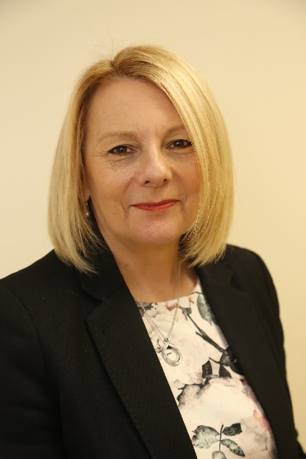 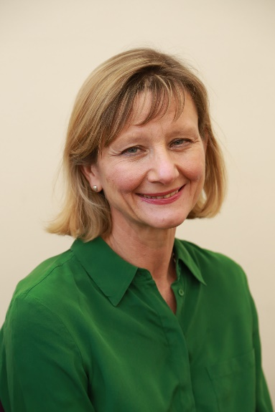

 Signature of Alison Davis 

Jayne Black Alison Davis

**Chief Executive Chief Medical Officer**

Our Clinical Strategy: A summary

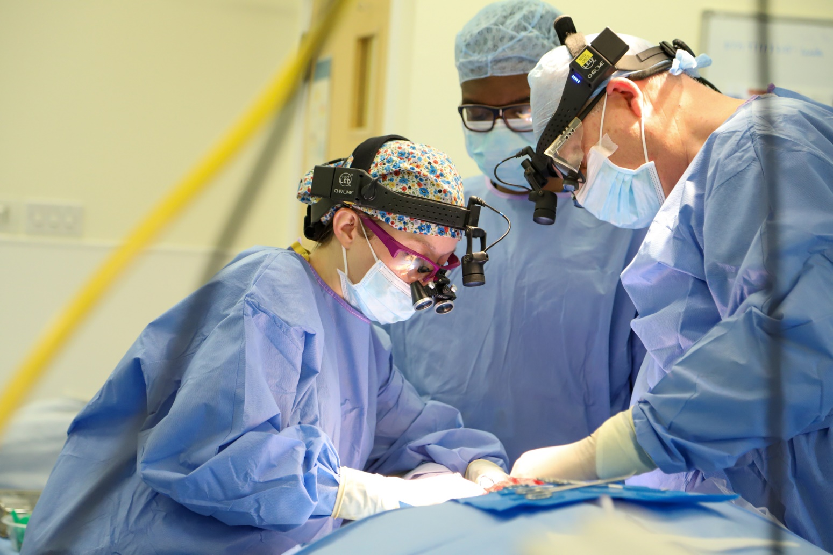

Introduction­­­­­

The launch of our Clinical Strategy in April 2024 is an exciting time as we set out how we intend to innovate and advance our clinical services in the next three, five and 10 years. We have benchmarked our aspirations against national and international leaders and have carefully considered the changing needs of the growing population of Medway and Swale (Sittingbourne and Sheppey).

The strategy explains how we will use the ethos and methodology from our improvement programme, [Patient First](https://www.medway.nhs.uk/about-us/patient-first.htm), to help us continually improve.

This is a three-year strategy, and we will refresh it in 18 months.

Informing our strategy

To help us develop this strategy, we are grateful for the contributions from our patients who receive our care and are best placed to tell us what we do well and what we can do better. It was equally vital that we included feedback from the people who plan, lead and deliver our services.

* We undertook targeted engagement activity with patients, staff and colleagues from within the local health and care system, including the Medway and Swale Health and Care Partnership (HaCP), council partners and voluntary organisations. We used data to benchmark against national performance
* We have also worked with partners across Kent and Medway within the Integrated Care System (ICS), acute, community and mental health providers.
* We developed evidence-based service level reports to understand each service’s current position and establish their strategic direction and priorities
* We ensured our Clinical Strategy aligned with the ICS Strategy and the [NHS Long Term Plan](https://www.longtermplan.nhs.uk/).

­­­­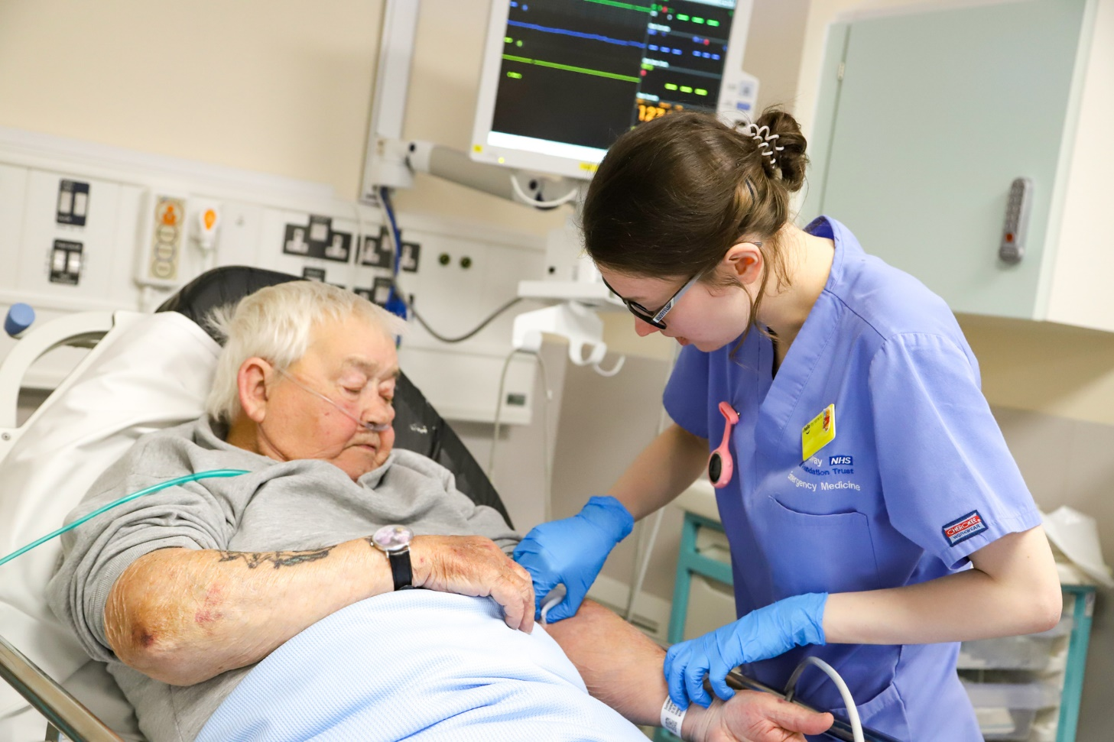

Facts about Medway and Swale

­­­­­





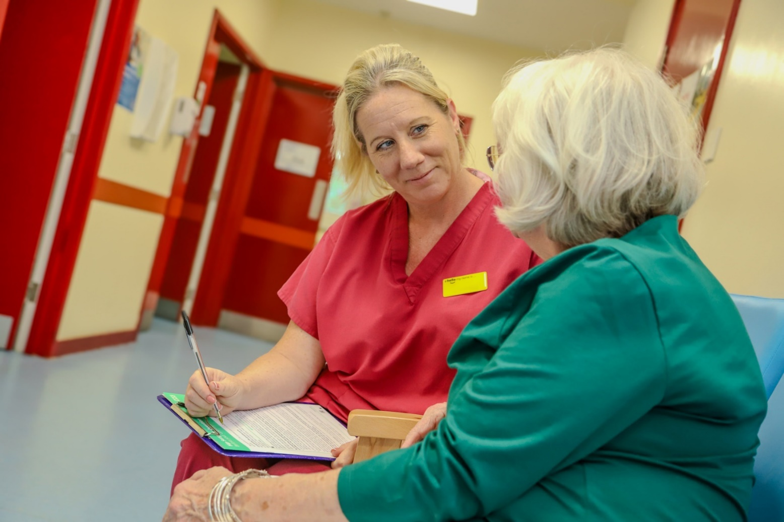

Ambition and vision

Our ambition is to help the people of Medway and Swale live independently and disease-free for longer. To this end, we describe our clinical strategic vision for the future as:

* achieving sustainable hospital care with an understanding of all co-dependencies ­­­and a sustainable plan for our services to meet the needs of the local population
* all services at the Trust will be in the top 25 per cent nationally, followed by achieving the top 10 per cent nationally, consistently striving to perform at high levels, using national benchmarking, to ensure population health is optimal and resources are focused on areas needing it most
* patient outcomes are heavily influenced by the quality of individual services and we aim to perform outstandingly to show best practice for safety, effectiveness, positive experiences, being well-led and sustainable.

Our vision for the local population is to make Medway and Swale a place where people are empowered and encouraged to look after themselves and others with services that are accessible and delivered equally well across the area.

Our clinical focus is on these priorities:

* reducing emergency and hospital admissions, improving community management of diseases and access/flow through the hospital and its services
* addressing our capacity challenges to ensure we provide a robust and consistent elective care offer in all clinical areas
* improving integration of services both locally and across the Kent and Medway system more broadly
* building on good practice and enhancing the hospital’s offer for high standard clinical services for adults, young people and children, benchmarking against national best practice (Model Health Systems and Getting It Right First Time, GIRFT) and aiming to be rated as outstanding by the Care Quality Commission (CQC)
* working in partnership with our adult and child mental health partners to ensure we offer a tailored approach for the care we provide
* continuing to be a strong partner and work collaboratively within the HaCP and the local Kent and Medway system
* developing financially sustainable services.

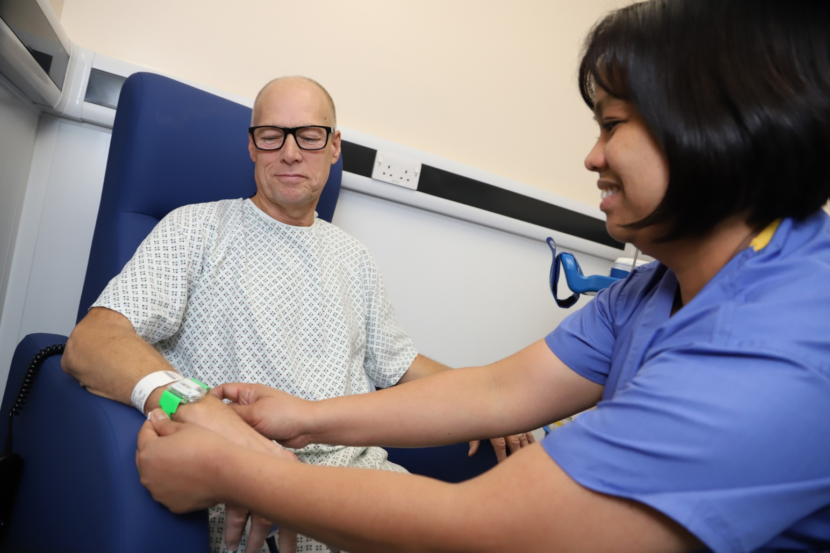

To deliver our Clinical Strategy we will:





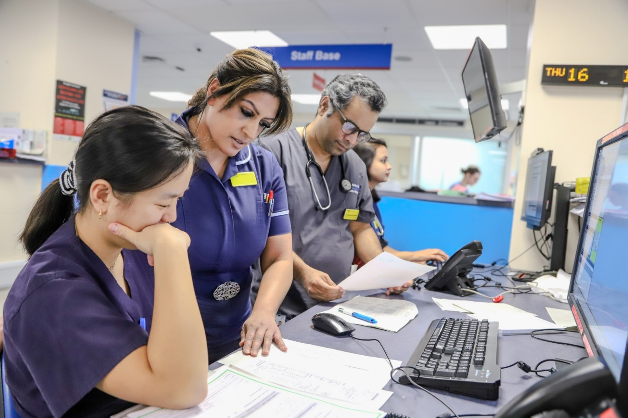

Ambitions for specialties and services

Our full Clinical Strategy sets out initial priorities for each of our specialties and services as well as longer term ambitions. As this is a summary, this document outlines the longer-term ambitions for each.

Acute and Emergency Medicine

* Emergency Department (ED) to deliver national standard in four-hour performance, take all ambulance handovers within 15 minutes, have no 12-hour delays to admission and have sufficient staff to deliver this
* Acute medicine department to see all patients within time targets specified by the Society of Acute Medicine Bench Marking Audit (SAMBA)
* 95 per cent of patients treated on the same day to be seen in Same Day Emergency Care (SDEC)
* Medical on-call team to be stationed in the Acute Medical Unit (AMU)
* No patients referred to Medicine will attend ED for medical assessments unless needing resuscitation
* All patients referred to Medicine will no longer attend the Urgent Treatment Centre (UTC) but instead attend SDEC and triaged as appropriate
* The length of stay on AMU will be less than 48 hours and short stay will be no more than five days
* Daily specialist medicine in-reach into both ED and AMU
* Improve flow of patients in ED by fully utilising the SDEC model
* Establish new strategy for UTCs to provide care in the community and reduce unnecessary ED attendance
* Look for opportunities to promote healthier life choices
* Build on existing award-winning educational strategies: maximising workforce capability, career potential and recruitment and retention
* Continue to generate, share and publish best practice initiatives so that we are recognised as a national leader in acute and emergency medicine.

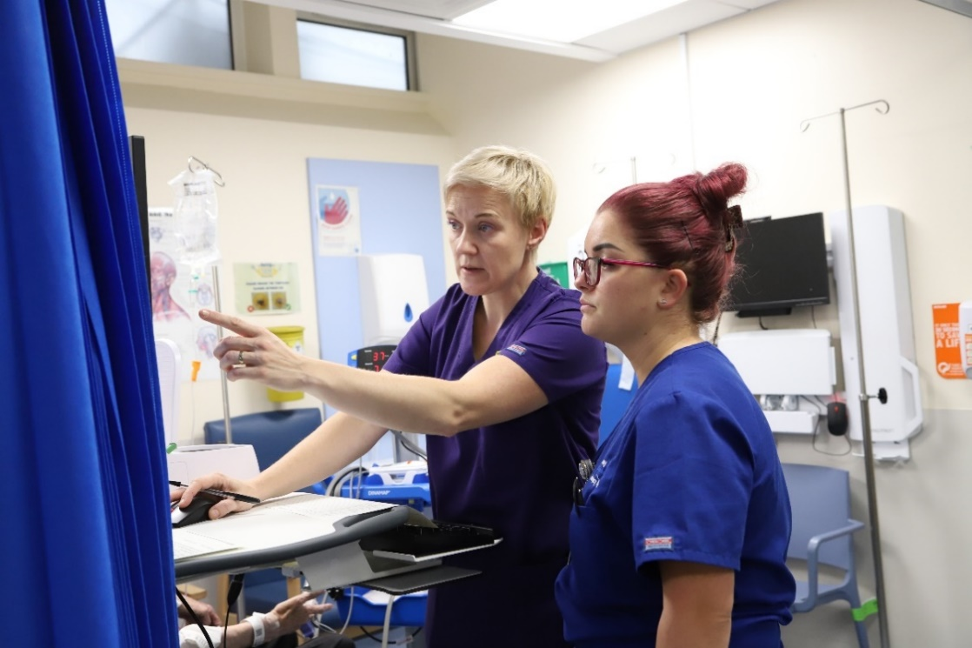

Breast Surgery Service

* Redesign the breast service in order to have capacity to meet increasing demand using best practice national guidance and Model Health System data
* Provide patients with the right diagnostic followed by the right procedure by the right person at the right time, through improved planning and capacity. We will aim to see increased day surgery rate of 75 per cent thereby better utilising the skilled surgical clinicians at Medway and reducing our reliance on insourced capacity.

Cancer Services

* Increase capacity on Galton Day Unit to provide additional activity for treatments, in line with the increased referral numbers supporting our population in terms of timely treatment. This will also support the Trust to achieve targets and relieve pressures
* Sustain the improvement that led to winning the South East region NHS Parliamentary Awards 2022 in the ‘Excellence in Healthcare’ category to maintain the Trust’s reputation nationally, recognising our staff’s dedication and empowering others to be ambitious.

Cardiology

* Develop a Primary Coronary Intervention Care Service to better serve our population’s needs and to support recruitment and retention in the service in collaboration with system partners
* Recruit more imaging consultants to enhance our offering; use the cardiorespiratory village opportunities, including increasing our capacity for cardiac interventions to their fullest and improve the patient experience by reducing waiting times, developing supporting roles to improve the service
* Decrease length of stay for patients waiting for cardiology procedures by increasing consultant capacity and the use of virtual appointments
* Implementation of holistic pathways eg Heart Failure Service.

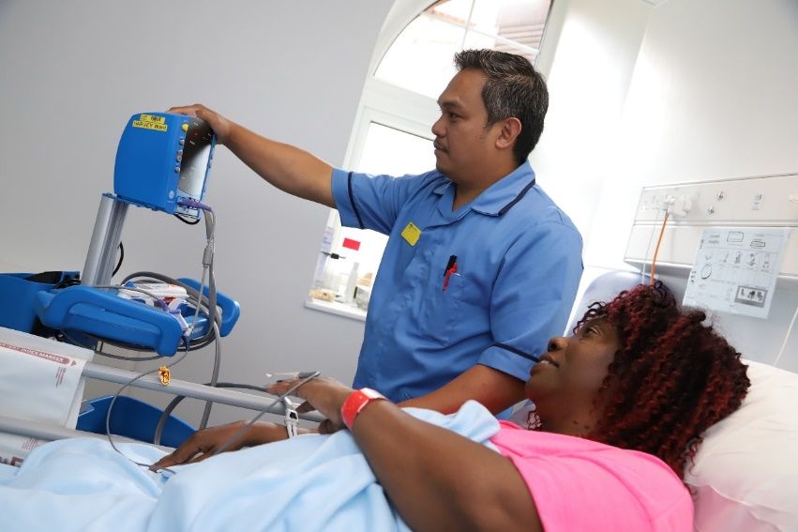

Colorectal Surgery

* Utilisation of the second surgical robot to offer more and different procedures in line with best practice understanding, while enhancing the reputation of the Trust and enabling us to become a reference centre for education and training
* Develop practice of the Non-Ablative Fractional Laser for treating colorectal cancer and other lower gastral intestinal diseases and disorders
* Enhance care and further improve patient experience and outcomes, and enhance skill-extension within our workforce.

Diabetes

* Continue to offer innovative services through collaborative working, for example Endocrine pathways, continuing glucose monitoring through mobile technology and a biomarkers for glycaemic control to provide the best possible treatment to our patients while also training, recruiting and retaining a highly skilled multidisciplinary workforce
* To be in the top decile nationally for treating and caring for our patients and empowering colleagues.

Diagnostic Imaging

* Expand to become the non-vascular Interventional Radiology hub for the system; to build upon the expertise already within the Trust, expand the offering, and maintain excellent clinical outcomes, leading to enhanced patient experience and improved staff recruitment and retention, working alongside system partners
* To implement the widespread use of artificial intelligence (AI) programmes in radiology to offer our patients the most current technology to enhance their outcome, while using AI to support training of our staff
* To introduce newly commissioned services, for example Interventional Radiology clinic, to assess follow-up patients and counsel patients regarding state-of-the-art procedures such as prostatic artery embolisation. This will ensure cohorts of patients are focused on, leading to better clinical outcomes and patient experience.
* To continue to invest in our diagnostic equipment so that we can provide state of the art facilities for our patients
* To support Community Diagnostic Centres to provide patients with diagnostic support outside of the acute setting to allow quicker waiting times for our elective patients and increased flow for our emergency patients.

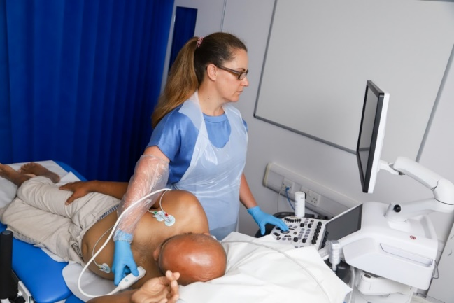

Ear, Nose and Throat

* Re-design outpatient pathways to maximise capacity, improve performance and patient outcomes
* Develop Straight To Test (STT) nurse role for head and neck cancer
* Continue to develop head and neck surgery pathway and relationship with Queen Victoria Hospital, East Grinstead
* Engage with community services and pathways through the Electronic Referral Operating System to help demand management
* Better alignment with support services (Audiology) to develop one-stop clinic methodology
* Identify alternative pathways for certain conditions using non-medical healthcare professionals.

Frailty

* Establish a Frailty Virtual Ward by building on current collaborative working with system partners, strengthening system relationships and providing patients with the best level of support in their own home
* To enable preventative medicine and reduce admissions through collaborative working to run community-based clinics
* Expand the number of community Rapid Access Clinic for the Elderly (RACE) to increase patient experience and decrease number of admissions by prevention
* Roll out Iron Infusion clinics into community settings
* Initiate an evidence-based assessment of patients attending ED following a fall under the newly proposed “Falls and Syncope” pathway.
* Opening of the Frailty Same Day Emergency Care (SDEC) in collaboration with external stakeholders

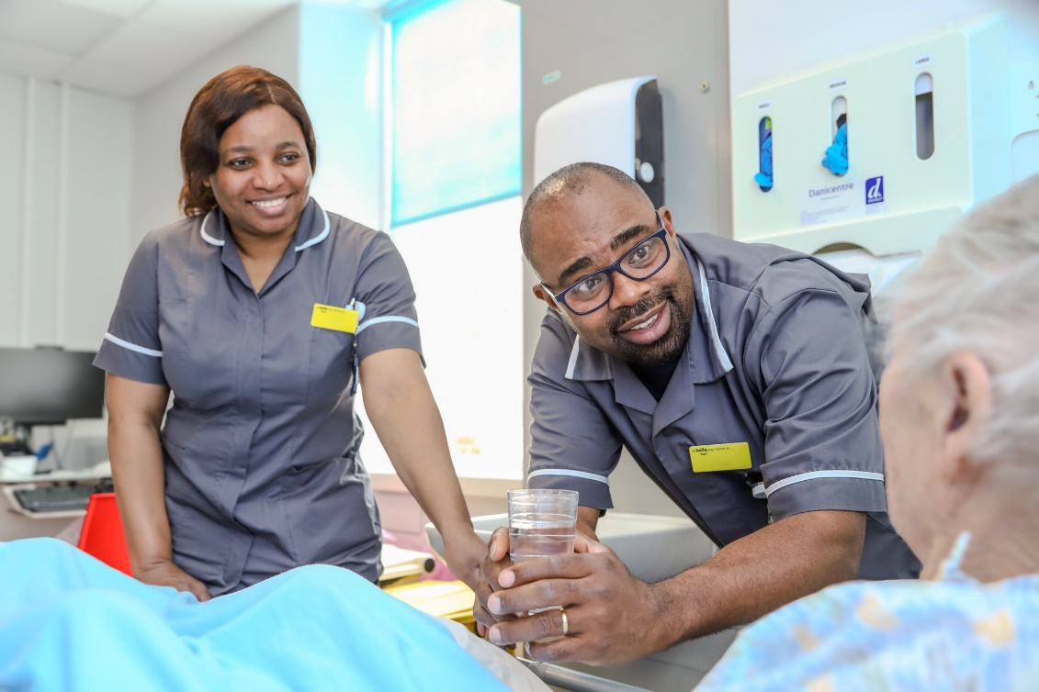

Gastroenterology

* Improve the hepatology service by developing the appropriate multidisciplinary team and expertise
* Working with partners to improve endoscopy capacity to reduce and sustain waiting time improvements for clinical treatment and explore different ways of working, for example Capsule Endoscopy, following the pilot at Maidstone and Tunbridge Wells (MTW) and CT colonography
* Achieve Improving Quality In Liver Services (IQILS) accreditation
* Maintain Joint Advisory Group accreditation for endoscopy service.

General Surgery

* Support plans to build an off-site surgery hub dedicated to elective work, which will assist in improving flow and day case rates on the Medway hospital site, focus resources more appropriately, improve patient experience and outcomes, and support the reduced waiting times for elective treatments across the system
* Reinforce pathways to improve clinical outcomes and patient experience
* Recruit additional multidisciplinary team roles to provide additional levels of cover and increased decision-making for earlier and more consistent interventions
* Develop an Enhanced Recovery Team to support faster access to emergency treatment with more focused recovery support to improve outcomes and reduce length of stay
* Extended Care Practitioner for Surgical Assessment Unit/Emergency Surgery Ambulatory Clinic to create non-medical pathways to alternative care and treatment.

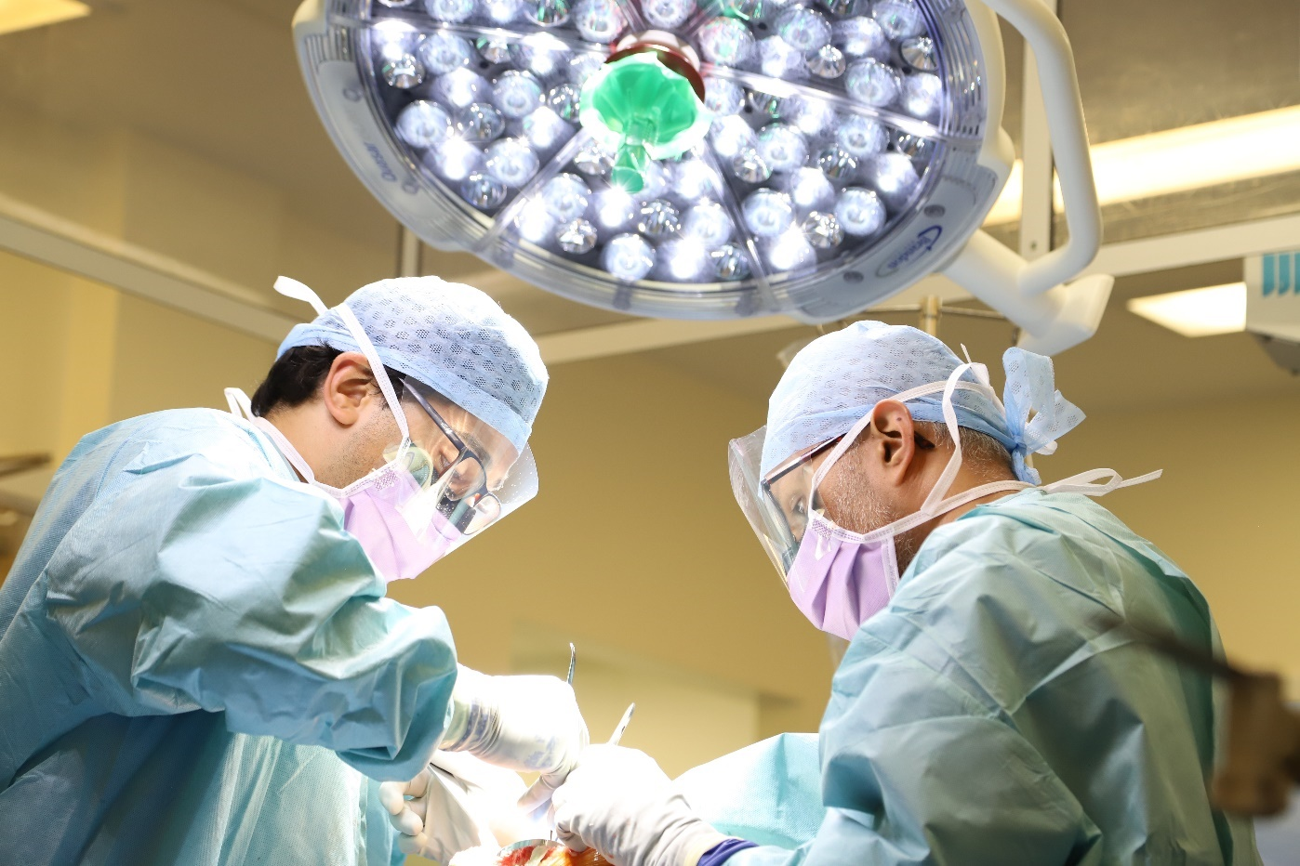

Gynaecology

* Meet the Cancer Faster Diagnosis Standard (75 per cent) by December 2024
* Develop Colposcopy provision, an Endometriosis service, an infertility pathway and a Gynaecology ambulatory pathway.

Maternity

* Building on current state, aim to be the south east hub for patients diagnosed with Abnormally Invasive Placenta and secure commissioning, ensuring the service is fully funded so it can be rolled out to its best abilities, improving patient experience and staff satisfaction for Kent and Medway
* Obtain a level two Foetal Medicine Commissioning status, improving the Trust’s reputation and increasing opportunities for staff to expand their skills and satisfaction
* Continue to provide maternity services that are recognised nationally to be good and working towards providing a CQC rated outstanding service.

Neonatal Critical Care Services

* Become 100 per cent compliant with GIRFT recommendations
* Maintain level three status as a unit to continue to deliver excellent care.

Neurology

* Redesign all intravenous Disease Modifying Therapies (DMT) to reduce costs in travel and time for patients and improve outcomes
* Develop a supported epilepsy pathway with an Epilepsy nurse specialist to allow resources to be focused and improve outcomes for these service users
* Develop, redesign and expand services to grow alongside the population in specific areas including epilepsy and multiple sclerosis; create a fully staffed and permanent base of consultants and specialist nurses to sustain improvements within one department to enable communication, staff support and retention
* Develop the Parkinson’s service in collaboration with Frailty colleagues.

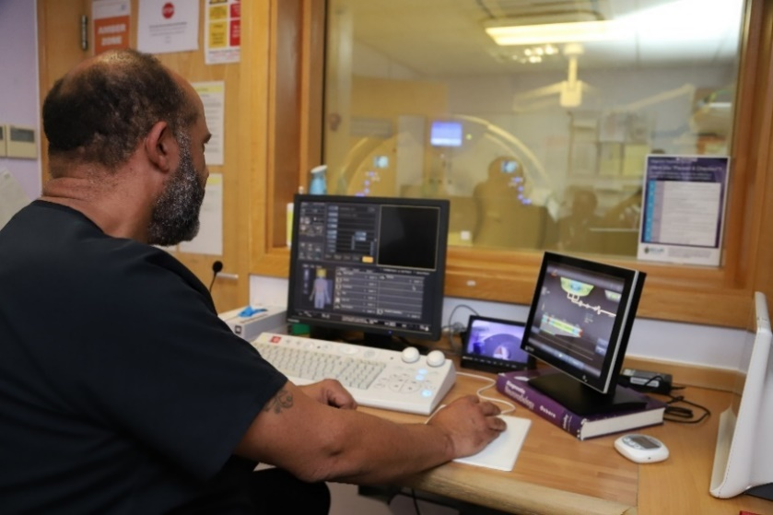

Orthodontics

* Develop a care pathway jointly with the Respiratory Sleep Service for the management of Obstructive Sleep Apnoea/Hypopnoea Syndrome (OSAHS) patients suitable for treatment with Mandibular Advancement Splints (MAS) improving clinical outcomes and patient experience
* Increase orthodontic activity to meet the significant demand for our services and work with Kent and Medway partners.

Paediatrics

* Become the children’s surgical hub for Kent and an exemplar in children’s surgery, providing a gold standard service
* Establish the “walk-in, walk-out” (WIWO) model to enable capacity to be increased, reduce surgical backlog, improve patient experience and improve flow
* Increase excellence in sub-specialisations, such as epilepsy, focusing on these cohorts of patients, increase staff job satisfaction through extra training, and focus resources
* Develop level two Paediatric Critical Care Unit (PCCU) status that undertakes interventions which are done less frequently to children with a higher level of critical illness which demands the provision of staff who have undergone additional training
* Work collaboratively with specialities across the Trust to have a robust and high-quality transition service for young people as they transfer into adult services.

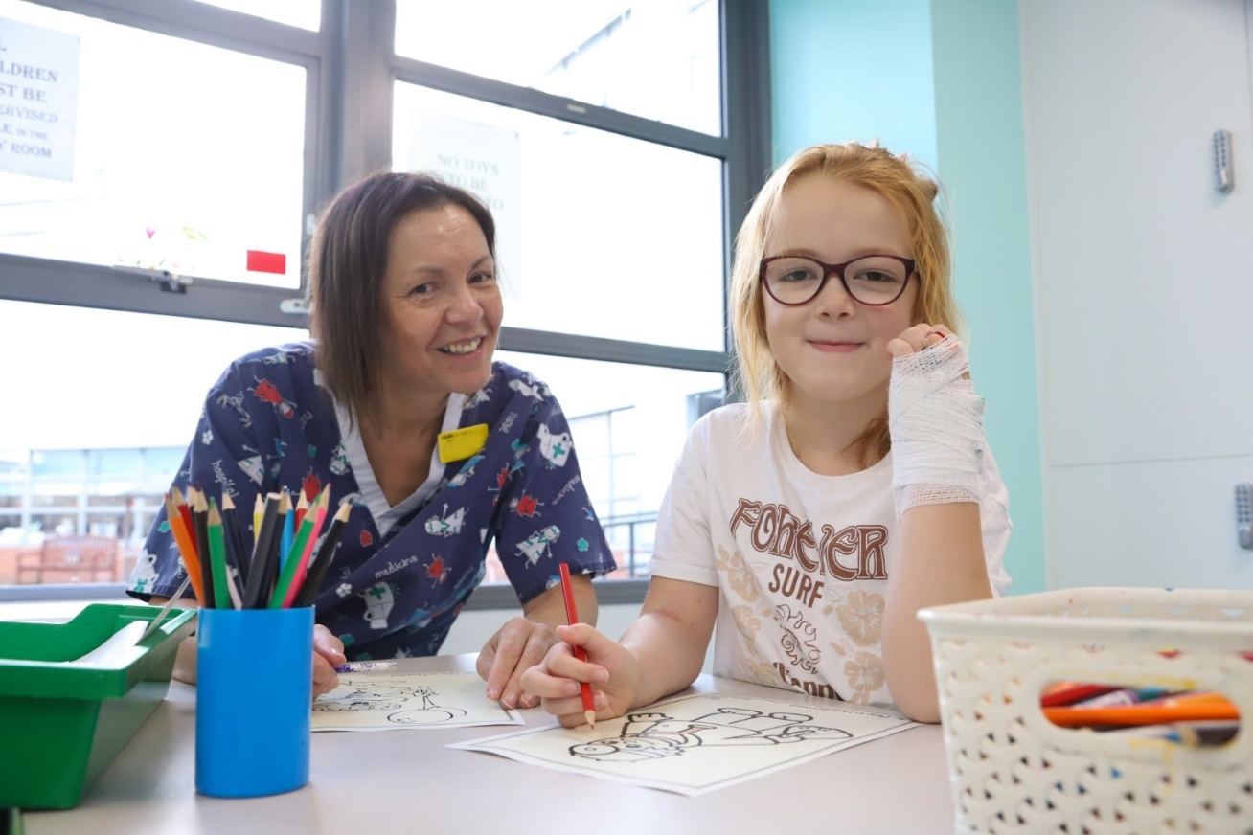

Pathology

* Collaborate on, and be a leading partner for the new Kent and Medway Pathology Network, ensuring our positive regional standing, and be able to take part in effective resource and knowledge sharing.

Pharmacy

* Engage in clinical service redesign to maximise the opportunities provided by staff, through the development of roles of Consultant Pharmacist prescribers and Specialist Pharmacy Technicians, improving staff satisfaction and recruitment and retention
* To use electronic systems to optimise medicines use, including electronic storage cabinets and closed loop medicines administration, ensuring efficiencies in line with Trust standards
* Develop a local integrated system of medicines optimisation to improve patient safety, effective and sustainable use of medicines and quality of care by having a pharmacy workforce that operates without organisational boundaries. This would be delivered through the development of a Kent and Medway Pharmacy Training and Development programme and a HaCP-based Antimicrobial stewardship programme
* Support colleagues, and improve patient experience, by developing medicines pathways across the system and establish Medway Pharmacy as a local distribution hub for medicines
* Explore opportunities for wider system integration of pharmacy services (for example Aseptics hub), optimise shared use of medicines data and be at the forefront of developing an ICS Paediatric drug formulary.

A person in a pharmacy looking at a medicine box



Peri-operative and Critical Care/Pain Management

* Perioperative care pathways enhanced to include shared decision making and pre-habilitation programmes
* Provide enhanced mentorship and support to junior staff to improve staff retention and promote a culture of continual learning
* Become research active in both critical care and pain management to ensure our patients receive the most up to date and innovative care.

Respiratory

### Put in place a one-stop asthma service to focus resources most effectively on this ever-growing cohort of patients to improve future prognoses and reduce admissions

### Offer pulmonary tests and sleep studies in Community Diagnostic Centres reducing the flow of patients to the main site and increase patient satisfaction by being able to treat patients closer to home.

* Support creation of the Cardio Respiratory Village on site to deliver more efficient services and to expand and focus others, for example, sleep.
* Implementation of the National Optimal Lung Cancer Pathway, working collaboratively with Radiology to ensure patients are treated appropriately and with the most up-to-date technology.

Rheumatology

* Achieve the British Society for Rheumatology (BSR) accreditation
* Consider strategic opportunities to develop the service, working with the ICS to ensure appropriate commissioning for a system wide approach
* Develop subspecialist clinics – Connective Tissue Disorders, Ankylosing Spondylitis, Ultrasound, Early Arthritis; Foetal Medicine/pregnancy clinics
* Develop and implement innovative training for GPs, post-graduate doctors in training, musculoskeletal practitioners
* Expand and strengthen community hospital clinics for local people.

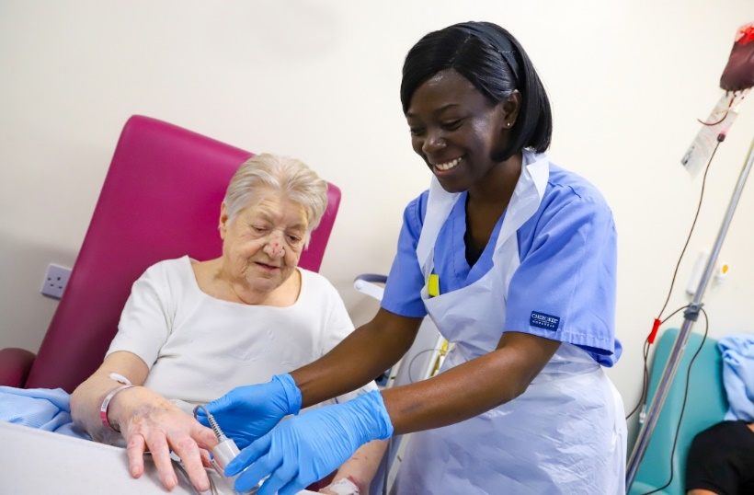

Trauma and Orthopaedics

* Re-establish best in region Referral To Treatment (RTT) performance to increase our reputation nationally and deliver the best of care
* As per GIRFT deep dive, establish data collection to inform a Non Ambulatory Fragility Fracture (NAFF) patients metric as a realistic and value-adding representation of our patients, enabling the Trust to become a leader in this new metric
* Expand and strengthen community hospital clinics for our local population
* New ways of working including day surgery for hip replacements, improving patient experience and continue work to retain low infection rates.

Urology

* Establish a urology advanced investigation unit to centralise all procedures and treatments as per GIRFT recommendations and population needs, so that the service provided is excellent and ensures continuity of care
* Utilisation of the Trust’s second surgical robot. The urology robotic programme has been extended to include two Colorectal Surgeons. The second robot will allow inclusion of Gynaecology. This will be an efficient use of Trust resources and allow the capacity and offer of both services to be increased
* Introduce new recommended procedures and technology for example, Transurethral Laser Ablation, “UroLift” to increase the services available to our patients reducing the need to refer to other trusts, securing regular income and improving patient care.

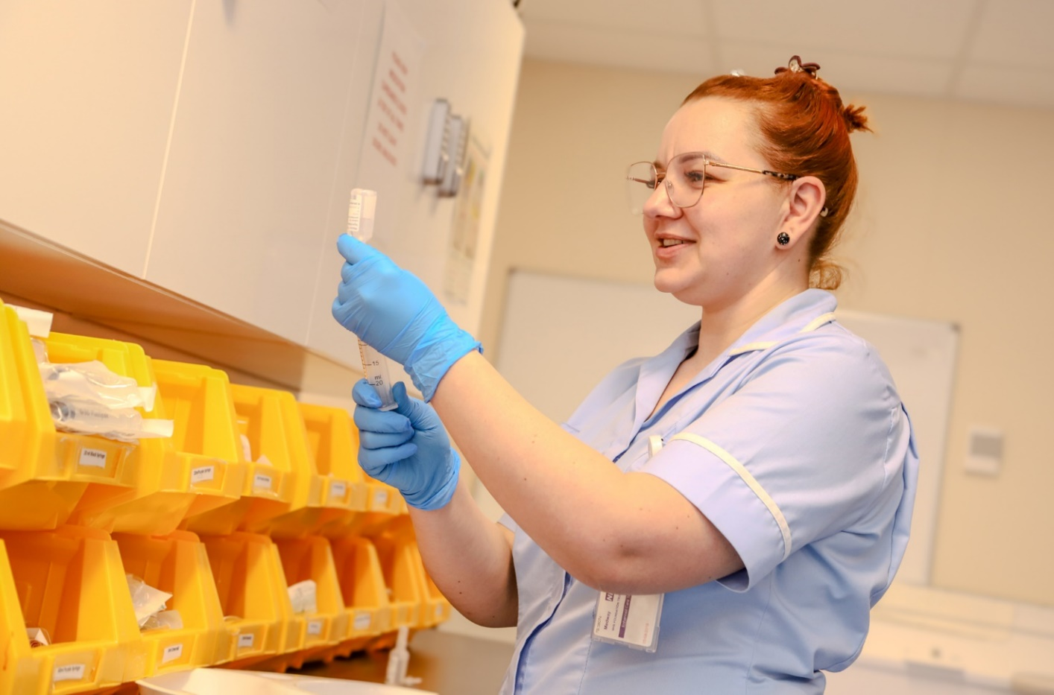

Enabling initiatives

In order to deliver this Clinical Strategy, there are other Trust-wide enabling initiatives that need to be delivered to ensure that all patients receive high quality care.

We need to:



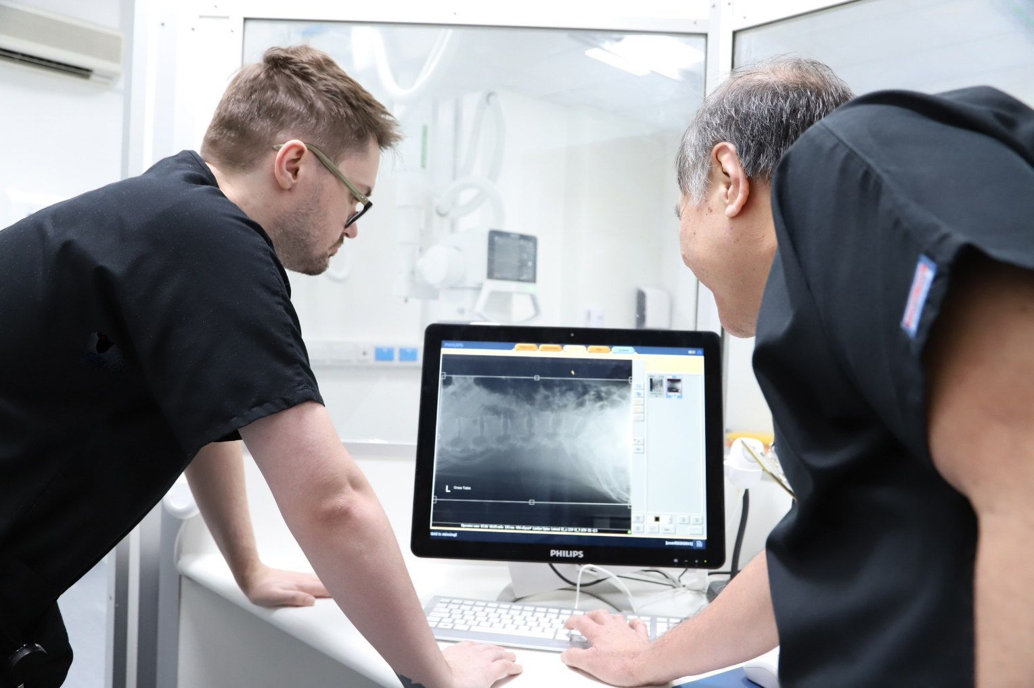

Next steps

In order to be successful, we will develop a health care network with the current hospital site being the hub for acute and complex care. We will continue to develop and deliver alternative health care provision through a networked approach with community colleagues together, with alternative provision of clinical services to resolve congestion issues.

As our clinical provision and network evolves we anticipate that there will be a need for a new elective hospital hub to meet the future demands of the population.

We will continue to work collaboratively with system partners to develop and deliver innovative solutions to the health care challenges we collectively face.

We will also work with regional and national colleagues to share and learn from best practice and drive out unwarranted variation. We will embed the use of national data to benchmark our services.

All our work will be underpinned by the continuation of education, training and development of all who work at the Trust in order that they have fulfilling jobs and careers.

­­­­

Back cover

Top: 
NHS Medway foundation trust logo in top right corner 

 Patient First logo in top left corner



Middle:
Blue triangle 

Bottom:

Best of care logo in bottom right corner

Divisional structure

Our new Divisional structure introduced in late 2023, with five divisions, as pictured below, will support us to deliver our Clinical Strategy at pace.

We anticipate new ideas and innovations will become apparent. We will therefore refresh this strategy in 18 months to ensure that it remains up to date and fit for purpose as well as reviewing it at three and five years.

A diagram explaining NHS Medway 
Trust's divisional structure, split in to 5 shapes showing division and corresponding care group

First division: 
Surgery and anaesthetics 
Care groups:
Surgical Services/Theatres and anaesthesia

Second division: 
Medicine and emergency care
Care groups:
Emergency and Acute/ Specialist medicine/Frailty 

Third division: 
Cancer and core clinical services 
Care groups: Cancer and access/Diagnostic and Therapies

Forth division
Women, Children and young people 
Care groups: Paediatrics/Maternity/Neonatal/Obstetrics and Gynaecology

Fifth Division
Central operations  
Care groups: EPRR/ Site Operations/ Integrated Discharge/ Systems and Performance/ Hospital @home 

Produced by the Trust’s Communications and Engagement Team